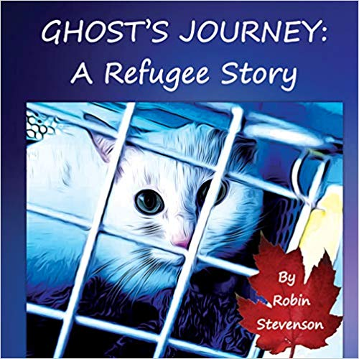
Ghost’s Journey:
A Refugee Story
By Robin Stevenson

B.C. Curricular & Core Competency Connections

Big Ideas - English Language Arts
- K / 1 (Families) Stories and other texts help us learn about ourselves and our families
- K – 2 Everyone has a unique story to share.
- 2 – 3 (Communities) Stories and other texts connect us to ourselves, our families, and our communities.
- 3 - Stories can be understood from different perspectives
- 4 – 5 Texts can be understood from different perspectives
- 4 – 9 (World) Exploring stories and other texts helps us understand ourselves and make connections to others and to the world.
- 6 – 7 Exploring and sharing multiple perspectives extends our thinking
- 8 – 9 People understand text differently based on their worldviews and perspectives

Big Ideas - Social Studies
- K – Rights, roles, and responsibilities shape our identity and help us build healthy relationships with others.
- 1 - Our rights, roles, and responsibilities are important for building strong communities.
- 1 - Healthy communities recognize and respect the diversity of individuals and care for the local environment.
- 2 - Local actions have global consequences, and global actions have local consequences.
- 2 - Individuals have rights and responsibilities as global citizens.
- 3 - People from diverse cultures and societies share some common experiences and aspects of life.
- 5 - Canada’s policies and treatment of minority peoples have negative and positive legacies.
- 5 - Immigration and multiculturalism continue to shape Canadian society and identity
- 6 - Complex global problems require international cooperation to make difficult choices for the future.
- 6 - Systems of government vary in their respect for human rights and freedoms.
- 9 - Emerging ideas and ideologies profoundly influence societies and events.
- 9 - Disparities in power alter the balance of relationships between individuals and between societies.
- 9 - Collective identity is constructed and can change over time.

Additional Secondary Connections
Math
- Engage in problem-solving experiences that are connected to place, story, cultural practices, and perspectives relevant to local First Peoples communities, the local community, and other cultures (G. 9)
- Connect mathematical concepts to each other and to other areas and personal interests (Gr. 9)
- Statistics - analyzing a given set of data (and/or its representation) and identifying potential problems related to bias, use of language, ethics, cost, time and timing, privacy, or cultural sensitivity (Gr. 9 Content)

Science
- Connect scientific explorations to careers in science (Science 10)
- Contribute to finding solutions to problems at a local and/or global level through inquiry (Science 10)
- Consider the role of scientists in innovation (Science 10)

Social Studies
- Compare and contrast continuities and changes for different groups at particular times and places (SS 10)
  - How have Canada’s immigration and refugee policies changed?
  - How has Canadian identity changed or stayed the same?

VPA
- Explore relationships between identity, place, culture, society, and belonging through arts activities and experiences (AE 8 & 9)
- Create personally meaningful bodies of artistic works that demonstrate an understanding and appreciation of social, cultural, environmental, and historical contexts (AE 9)
Physical Health Education
- Analyze strategies for responding to discrimination, stereotyping, and bullying
- Explore and describe factors that shape personal identities, including social and cultural factors

English
- Recognize and identify personal, social, and cultural contexts, values, and perspectives in texts, including gender, sexual orientation, and socio-economic factors (ES 12)
- Construct meaningful personal connections between self, text, and world (ES 12)
- Understand the influence of land/place in First Peoples and other Canadian texts (SL 11)

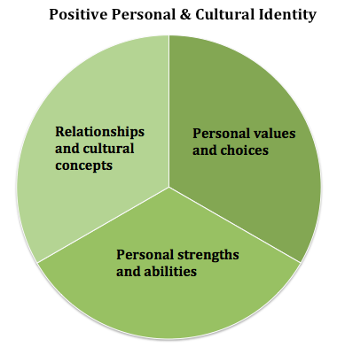
Relationships and Cultural Contexts
Students understand that their relationships and cultural contexts help to shape who they are. This includes culture in its broadest sense, including how one identifies in terms of ethnicity, nationality, language(s), abilities, sexual orientation, gender identity, age, geographic region, and religious or spiritual beliefs. Students explore who they are in terms of their relationship to others and their relationship to the world (people and place) around them.
Recognizing Personal Values and Choices
Students define who they are by what they value. They understand how what they value has been influenced by their life experiences. They identify how their values help to shape their choices, in all contexts of their lives.
Identifying Personal Strengths and Abilities
Students acknowledge their strengths and abilities, and they intentionally consider these as assets, helping them in all aspects of their lives. Students understand that they are unique and are a part of larger, and often multiple, communities. They explain how they are using their strengths and abilities in their families, their relationships, and their communities.
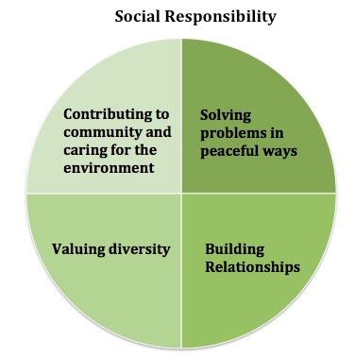
Contributing to community and caring for the environment
Students develop awareness of and take responsibility for their social, physical, and natural environments by working independently and collaboratively for the benefit of others, communities, and the environment. They are aware of the impact of their decisions, actions, and footprint. They advocate for and act to bring about positive change.

Resolving problems
Students identify and develop an appreciation for different perspectives on issues. They show empathy, disagree respectfully, and create space for others to use their voices. They generate, use, and evaluate strategies to resolve problems.

Valuing diversity
Students value diversity, defend human rights, advocate for issues, and interact ethically with others. They are inclusive in their language and behaviour and recognize that everyone has something to contribute. Their approach to inclusive relationships exemplifies commitment to developing positive communities.

Building Relationships
Students build and maintain diverse, positive peer and intergenerational relationships. They are aware and respectful of others’ needs and feelings and share their own in appropriate ways. They adjust their words and actions to care for their relationships.

