Theme Song Mind Map

The objective of the Mind Map is to create a visual representation of your thinking and processing. You are encouraged to use colour, doodles, highlighting, graphics (like arrows, flow charts, thought bubbles, speech bubbles, etc.) as well as any other visual features that will help to demonstrate connections that you are making between content you include in your Mind Map.

Questions to consider (Though keep in mind, that any other thought and ideas about choosing your song are welcome. You are NOT limited to the questions posed here:

How does your theme song make you feel?
What do you visualize when you hear your song?
What do you experience when you hear your song?
What physical response do you have to your song?

What is the song about?
What is the message of the song?
What connections do you make to the lyrics/mood/rhythm?
What specific lyrics define the song for you?
Which lyrics are most meaningful?
What message do you want the song to communicate about you?
What, if any, connections do you have to the artist?

What is a situation where you would play your theme song?
When would your theme song come in handy?
When would you use it?
What activities would your theme song be good background music for?

Why is this song a good pick?
Why choose this song? Why not others?

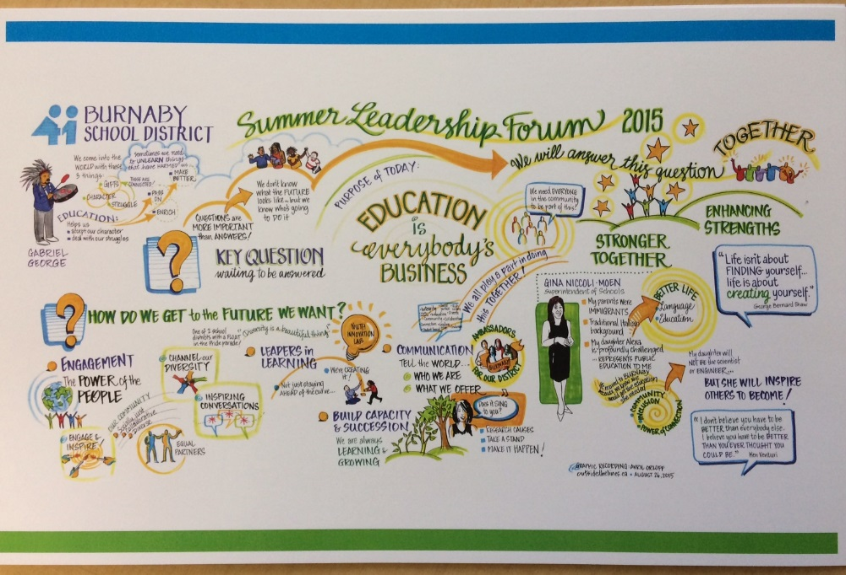
Some examples of Mind Maps that are visual representations of learning and / or thinking are included here for your reference.

Consider how you might organize and represent your thinking in a similar visual structure, using colour, graphics, and doodles

