Name: _______________________________________
Reflecting on your exploration of identity, please summarize the steps we took, from the beginning of the task to the completion of your assignment. (Summarize the topics discussed in addition to the tasks you were asked to engage in). Try to organize them in sequence. *Can be done in point form

What key understandings have you developed? What specific things have you learned (or affirmed)?

What important understandings are you able to share with others? What do you want people to know or understand?
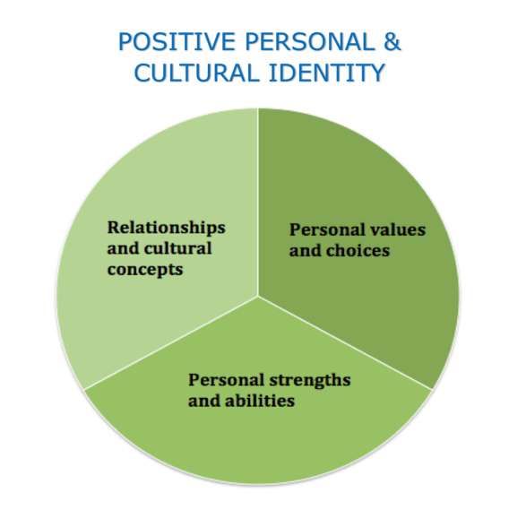
Consider the Positive Personal and Cultural Core Competencies above. Connect your learning to any of these aspects. Identify which aspect you are referring to, and describe how your actions, and / or your understandings demonstrate that dimension.

