Highlighting “Victor’s Pink Pyjamas” and “Super Manny Stands Up”
Some Possibilities in Preparation for Pink Day, Wednesday, February 27, 2018

As many schools recognize Pink Shirt Day at the end of February, I’d like to highlight the following titles, “Victor’s Pink Pyjamas” and “Super Manny Stands Up” from the recommended list for 2018 – 2019. These might help to provide supplemental school plans and offer in-class lessons to develop enhanced understandings of the origins of Pink Shirt Day.

This is not intended to be prescriptive and may require some adaptions or revisions for the grade level you are working with. It is simply intended to provide a framework and some resources to explore the topic.

1) Brainstorm reasons that people get bullied or harassed.

Possible answers
- Non-conformity (i.e. boys with feminine behaviours / girls with masculine behaviours)
- Body composition – (i.e. perceptions of being too fat, or too skinny)
- The way people dress (i.e. generic brands vs. name brands, wearing turbans or hijabs)
- Skin colour
- Ability (anything from coordination / athleticism or lack thereof, to physical / medical limitations)
- Neuro-diversity
- Socio-economic status
- Intelligence
- Perceptions of not being “normal”

2) Engage students in a conversation about colours and how they might be perceived as being masculine or feminine / as being “girlish” or “boyish.

A suggested activity to spark this conversation…
Collect paint swatches from a home renovation or paint store.
Ask students to categorize them as options for painting 1) a girl’s room, 2) a boy’s room, 3) a room for anyone.
Get students to reflect on why they’ve made particular choices.
Consider “ownership” of colours and how these ideas might be “constructed” or “influenced.”

Read:
Victor’s Pink Pyjamas by Laura Alary

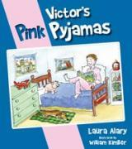  ISBN: 9781770645714 | Victor’s Pink Pyjamas  By Laura Alary  Illustrated by William Kimber  Victor’s favourite pair of pyjamas accidentally go through the wash with a pair of red socks, turning his comfortable, white pyjamas pink. Victor refuses to abandon his cozy pyjamas regardless of their new tint. Victor’s father, concerned he will be ridiculed because of the feminine colour insists he needs replace them. But Victor, is quick to defend his pyjamas, and provides some thoughtful reasoning to reject the (masculine or feminine) stereotypes that we often attach to colours. | Suitable for all grades.  - Provides opportunities to explore creative thinking around a topic or problem  - Allows for some thoughtful investigation of masculine or feminine stereotypes that are attached to colours  - Prompts some conversation around how we treat others and the idea of being able to assert yourself  - Provides examples of how to provide logical support for a position or perspective

Discuss perceptions of the colour pink.

Using a Venn Diagram and paint. **This lesson and the accompanying examples come from K/1 teacher, Breanne Sumpter, at Chaffey-Burke. She paired the story “Victor’s Pink Pyjamas” with “Pink” by Lynne Rickards to engage students in these conversations.
Colour one of the circles red.
Colour the other circle white.
Highlight how pink is formed by the overlapping portions of the circle (similar to how Victor’s pyjamas result in their pink colour)
**You may experiment with which paints will most effectively create this effect, as well as the timing of application (i.e. ensuring one colour is still wet when the second is applied, and determining whether the result is influenced by whether red is applied first or second). You could choose to use this to develop understandings about scientific / experimental inquiry if you are interested in devoting the time and broadening the learning experience.

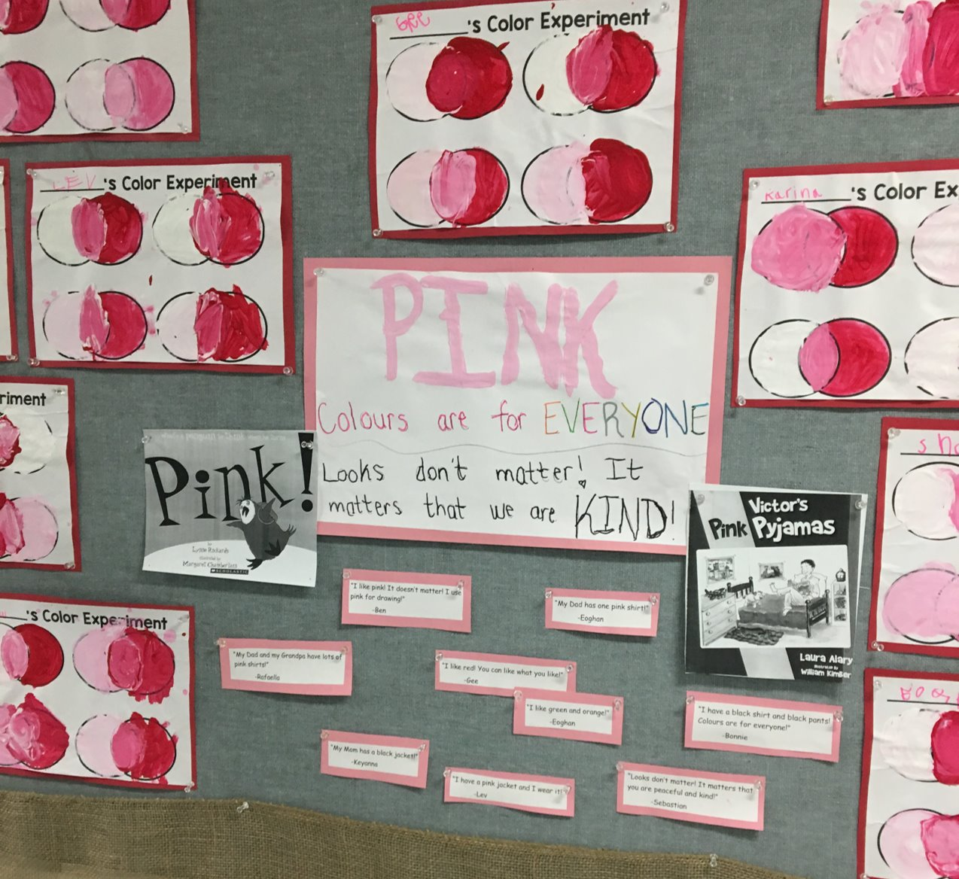

3) Revisit brainstorm about why people get bullied or harassed. Encourage students to identify the concerns characters had about how Victor would be treated if he wore his pink pyjamas in front of people.

4) Select another story that explores someone being harassed or bullied. Identify how a character was treated, and what motivated others to treat the character that way.
Consider:
- Oliver Button is A Sissy by Tomie DePaola
- Hooway for Wodney Wat – Helen Lester
(I happened across this readers’ theatre script if you wanted to incorporate drama into your exploration of the topic
http://www.timelessteacherstuff.com/readerstheater/WodneyWat.pdf)
- Nerdy Bird Tweets by Aaron Reynolds
- Tales From the Bully Box by Cat Woods, Sarah Tregay, Lauren Neil, Steven Carman, Linda Brewer, Eden Grey, K.R. Smith, Precy Larkins
- Stick and Stone by Beth Ferry

5) Discuss possible solutions to bullying.
- What can we do if we find ourselves a target of bullying?
- Who can help us?
- What can we do if we observe someone else being bullied?
- How can we help?
- How can we prevent bullying?

6) Share:
- Super Manny Stands Up by Kelly DiPucchio

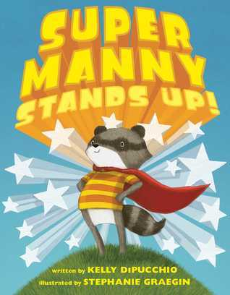  ISBN: 978-1-4814-5960-0 | Super Manny Stands Up!  By Kelly DiPucchio  Illustrated by Stephanie Graegin  Manny feels empowered to battle unsavory sea creatures, zombie bears, and evil clouds when he dons one of his colourful capes. With each cape he wears he declares he is fearless, strong, brave, powerful or invincible. He applies this positive self-talk when faced with how to deal with a bully picking on one of his vulnerable classmates. | Suitable for all grades.  - Fosters some conversation around positive self identity and positive self-talk  - Provides some context for discussing the role of an upstander

Discuss the roles of “bully,” “bullied,” and “bystander.” Consider the role of “upstander.”

- We’re All Wonders by R.J. Palacio
Discuss diversity, and acceptance of all types of people. Discuss choosing kindness and maintaining the dignity of people we interact with.

