Highlighting “Stella Brings the Family”

A Pro-Active Suggestion for Inclusive Mothers' Day and Fathers' Day Celebrations

Here is a quick suggestion for being proactive about addressing some of the challenges around recognizing Mothers' and Fathers' Day in our classrooms, particularly when our students don't have "traditional" family structures. Some educators are reluctant to recognize Mothers' and Fathers' Days in the classroom, because there can be complicated and emotional dynamics around them. Engaging in a lesson about celebrating someone important in advance of those days may alleviate some of the concerns or challenges that we face in those contexts.

Stella Brings the Family by Miriam B. Schiffer
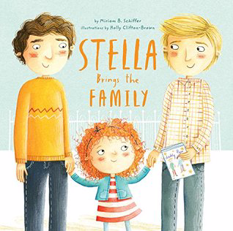

​Stella is invited to bring her mother to Mothers' Day celebrations in her classroom. Stella is unsure what to do because she doesn't have a mother - she has 2 dads. She ponders how to solve the problem, wondering who she can bring to the party. In the end, the message communicated is that she is surrounded by people who love her and that even if a mom isn't present, Stella is welcome to bring family that is important to her.

