Intermediate Readalouds / Considerations for Lit Circles or Battle of the Books
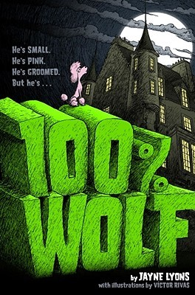  ISBN: 978-1-4424-0252-2 | 100% Wolf  By Jayne Lyons  Freddie is eagerly anticipating his coming of age as a werewolf. Surprisingly, on the occasion of his transformation, he changes into a pink poodle instead of a wolf. This causes him to be ridiculed and outcast from his pack until the other werewolves recognize his usefulness and come to value his differences. A relatable mix of humour and adventure. | Suitable for intermediate grades (4+)  Recommended as a read aloud  - Can be a catalyst for conversations about recognizing and appreciating differences  - Aligns nicely with conversations around acceptance and diversity  - Could be used to connect to transgender, gay, or other queer experiences where someone may have an identity or appearance different than anticipated  - Could initiate conversation about the concept of “coming out” and revealing identity  - Could build on conversations about bullying or mistreatment of others based on aspects of their identity beyond their control
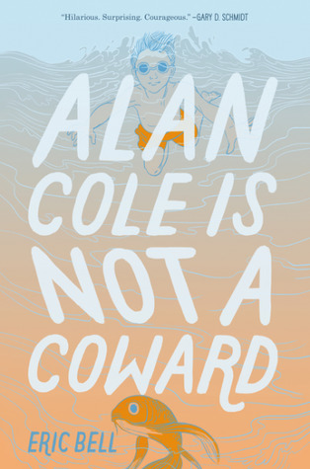  ISBN: 978-0-06-256702-4 | Alan Cole is Not a Coward by Eric Bell  An engaging story about a young closeted boy who is coerced into performing a series of dares by his brother who threatens to “out” him if he doesn’t participate. The main character, Alan, overcomes fears to accept and to claim his own identity within his school and within his family. | Suitable for intermediate grades (4+)  Recommended as a read aloud.  - Prompts conversations around resiliency and identity  - Provides opportunities to discuss awareness of unhealthy situations or relationships and how to problem solve or respond to them
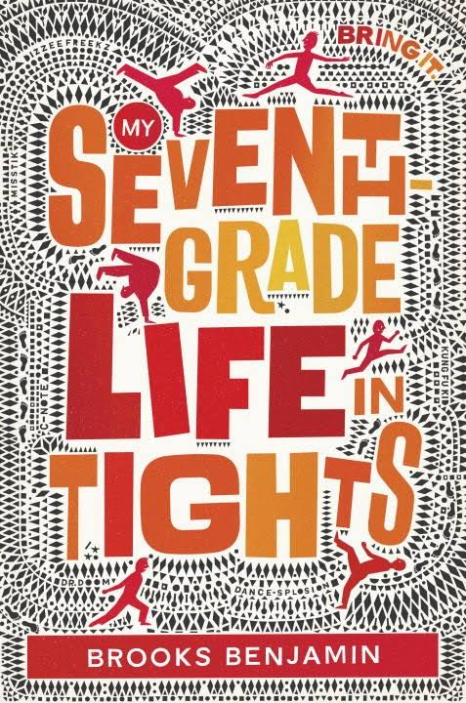  ISBN: 978-0-553-51250-2 | My Seventh Grade Life in Tights  By Brooks Benjamin  Dillion is much more interested in dancing than in playing football (something his father is much more enthusiastic about than he is). He dances in a small group with his friend, Austin (who happens to be gay), and his friend, Kassie, who he is developing romantic feelings for. He gets involved in a scheme to participate in a dance competition in order to win lessons from a prestigious dance school. Throughout the story, he worries that DeMarcus, a popular football teammate is interested in pursuing Kassie. It is revealed later on in the story that DeMarcus is interested in one of the members of Dillon’s dance team, but it turns out that it’s not Kassie. | Suitable for intermediate grades (5+)  Recommended as a classroom read aloud.  - Provides opportunities to discuss gender stereotypes  - Subtle messages about acceptance and diverse identities  - Provides opportunities for discussion about identifying complex feelings and recognizing what they are in response to
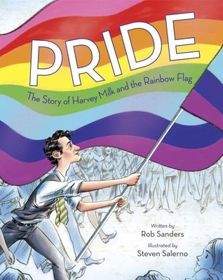  ISBN: 978-0-399-55531-2 | Pride: The Story of Harvey Milk and the Rainbow Flag  By Rob Sanders  Illustrated by Steven Salerno  A quick overview of the story of Harvey Milk, one of the first openly gay man elected to public office. It documents the development of the pride flag as a symbol for the LGBTQ+ community and the relevance of advocacy. | Suitable for all grades.  - Provides a good catalyst for talking about the pride flag, and its symbolism  - Gives some context for the battle for civil and human rights and the struggle for equality  - Prompts discussion about the achievements of people who identify as LGBTQ+  - Provides biographical notes about Harvey Milk, as well as Gilbert Baker (the artist credited with creating the original Pride Flag)  - Provides timelines of Harvey Milk’s life and achievements and of the Rainbow Flag
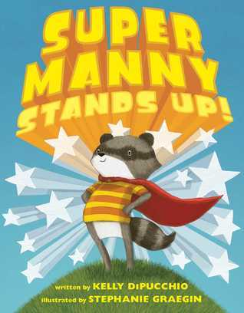  ISBN: 978-1-4814-5960-0 | Super Manny Stands Up!  By Kelly DiPucchio  Illustrated by Stephanie Graegin  Manny feels empowered to battle unsavory sea creatures, zombie bears, and evil clouds when he dons one of his colourful capes. With each cape he wears he declares he is fearless, strong, brave, powerful or invincible. He applies this positive self-talk when faced with how to deal with a bully picking on one of his vulnerable classmates. | Suitable for all grades.  - Fosters some conversation around positive self identity and positive self-talk  - Provides some context for discussing the role of an upstander
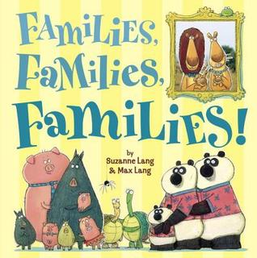  ISBN: 978-0-553-49938-4 | Families, Families, Families  By Suzanne Lang and Max Lang  A humourous album of family pictures displaying a variety of family structures and relationships. The characters are relatable, cartoonish animals and the artwork is visually appealing. | Suitable for all grades.  - Provides opportunities to talk about various family structures that exist in our communities in a non-threatening manner  - Places emphasis on “if you love each other, you are a family.”
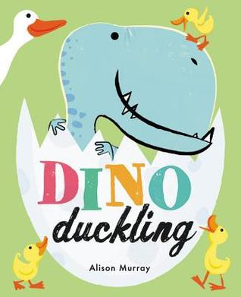  ISBN: 978-0-316-51313-5 | Dino Duckling  By Alison Murray  An updated, charming and humourous rendition of the “Ugly Ducking.” Dino Duckling is clearly different from his siblings. Even as an egg, it was clear that Dino was different. Dino has difficulty fitting in and doing all the typical duckling activities, he and his family are taught many skills and values, including to celebrate differences. Despite the difficulties of being different, Dino’s family sticks by him and adjusts their routines and plans to ensure he remains a valued member of his family. | Suitable for all grades. Highly appealing for primary grades.  - Provides opportunities to discuss unique family dynamics or structures  - Demonstrates how families stick together and work out problems together  - Places emphasis on celebrating differences
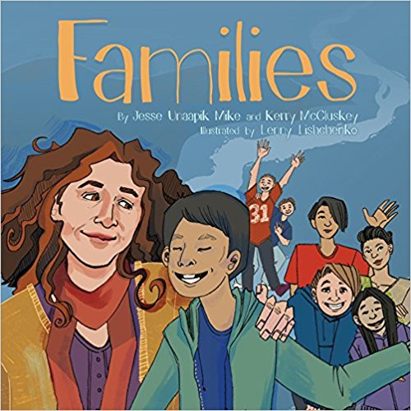  ISBN: 978-1-77227-181-4 | Families  By Jesse Unaapik and Kerry McCluskey  Illustrated by Lenny Lishchenko  A story about family diversity told from the perspective of an Indigenous family in Iqaluit. Talittuq, a grade 2 student starts a conversation with his mom about why his father doesn’t live with them. At school, he notices the different family structures of the various members of his school community, including friends and cousins who live with two moms, two dads, a mom and a dad, a grandmother, or a stepdad. | Suitable for all grades.  - Can provide a platform for conversations about family diversity  - Provides opportunities for conversations about identity and acceptance  - Offers Indigenous representation  - Allows for the exploration of vocabulary relevant to the importance of language and culture in Indigenous communities  - Provides opportunities to make explicit connections to the First Peoples Principles of Learning
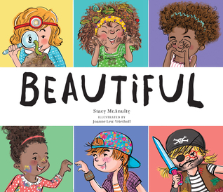  ISBN: 978-0-7624-5781-6 | Beautiful  By Stacy McAnulty  Illustrated by Joanne Lew-Vriethoff  A colourful book that subtly demystifies some of the stereotypes that exist about girls and beauty. Though the words tend to reinforce some of the stereotypes, the images challenge some of the existing stereotypes and provide some positive representations of things like girls enjoying science themed activities (having smart style), and engaged in sports (moving gracefully). | Suitable for all grades.  - Provides opportunities to explore and discuss some of the stereotypes about the expectations we typically have of girls
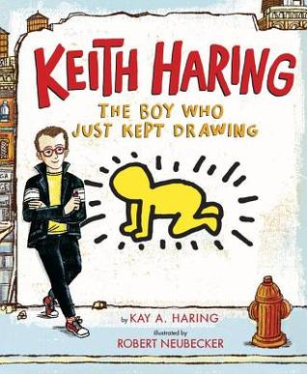  ISBN: 978-0-525-42819-0 | Keith Haring: The Boy Who Just Kept Drawing  by Kay A. Harding  illustrated by Robert Neubecker  A charming story about real life, world-renowned artist, Keith Haring, who simply loved to draw. He drew on any surface he could find. He didn’t limit his drawings to canvasses or museums. He insisted on drawing huge public murals so that everyone could enjoy the images. | Suitable for all grades.  - A good inspiration tool for a study of art forms and where inspiration comes from.  - Could be a good outlet for developing understandings about the role of art and social justice / social issues  - Students would be able to imitate Keith’s iconic simple line drawing forms.  - includes additional non-fiction information about Keith’s life experiences, including his diagnosis and death from AIDS, as well as how he used proceeds from his artwork to generate activism and awareness about AIDS.  - might be a useful tool around December 1st to acknowledge World Aids Day.  - This book could be combined with Todd Parr’s books for a study of simple yet distinctive art styles
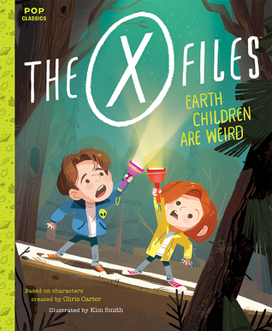  ISBN 978-1-59474-979-7 | The X-Files: Earth Children are Weird  Based on Characters by Chris Carter  Illustrated by Kim Smith  A clever reinvention of the X-Files characters as children, which features the two children having a back yard sleepover. Mulder constantly panics, reacting to things that happen and leaping to supernatural conclusions, while Scully reveals rational, scientific explanations for what they experience. | Suitable for all grades.  - A novel way of discussing character attributes, gender roles, and stereotypes
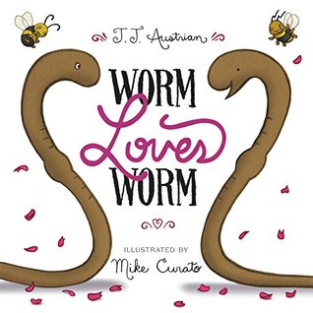  ISBN: 978-0-06-238633-5 | Worm Loves Worm  By J.J. Austrian  Illustrated by Mike Curato  A fun story about two worms who fall in love and decide to get married. Their friends begin to assist with planning the wedding involving typical wedding expectations which is challenging because the worms are anything but typical. Unable to wear rings on fingers they don’t have, they choose to wear their rings as belts. Unable to determine who is the bride or who is the groom, they each volunteer to fulfill portions of both roles. | Suitable for all grades.  - When the Cricket in his role as minister pauses to claim “That isn’t how it’s always been done,” the response is “Then we’ll just change how it’s done.”  - Provides opportunities to discuss finding happiness and being your authentic selves  - Provides opportunities for conversation about traditions or customs that may be uncomfortable, antiquated, or not relevant for a particular situation  - Can be a good tool for discussing problem solving and compromise  - Overall message: they marry because they love each other
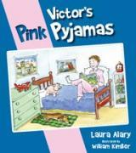  ISBN: 9781770645714 | Victor’s Pink Pyjamas  By Laura Alary  Illustrated by William Kimber  Victor’s favourite pair of pyjamas accidentally go through the wash with a pair of red socks, turning his comfortable, white pyjamas pink. Victor refuses to abandon his cozy pyjamas regardless of their new tint. Victor’s father, concerned he will be ridiculed because of the feminine colour insists he needs replace them. But Victor, is quick to defend his pyjamas, and provides some thoughtful reasoning to reject the (masculine or feminine) stereotypes that we often attach to colours. | Suitable for all grades.  - Provides opportunities to explore creative thinking around a topic or problem  - Allows for some thoughtful investigation of masculine or feminine stereotypes that are attached to colours  - Prompts some conversation around how we treat others and the idea of being able to assert yourself  - Provides examples of how to provide logical support for a position or perspective
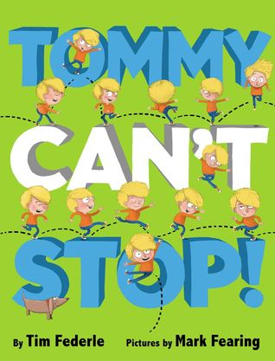  ISBN: 978-1-4231-6917-8 | Tommy Can’t Stop  By Tim Federle  Illustrated by Mark Fearing  Contains colourful, cartoonish drawings. Tommy is an energetic young boy whose family tries to manage his exuberance. He is constantly moving, unable to stop, causing disruption and distraction. One suggested strategy is tap dance class, which Tommy is reluctant to try. Ultimately, it turns out to be the ideal solution. | Suitable for all grades.  - Provides opportunities to discuss strategies for self-regulation  - Provides opportunities to address some gender stereotypes that exist about boys’ rambunctious behaviour and about preconceptions people might have about boys who dance
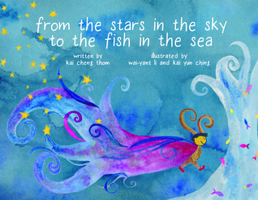  ISBN: 978-1-55152-709-3 | from the stars in the sky to the fish in the sea  by Kai Cheng Tom  illustrated by Wai-Yant Li and Yun Ching  Enchanting story with simple, but fantastical drawings layered over soothing watercolour backgrounds. The story follows Miu Lan, a magical baby whose identity is ambiguous at birth. Miu Lan is a combination of all things: boy and girl, bird and fish, cat and rabbit, tree and star. Their identity is challenged when they go to school and other students don’t know how to respond to their evolving appearance. Miu Lan’s mother reassures them with the refrain: “whatever you dream of, I believe you can be, from the stars in the sky to the fish in the sea.” | Suitable for all grades.  - Provides opportunities to discuss the ways in which we express our identities, including our physical appearance  - Students will likely relate to the character’s experience at school and the challenges they encounter fitting in  - Ultimately, the story is about being your authentic self and about belonging  - Uses they / them / their pronouns when referring to the character
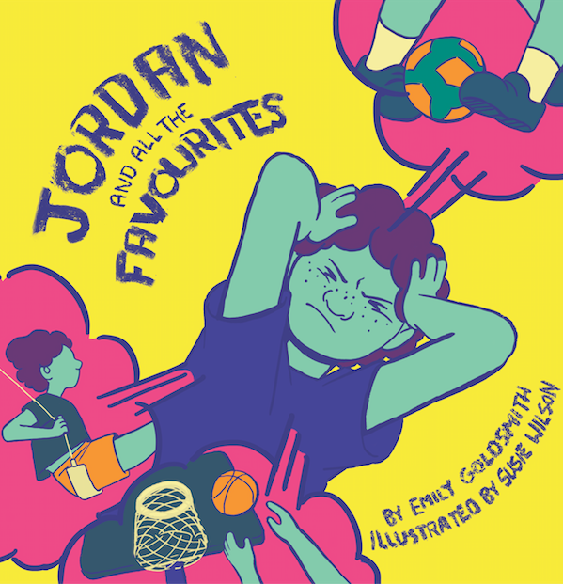  ISBN: 9781974470921 | Jordan and All the Favourites  By Emily Goldsmith  Illustrated by Susie Wilson  An engaging story about a student navigating the expectations of their peers within their school community. Jordan announces each day that each different spot they eat lunch is their favourite. Peers are quick to challenge this declaration, insisting that people can only have one favourite. Jordan is troubled and confused about these restrictions until clarification comes from talking to Mr. Brar, who provides some insight on the topic. | Suitable for all grades  - The visuals add layers of complexities to the story – Jordan is seen in a variety of outfits that may create opportunities for talking about preferences, gender expression, and acceptance  - Provides opportunities to discuss some of the challenges we face being our authentic selves when contradicting messages exist about who or what we should be  - Uses they / them / their pronouns when referring to the character
ISBN: 978-1974644025 | Les endroits préférés de Maxim  **This is the French language version of Jordan and All the Favourites  By Emily Goldsmith  Illustrated by Susie Wilson | Suitable for all grades  - The visuals add layers of complexities to the story – Jordan is seen in a variety of outfits that may create opportunities for talking about preferences, gender expression, and acceptance  - Provides opportunities to discuss some of the challenges we face being our authentic selves when contradicting messages exist about who or what we should be  - Uses they / them / their pronouns when referring to the character

