Creating Space for Understanding: The Concept of Remembrance featuring a SOGI Connection

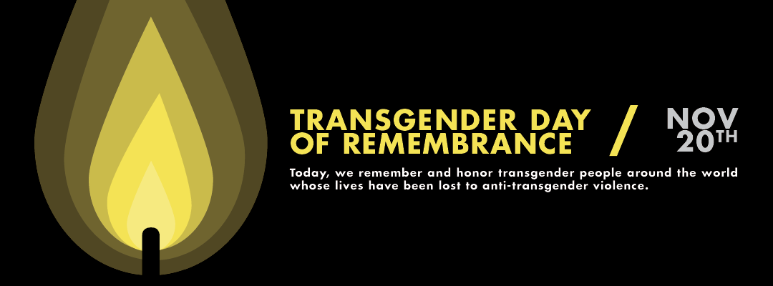

Last year, I was aware of the Transgender Day of Remembrance, which occurs annually on November 20th, but I knew that I wasn’t going to be in my classroom on that day, because I was in my district role instead. I was a bit resigned to the missed opportunity to acknowledge it until a few days afterward. As I was walking down the hallway to my classroom, it occurred to me that bulletin boards still featured Remembrance Day poppies, poetry on Remembrance, reflections on peace, and commentary on “Why We Remember.” Those conditions actually provided the ideal context to have a conversation about the Trans Day of Remembrance in my Grade 6/7 classroom.

In my classroom, I adjusted the schedule and created space to have a conversation. The conversation was initiated by prompts on the board:

What is the purpose of Remembrance?
What are examples of things (occasions or events) we choose to remember or acknowledge?
Why are these things worthy of Remembrance?

Students had a pretty good understanding of the importance of Remembrance Day and the conversation started off with replies like:
The purpose of Remembrance is:
- To show respect for people who suffered
- To give thanks for people who made sacrifices
- To acknowledge the progress we’ve made
- To celebrate achievement we’ve accomplished
- To avoid making the same mistakes we’ve made throughout history
- To learn about the things we benefitted from but that we didn’t experience ourselves

We then began to generate a list of things we remember or acknowledge.

The first suggestion someone made was their birthday, so we had a brief conversation about the importance of birthdays, and how we recognize and celebrate them on an annual basis.
That conversation expanded to anniversaries. Initially, students spoke about things like their parents’ wedding anniversaries and then we moved towards annual events or remembrances that were acknowledged more universally. We talked more about Remembrance Day and the significance of it. We talked about the historical significance of “on the eleventh hour of the eleventh day of the eleventh month.’ We reiterated the importance of the observance of a “Moment of Silence” and reflecting on the loss of lives. We talked about Orange Shirt Day / Every Child Matters and the importance of Truth and Reconciliation, which included some conversation about Residential Schools and recognizing the impact colonization had on Indigenous populations. Students made a connection to Japanese Internment, and we had some conversation about how Japanese-Canadians were treated during that time, how important it was to acknowledge how unfair some of the practices were, and how we avoid doing the same thing to an arbitrary group of people in the future, including a conversation about Human Rights and laws that are intended to protect people from injustice. We talked about the Terry Fox Run and how we acknowledge the Terry’s achievements, and the contribution he’s made to Cancer Awareness and Treatment. We elaborated on how cancer treatment has evolved and improved because of the funds raised annually. We also acknowledged that we’ve learned things from people who passed away, who weren’t able to benefit from the lessons we’ve learned about cancer and how to combat it. We talked about Pink Shirt Day and the International Day of Pink, and how we attempt to address bullying by drawing attention to homophobia and the role it often plays in bullying. I saw this as an ideal opportunity to ask students if they had been aware of another “Day of Remembrance” that had just passed. No one indicated any knowledge of “The Trans Day of Remembrance” acknowledged on November 20, or that a ceremony might have been held in their community. Consequently, someone mentioned that they thought they might have heard something about that on the news.

We had a brief conversation about the definition of transgender. Most students were already familiar with the term and had a pretty solid understanding of it. I asked if anyone might know why there was a Transgender Day of Remembrance. Someone suggested it might be to acknowledge their “coming out” and another student articulated that a day of remembrance usually meant someone died. This lead to a conversation about:
- prejudice or discrimination towards transgender people
- confusion and fear over what it means for people to be trans
- clarification of the definitions of “transgender” and “cisgender” (cisgender was a relatively new, and fascinating term for students, which enhanced their understanding of the term transgender)
- violence directed at trans people
- suicides of trans people who lacked support or acceptance
- responses to crimes directed at trans people – including assaults / murders

We talked about how a typical ceremony or observance might involve the reading of the names of trans people who lost their lives over the course of the year. (One student pointed out that it was similar to the “In Memorium” portion of the Oscars – I was surprised that a 6th grader watched the Oscars). Some else commented that it was like when they showed series of pictures of unarmed, black men that were killed in incidents involving police and made a connection to the Black Lives Matter movement.

We wrapped up the conversation with some suggestions about creating safe spaces for others and, specifically, for people who identify as transgender or non-binary. This included concepts of being an ally, the availability of universal washrooms, providing education, and acceptance.

Overall, a powerful and productive conversation that allowed them to make connections to many important learning opportunities they’d been exposed to in classrooms, at home, and in the media, over the course of their young lives.

Some resources to provide some context for the conversation
CBC News Article: Day of Remembrance a time to Reflect on Anti-Transgender Violence (Nov 20)
https://www.cbc.ca/news/canada/edmonton/transgender-violence-remembrance-day-1.4409770

Information about Transgender Awareness Week (Nov 12 -19)
https://www.glaad.org/transweek

