Positive Problem Solving – Adaptable for grades from 3 - 7
Identifying and Applying a Problem Solving Model

How Two Moms Took on Trolls to Support an LGBTQ Kid
By Bryan Gidinski

Summary of skills extracted from elaborations regarding B.C. Social Studies Curricular Competencies (Grades 3 – 7):
- Use Social Studies inquiry processes and skills to ask questions; gather, interpret, and analyze ideas; and communicate findings and decisions
- Ask relevant questions to clarify and define a selected problem or issue
- Demonstrate a willingness to use imagining and predicting in relation to a selected problem or issue
- Generate a variety of responses to a specific problem or issue
- Consider advantages and disadvantages of a variety of solutions to a problem or issue
- Individually, or in groups, design a course of action to address a problem or issue, and provide reasons to support the action

Grade specific elaborations relevant to Problem Solving within: Use Social Studies inquiry processes and skills to ask questions; gather, interpret, and analyze ideas; and communicate findings and decisions.

Grade 3
- Ask relevant questions to clarify and define a selected problem or issue.
- Make predictions in relation to a selected problem or issue.
Grade 4
- Identify and clarify a selected problem or issue (e.g., provide details; state reasons, implications).
- Create a plan of action to address a chosen problem or issue.
Grade 5
- Summarize information and viewpoints about a problem or issue.
- Select ways to clarify a specific problem or issue (e.g., discussion, debate, research, reflection).
Develop a plan of action to address a selected problem or issue:
- Individually, or in groups, design a plan of action to address a problem or issue (e.g., fundraising campaign, clothing or food drive, letter writing to a politician, editorial in school or community newspaper, petition).
Grade 6
- With teacher and peer support, select a relevant problem or issue for inquiry.
- Use comparing, classifying, inferring, imagining, verifying, identifying relationships, and summarizing to clarify and define a problem or issue.
Develop a plan of action to address a selected problem or issue:
- Collect and organize information to support a course of action.
- Individually, or in groups, implement a plan of action to address a problem or issue (e.g., fundraising campaign, clothing or food drive, letter writing to a politician, editorial in the school or community newspaper, petition).
Grade 7
- Select a relevant problem or issue for inquiry.
- Use comparison, classification, inference, imagination, verification, and analogy to clarify and define a problem or issue.

From the Social Responsibility Competency Profiles

2. Solving problems in peaceful ways

Students identify and develop an appreciation of different perspectives on issues; they generate, use, and evaluate strategies to resolve problems.
sample “I” statements
- I can solve some problems myself and can identify when to ask for help.
- I can identify problems and compare potential problem-solving strategies.
- I can clarify problems, consider alternatives, and evaluate strategies.
- I can clarify problems or issues, generate multiple strategies, weigh consequences, compromise to meet the needs of others, and evaluate actions.
1) Begin lesson by playing the video clip:
Stuck on an Escalator
https://www.youtube.com/watch?v=Kq65aAYCHOw

2) Establish a “Problem Solving Model” to use in deconstructing the video and the problem it depicts. I used this Simple 5 Step process for Solving Problems from encourageplay.com

IDENTIFY THE PROBLEM
Kids need to be able to first identify the problem they are having. Sometimes kids will identify one thing as the problem, but it really turns out to be something else. Make sure you understand the situation and clarify the specific problem.

GENERATE IDEAS
They need to be able to generate several ideas for solving an issue. Not all of them will work, but you’re not trying to pick out ones that will and won’t work during this step. Right now, it’s just about generating ideas.

EVALUATE IDEAS
Here’s where you go through and figure out which ideas are ones to try and which ones to leave behind.

DECIDE ON A SOLUTION AND TRY IT
Pick an idea for solving the problem and give it a try.

DID IT WORK?
After you’ve tried to solve the problem, check in to see if it worked. If it did, awesome! If it didn’t, just go back and pick another solution that you thought of during the “Evaluate Ideas” step and see if that works.

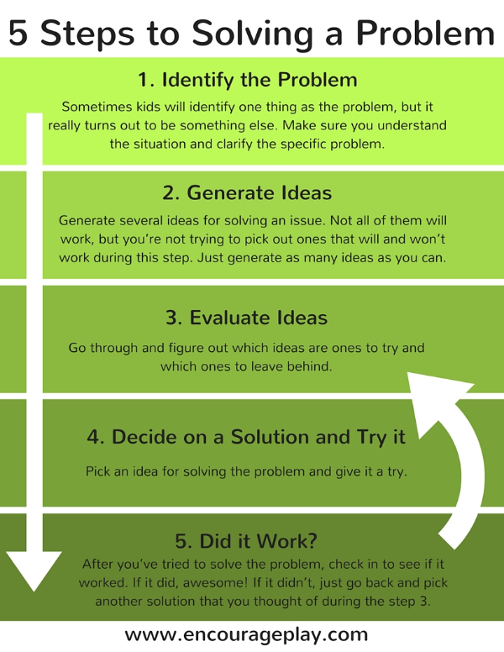

3) Once students are familiar with the problem solving process, use the video:
How Two Moms Took on Trolls to Support an LGBTQ Kid
https://www.youtube.com/watch?v=IY-kQtI2hY4

You can either play the full video and then reflect on the experiences depicted. Or consider, chunking portions to allow for meaningful conversation, and active strategizing of solutions.

Pause at 1:19
Define the context. Identify the problem.
What was going on?
What was the problem that the moms featured in the video felt the need to address?
How did the problem become a problem?

Generate Ideas (Brainstorm Solutions)
What possible solutions can you brainstorm?

Evaluate Ideas
Consider which strategies or solutions might best address the problem. Consider the likely outcomes of the various solutions. What are some risks involved in implementing different solutions?

Continue playing video.
Decide on a solution and try it. / Did it work?
Which solution did they choose?
What was the outcome?
How did the actual outcome compare to the expected outcome?
How might other solutions have changed the outcome?

Some additional clips to provide context or extend upon the problem solving scenario:

News Article about the controversy generated by the scheduling of the reading of “I am Jazz” at an elementary school.
https://www.youtube.com/watch?v=jB0dIiNhlfA

Jazz Jennings Reading “I Am Jazz.”
https://www.youtube.com/watch?v=BF5D2lsPfsU

