Recommended Titles to Foster SOGI Inclusive Integrated Curriculum – 2019 - 2020
Picture Books
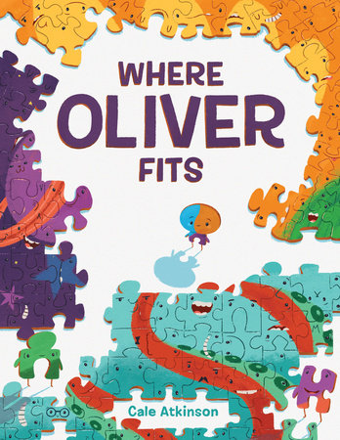  ISBN: 978-1-101-91907-1 | Where Oliver Fits  By Cale Atkinson  A dynamic story about Oliver, a puzzle piece trying to find the place in which he fits. He struggles with rejection, attempting to reinvent himself to find the place he belongs. A fun, and relatable story about the choices and challenges we face on our journey to becoming our authentic selves. | Suitable for all grades  Provides opportunities to explore and discuss:  - Similarities and differences  - Individual identity and the various factors that contribute to each person’s uniqueness  - Concepts of belonging and inclusion  - Seeking connection within communities  - Concepts of authenticity and conformity
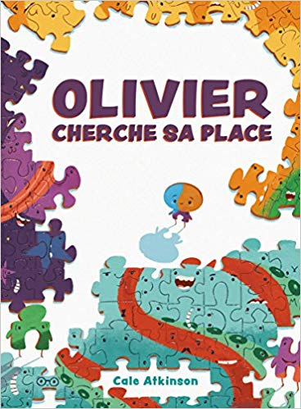  ISBN: 978-1443164337 | Olivier Cherche Sa Place  By Cale Atkinson  (French language version of Where Oliver Fits)  A dynamic story about Oliver, a puzzle piece trying to find the place in which he fits. He struggles with rejection, attempting to reinvent himself to find the place he belongs. A fun, and relatable story about the choices and challenges we face on our journey to becoming our authentic selves. | Suitable for all grades  Provides opportunities to explore and discuss:  - Similarities and differences  - Individual identity and the various factors that contribute to each person’s uniqueness  - Concepts of belonging and inclusion  - Seeking connection within communities  - Concepts of authenticity and conformity
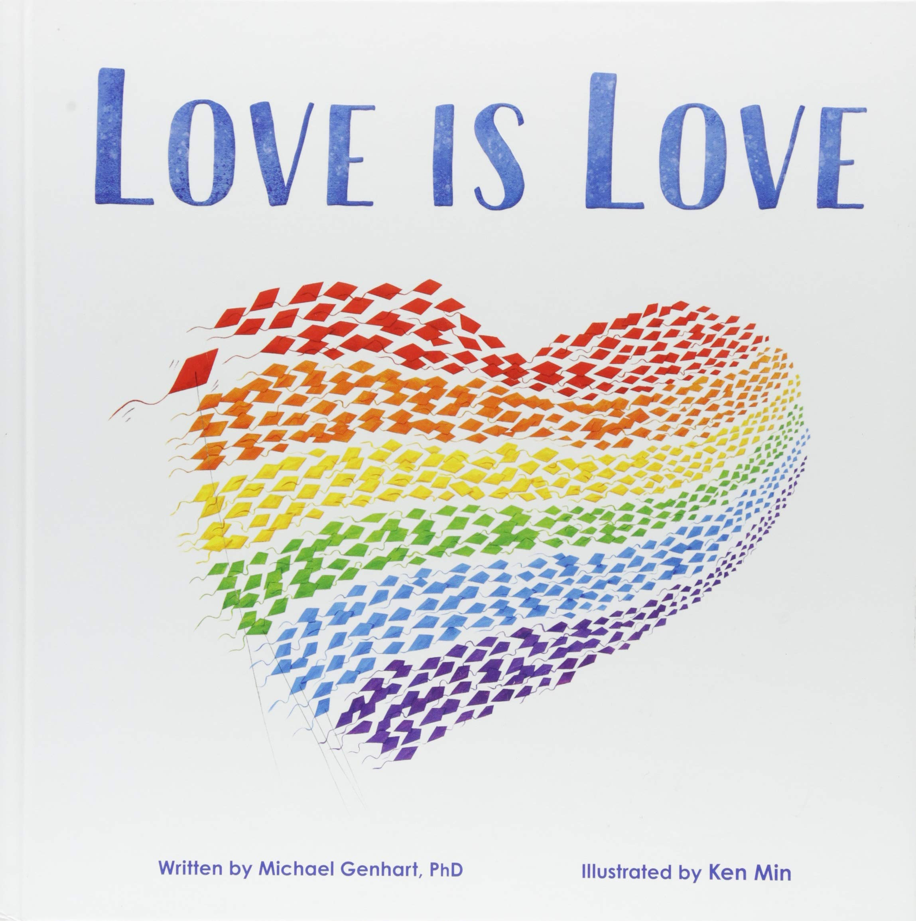  ISBN: 978-1-939775-13-9 | Love is Love  By Michael Genhart  This gentle story explores the concept of discrimination with regard to family members who are gay. It begins with a young boy being harassed because he wore a t-shirt with a rainbow in honour of his two dads. He is told that his shirt is gay and that his family isn’t real. | Suitable for all grades  Provides opportunities to explore and discuss:  - Similarities and differences  - Acceptance and belonging  - What makes a family a family  - Discrimination / Bullying  - Pride  - Love
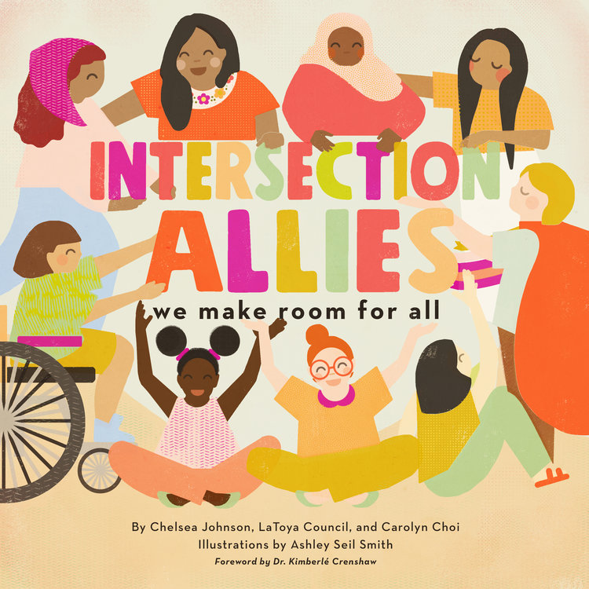  ISBN 978-1-948340-08-3 | Intersection Allies  By C. Johnson, L. Council, & C. Choi  A playful, but sophisticated text that explores the different identities that influence our experiences in the world. Its message is regardless of how we are perceived, everyone deserves to be treated fairly and respectfully. “Where there’s room for some, we make room for all. Friends can be allies no matter how small.” | Suitable for Grades 4+ (can be used with younger grades for the visuals as they provide diverse representations of identities, but has some sophisticated content that might be too advanced for younger readers)  Provides opportunities to explore and discuss:  - Acceptance, friendship, loyalty  - Concepts of allyship / Being an ally  - Environmental stewardship  - Identity and the intersectionality of factors like race, religion, citizenship, class, age, gender, size, and skin colour contribute to each person’s experience in the world – and the differences this may equate to
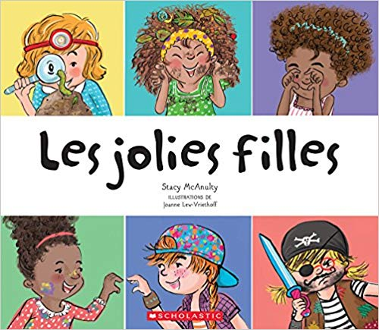  ISBN: 978-1443164283 | Les jolies filles  By Stacy McAnulty  Illustrated by Joanne Lew-Vriethoff  (This title was highlighted last year. This is the French language version)  A colourful book that subtly demystifies some of the stereotypes that exist about girls and beauty. Though the words tend to reinforce some of the stereotypes, the images challenge some of the existing stereotypes and provide some positive representations of things like girls enjoying science themed activities (having smart style), and engaged in sports (moving gracefully). | Suitable for all grades.  Provides opportunities to explore and discuss:  - stereotypes about the expectations we typically have of girls
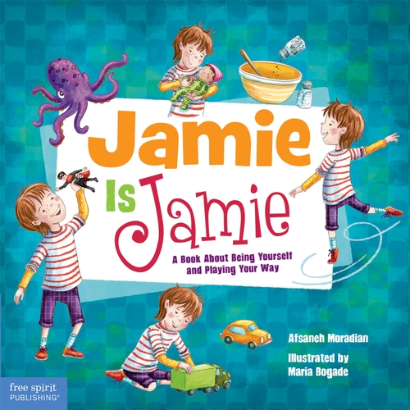  ISBN: 978-1-63198-139-5 | Jamie is Jamie: A Book About Being Yourself and Playing Your Way  By Afsaneh Moradian  Jamie has recently moved into a new neighbourhood and begins school as the new kid. In Jamie’s classroom, Jamie is interested in fixing toy cars, spinning like a ballerina, caring for a crying doll, and playing with action figures. Some of the other kids question whether or not Jamie can participate based on some preconceptions about which activities are stereotypically masculine or feminine. | Suitable for all grades  Provides opportunities to discuss:  - Preferences  - Inclusion  - Stereotypes about play and toys  - Playing imaginatively and cooperatively  - Choosing happiness  - Respecting others
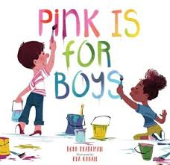  ISBN: 978-0-7624-6247-6 | Pink is For Boys  By Robb Pearlman  A clever series of illustrations that capture how colours are for everyone, using simple examples of situations and circumstances where boys and girls are enjoying experiences that might be associated with certain colours. | Suitable for all grades  Opportunities to discuss:  - Stereotypes about colours  - Preconceptions about perceived masculinity or femininity  - Equality and acceptance / withholding judgment  - Inclusion and belonging  - Imaginative play
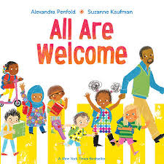  ISBN:978-0-525-57964-9 | All Are Welcome  By Alexandra Penfold and Suzanne Kaufman  An inviting narrative about a community where all are welcome. The story has simple text, in rhyming verse, that addresses several aspects of diversity from clothing, to cultural origin and identity, to foods that are enjoyed, to special talents, to family composition. The illustrations are colourful and playful and provide opportunities for students to see a diverse representation of members of a school community. | Suitable for all grades  Provides opportunities to discuss:  - Similarities and differences  - Diversity  - Individual identity and the various factors that contribute to each person’s uniqueness  - Concepts of belonging and inclusion  - How one contributes to a community  - Unique talents
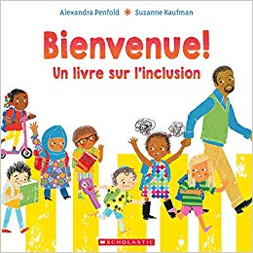  ISBN: 978-1-443-16995-1 | Bienvenue! Un livre sur l’inclusion  By Alexandra Penfold and Suzanne Kaufman  (French Language Version of All Are Welcome)  An inviting narrative about a community where all are welcome. The story has simple text, in rhyming verse, that addresses several aspects of diversity from clothing, to cultural origin and identity, to foods that are enjoyed, to special talents, to family composition. The illustrations are colourful and playful and provide opportunities for students to see a diverse representation of members of a school community. | Suitable for all grades  Provides opportunities to discuss:  - Similarities and differences  - Diversity  - Individual identity and the various factors that contribute to each person’s uniqueness  - Concepts of belonging and inclusion  - How one contributes to a community  - Unique talents
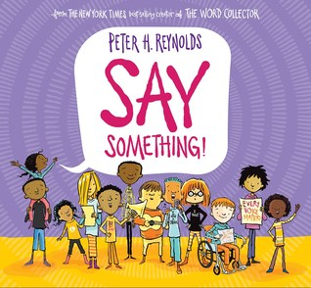  ISBN: 978-0-545-86503-6 | Say Something  By Peter H. Reynolds  An inspirational book that encourages readers to find their voices and “Say Something.” | Suitable for all grades.  Provides opportunities to discuss  - Voice / Confidence  - Passions  - Justice / injustice  - Bully / Bullied / Bystander / Upstander  - Authenticity and creativity  - Ways to utilize voice  - Safety
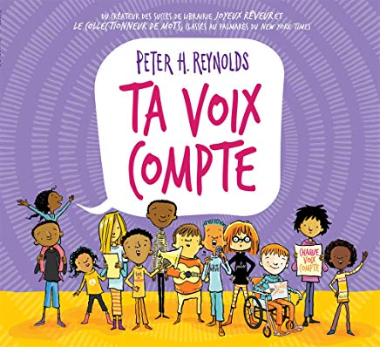  ISBN: 978-1-443-17438-12 | Ta Voix Compte  By Peter H. Reynolds  An inspirational book that encourages readers to find their voices and “Say Something.” | Suitable for all grades.  Provides opportunities to discuss  - Voice / Confidence  - Passions  - Justice / injustice  - Bully / Bullied / Bystander / Upstander  - Authenticity and creativity  - Ways to utilize voice  - Safety
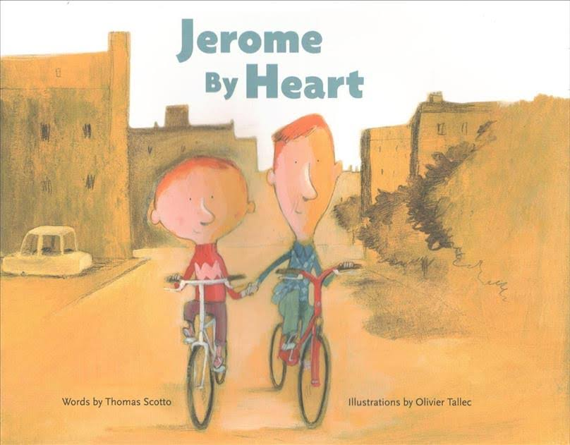  ISBN: 978-1-59270-250-3 | Jerome By Heart  By Thomas Scotto  Told from Raphael’s point of view, this is a charming story about two young boys who have a deep and mutual affection for each other. It is a subtle, nuanced story that depicts love in genuine, relatable ways. | Suitable for all grades  Provides opportunities to discuss:  - Love and affection  - People who are meaningful or significant  - Friendship and the qualities that make a good friend  - Assumptions people make about real or perceived sexual orientation
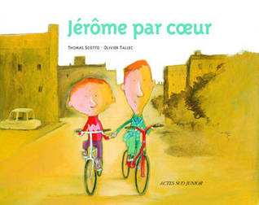  ISBN: 978-2330049294 | Jerome par Coeur  By Thomas Scotto  (French language version of Jerome By Heart)  Told from Raphael’s point of view, this is a charming story about two young boys who have a deep and mutual affection for each other. It is a subtle, nuanced story that depicts love in genuine, relatable ways. | Suitable for all grades  Provides opportunities to discuss:  - Love and affection  - People who are meaningful or significant  - Friendship and the qualities that make a good friend  - Assumptions people make about real or perceived sexual orientation
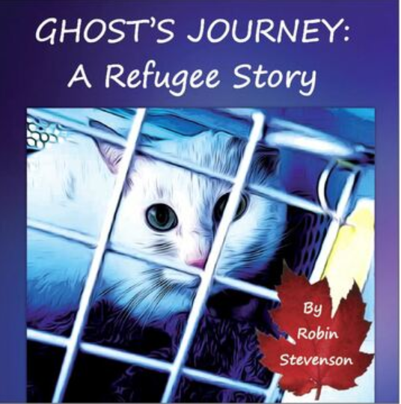  ISBN 978-1-7753019-4-3 | Ghost’s Journey: A Refugee Story  By Robin Stevenson  This gentle story, told from Ghost’s perspective, documents the journey of a pair of gay men and their cat, Ghost, who travel to Vancouver, seeking refugee status after their safety is jeopardized back home in Indonesia.  Stevenson provides information about the charitable organizations that enabled the characters to move to Canada and live their lives freely. | Suitable for Grade 3+  Provides opportunities to discuss  - Different kinds of families  - Definitions of what it means to be a refugee, and the process of immigration  - Human Rights, including differences in how LGBTQ+ people are treated or regarded in different countries  - Impressions of humans and their experiences from the perspective of an animal / pet
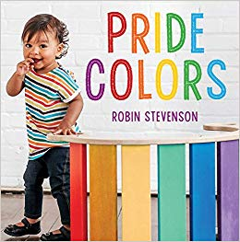  ISBN: 978-1459820708 | Pride Colors  By Robin Stevenson  A simple exploration of the colours of the rainbow, with simple language and inclusive imagery. | Suitable for all ages  Provides opportunities to discuss:  - Love and affection  - Authenticity  - Families
Intermediate Readalouds / Considerations for Lit Circles or Battle of the Books
ISBN: 978-0-425-28851-1 | Felix Yz  By Lisa Bunker  Felix loses his scientist father in a catastrophic accident that results in his own fusion with a being from another dimension, Zyx. As Felix matures into his teen years, he deals with the complications of managing his romantic feelings for another boy at school, the struggle for control over his own words and actions (between Zyx and himself), and the pressures of the countdown to the impending procedure that will separate him from Zyx. | Suitable for Grades 5+  - Offers a playful handling of pronouns with the combined Felix / Zyx character and with a grandparent whose gender is undefined for most of the story.  - Can assist with the awkwardness of using unfamiliar pronouns so they can become routine.  - Has an engaging narrative about the struggle to be one’s authentic self and the pressures to conform (which can be challenging when you have a secret (or secrets) you’re scared to reveal)  - Aligns with conversations about having empathy for others, understanding unique characteristics that define identity,  - Has themes of perseverance, resiliency, and overcoming challenges (physical, social, emotional)
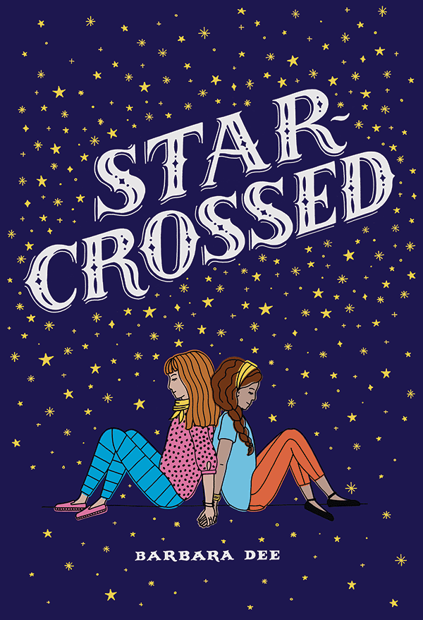  ISBN: 978-1-4814-7849-6 | Star-Crossed  By Barbara Dee  Protagonist Mattie, overcomes her fears and anxieties to audition for a role in her middle school’s performance of Shakespeare’s “Romeo and Juliet.” Things become complicated for Mattie, as her feelings shift from Elijah, who she has a crush on, to Gemma, who she is developing feelings for. | Suitable for intermediate grades (5+)  - Can prompt some conversation about how, in Shakespearean times, all the roles would have been played by men  - Provides opportunities to recognize how gender roles have adjusted over time  - Subtle messages about acceptance and diverse identities  - Can be a catalyst for conversations about adhering to stereotypes or having an openness to authenticity  - Provides opportunities for discussion about identifying complex feelings and recognizing what they are in response to
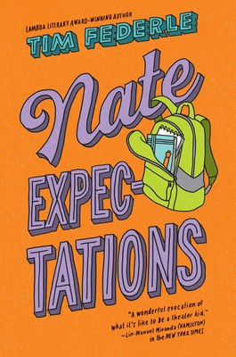  ISBN: 978-1-4814-0412-9 | Nate Expectations*  By Tim Federle  Fresh off his stint on Broadway in E.T. The Musical, Nate returns to middle school. His popular boyfriend, now separated by long-distance is less attentive, and appears to have “ghosted” Nate. Dejected, Nate, with the help of his best friend Libby, stages a musical adaption of “Great Expectations” and humourous and poignant situations unfold.  *This is the third installment in a series, but can be read independent of the other titles. | Suitable for intermediate grades (4+)  - Can be a catalyst for conversations about recognizing and appreciating differences  - Aligns nicely with conversations around acceptance and diversity  - Could initiate conversation about the concept of “coming out” and revealing identity  - Can inspire conversations about standing up for yourself, loyalty, the complexity of interpersonal relationships  - Can inspire conversations about making judgements based on first impressions and how those impressions can change
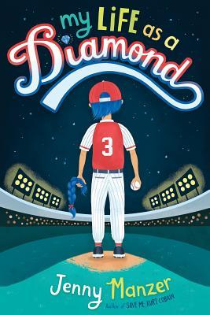  ISBN: 978-1-4598-1831-6 | My Life as a Diamond  By Jenny Manzer  Caz and his family have recently moved to a new city and Caz seeks to establish himself in a new baseball league. He tries out for a neighbourhood team and quickly builds new friendships and a reputation for himself. His new found happiness and acceptance is jeopardized when a secret from his past surfaces. | Suitable for intermediate grades (4+)  - Can be a catalyst for conversations about recognizing and appreciating differences  - Aligns nicely with conversations around acceptance and diversity  - Can be a tool to introduce and understand the concept of what it means to be transgender and to have empathy for people who are  - Could initiate conversation about the concept of “coming out” and revealing identity  - Could build on conversations about bullying or mistreatment of others based on aspects of identity beyond their control
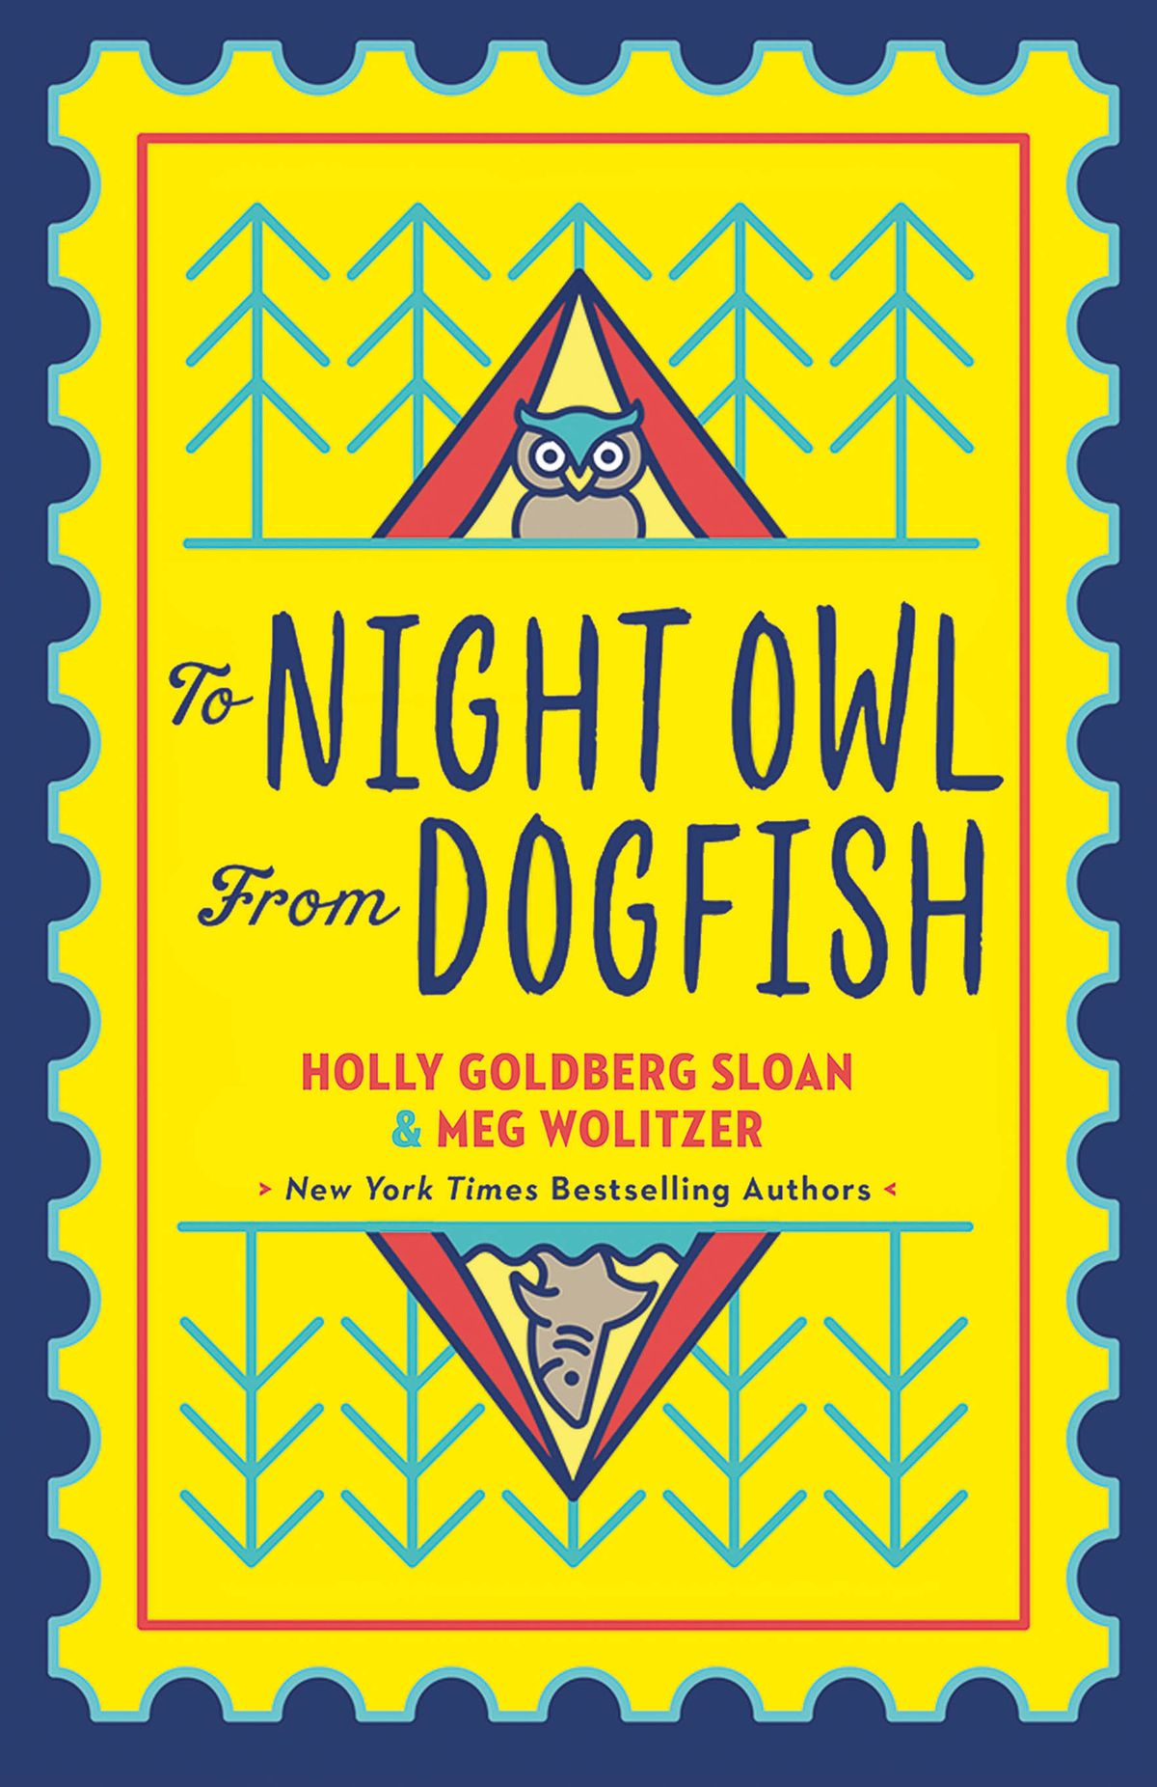  ISBN: 978-0525553236 | To Night Owl From Dogfish  By Holly Goldberg Sloan & Meg Wolitzer  This story, told through multiple perspectives in a series of emails and text messages documents the growing bond between two girls connected because their fathers (who are dating) want them to get to know each other. The two girls attend camp together, while their dads travel through Europe. | Suitable for intermediate grades (5+)  - Can initiate conversations about friendship and what prompts friendships to form  - Can build on conversations about family structures and family diversity, including blended families  - Offers opportunities to explore writing structures (emails / texts) and how they can be applied strategically to create voice and compel a narrative
Graphic Novels
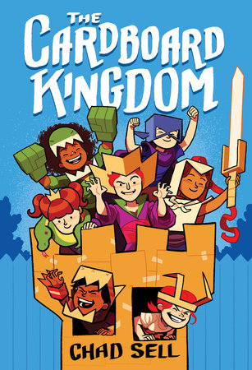  ISBN: 978-1-5247-1938-8 | The Cardboard Kingdom  By Chad Sell  A colourful series of stories that captures the imagination of children at play. This graphic novel features a selection of kids using their imaginations to morph into sorceresses, banshees, monsters, gargoyles, and knights, (among other characters). It contrasts some of the challenges of navigating real life scenarios, and expressing some complex emotions by engaging in imaginative, fictional worlds, complete with cardboard costumes and props. | Suitable for Grades 3+  Provides opportunities to discuss:  - Identity and the exploration of it  - Friendship and being part of a community  - Imagination and creative play  - Acceptance, belonging, and valuing diversity  - Dealing with challenges / solving problems  - Stereotypes about gender / gender roles  This could provide a fun connection to ADST and activities involving creating and constructing with cardboard.
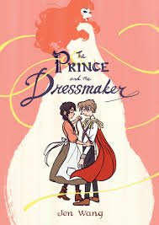  ISBN: 978-1-62672-363-4 | The Prince and the Dressmaker  By Jen Wang  Prince Sebastian is inspired by the creations of young Frances, an aspiring designer. He hires her as his personal seamstress to design and create dresses for him to wear, as his alter ego, Lady Crystallia. The story navigates the challenges of adhering to societal expectations and pursuing one’s passions and interests to establish one’s authentic self. | Suitable for Grades 5+  Provides opportunities to discuss:  - Identity and the exploration of it  - Authenticity, loyalty and friendship  - The limitations of being closeted  - Gender roles and stereotypes  - Balancing expectations of family or society with living an authentic life  This could provide a fun connection to ADST and the concept of design.
Non-Fiction
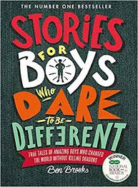  ISBN: 978-0-7624-6592-7 | Stories For Boys Who Dare to Be Different: True Tales of Amazing Boys Who Changed the World Without Killing Dragons  By Ben Brooks  A compilation of brief biographical stories of boys who achieved great things, often in ways in which defy stereotypes about what is valued about men. Many scenarios include people overcoming adversity. Some noteable people included in the anthology: Barack Obama, Harvey Milk, Lionel Messi, Stephen Hawking, Daniel Radcliffe, Iqbal Masih, Stephen Spielberg, Ludwig Van Beethoven  Specific SOGI connections include: Oscar Wilde, Harvey Milk, Alan Turing, Frank Ocean, Alan L. Hart | Suitable for Grades 3+  Provides opportunities to discuss:  - Stereotypes about masculinity  - Unique qualities, special talents or special interests  - Vulnerability and resiliency  - Overcoming adversity
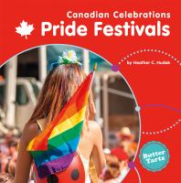  ISBN: 978-1-77308-363-6 | Canadian Celebrations: Pride Festivals  By Heather C. Hudak  This colourful non-fiction resource uses simple vocabulary and vibrant pictures to inform its readers about Pride Festivals. In it, the author, defines common terms, provides some historical context for Pride, and highlights some of the Pride events that occur across Canada. | Suitable for Grades 2 – 5  This may be useful as a resource for ELL and / or Guided Reading programs.  Non-fiction / Part of a series which includes other notable celebrations (i.e. National Indigenous Peoples Day, Remembrance Day, Family Day)
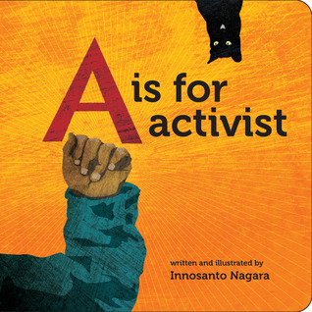  ISBN: 978-1-60980-693-4 | A is For Activist  By Innosanto Nagara  An ABC Book that uses playful, poetic language to highlight social justice issues. | Suitable for Grades 4+ (possibly for primary if choosing excerpts or doing additional pre-teaching to support understandings)  Provides opportunities to discuss:  - Advocacy, activism, allyship  - Feminism  - Pride and LGBTQ+ equality  - Access to healthy food  - Fossil fuel dependence  - Indigenous and immigrant  - Educational policy  - The role of unions  - Appreciation of diversity
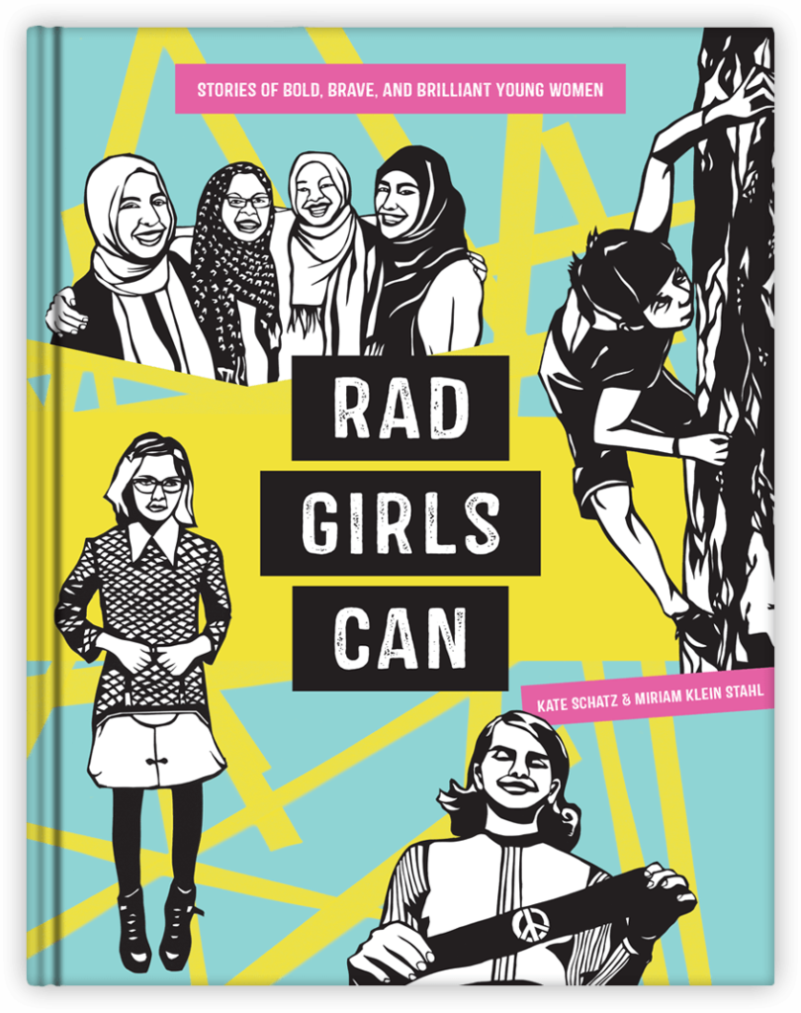  ISBN: 978-0-399-58110-6 | Rad Girls Can: Stories of Bold, Brave, and Brilliant Young Women*  By Kate Schatz and Miriam Klein Stahl  An anthology of brief biographical stories about girls who accomplished significant things, and at a young age. Many do so by challenging the status quo. Some are involved in advocacy and activism. Some noteable people included in the anthology: Anne Frank, Malala Yousafzai, Ruby Bridges,  Specific SOGI connections include: Jazz Jennings, Janet Mock, Amandla Stenberg  *The book also includes, in its introduction, a note on gender that is trans-inclusive. | Suitable for Grades 5+  Provides opportunities to discuss:  - Feminism  - Gender equity  - Representation of accomplished girls / women  - Advocacy and activism  - Stereotypes about femininity  - Unique qualities, special talents or special interests  - Overcoming adversity  - Trans-inclusivity

