Branching Out:
Conceptualizing SOGI Inclusive Units in Primary and Early Intermediate Grades

Bryan Gidinski
bryangidinski@gmail.com

Bryan will share perspectives on how to bring LGBTQ+ identities and understandings into primary and intermediate classrooms in ways that are connected to curriculum, focusing on building robust and broad understandings embedded in long term unit planning instead of single or separate SOGI focused lessons.

Overview of Topics:
Happiness
Identity
- Names
- Families
- Preferences / Favourites
- Comfort
- Stereotypes
- Authenticity
Inclusion and Belonging
Exclusion and Bullying
Rights and Responsibilities

A few caveats....
1) This is not intended to be a prescriptive plan, but rather a model for how strategically diverse identities can be included and explored in meaningful ways that are connected to existing topics / curricular objectives.

2) The underlying principle to enhance inclusion is what I refer to as Strategic Text Selection, which is simply choosing texts that allow you to introduce ideas or concepts into the classroom, in ways that are connected. It is an attempt to avoid the isolated lesson (I.e. the “gay” lesson, or the “transgender” lesson).

3) This particular document was created for a SOGI Summit and was focused on integrating understandings about Sexual Orientation and Gender Identity into classrooms, so you see an emphasis on picture books that features LGBTQ+ identities. The same principles can (and should be used to include other diverse representations so that students see themselves reflected in the texts shared and the conversations held in their classrooms.

4) It is not the intent that the examples of book lists are the only books that are used, or that they are all used. It is an attempt to model how easily SOGI can be integrated into existing curricular objectives and to provide choices so educators can identify the best books with the best connections to their classroom contexts. Educators can use the same principles to seek out and include books that feature other diverse identities as well (I.e. Black, Indigenous, People of Colour).

B.C. Curriculum Connections
Social Studies
K
Our communities are diverse and made up of individuals who have a lot in common.
Stories and traditions about ourselves and our families reflect who we are and where we are from.
Rights, roles, and responsibilities shape our identity and help us build healthy relationships with others.
ways in which individuals and families differ and are the same
personal and family history and traditions
needs and wants of individuals and families
rights, roles, and responsibilities of individuals and groups
people, places, and events in the local community, and in local First Peoples communities

1
We shape the local environment, and the local environment shapes who we are and how we live.
Our rights, roles, and responsibilities are important for building
strong communities.
Healthy communities recognize and respect the diversity of individuals and care for the local environment
characteristics of the local community that provide organization and meet the needs of the community
diverse cultures, backgrounds, and perspectives within the local and other communities
relationships between a community and its environment
roles, rights, and responsibilities in the local community
key events and developments in the local community, and in local First Peoples communities

2
Positive Personal and Cultural Identity Profiles

Social Awareness and Responsibility
Building relationships
Students build and maintain diverse, positive peer and intergenerational relationships. They are aware and respectful of others’ needs and feelings and share their own in appropriate ways. They adjust their words and actions to care for their relationships.
Contributing to community and caring for the environment
Students develop awareness of and take responsibility for their social, physical, and natural environments by working independently and collaboratively for the benefit of others, communities, and the environment. They are aware of the impact of their decisions, actions, and footprint. They advocate for and act to bring about positive change.
Resolving problems
Students identify and develop an appreciation for different perspectives on issues. They show empathy, disagree respectfully, and create space for others to use their voices. They generate, use, and evaluate strategies to resolve problems. Valuing diversity
Valuing diversity
Students value diversity, defend human rights, advocate for issues, and interact ethically with others. They are inclusive in their language and behaviour and recognize that everyone has something to contribute. Their approach to inclusive relationships exemplifies commitment to developing positive communities.

Setting the Context

Loose Parts
Monday Hearts for Madalene

Ongoing Activity appropriate for Primary Classrooms
Using images from the book Monday Hearts for Madalene by Page Hodel, provide found objects / loose parts for students to build their own hearts. You can photograph and maintain a gallery of the heart.
It is difficult to find a copy of the book, but a google search and / or the following links will get you some images and an awareness of Page and Madalene’s story and the origin of the hearts. Essentially, Page and Madalene fell in love, but Madalene was diagnosed with cancer shortly thereafter.

“Every Sunday night after work, I would make a little heart on Madalene’s doorstep out of leaves or flowers or buttons, anything pretty I could find. I wanted her to find a sweet little “ I love you ” waiting for her when she went out the door to go to work on Monday morning...to start her week with a visual reminder of our beautiful love.” - Page Hodel

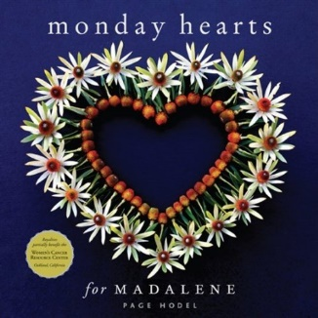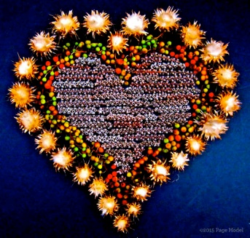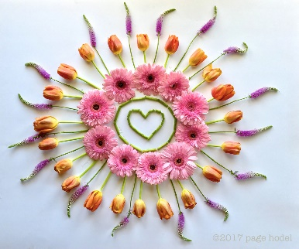

http://mondayheartsformadalene.com/

https://www.youtube.com/watch?v=ECpKggrgxA0 (provides an abbreviated video gallery of images from the book)

https://www.wired.com/2011/07/monday-hearts-for-madalene/

Suggestions:
Initiate the activity by sharing a teacher-created heart, a positive message of welcoming, acceptance, and a desire to show kindness and love for another person.
After some modelling, invite students to create and share their hearts
Perhaps incorporate into “Student of the Week” sharing

This concept could also be adjusted to another image like a Rainbow, which can later be further developed into understandings about Pride, and the themes represented by the Pride Flag.
**Link for Pridentity **

Explore Feelings

Use the book Happy by Mies Van Hout
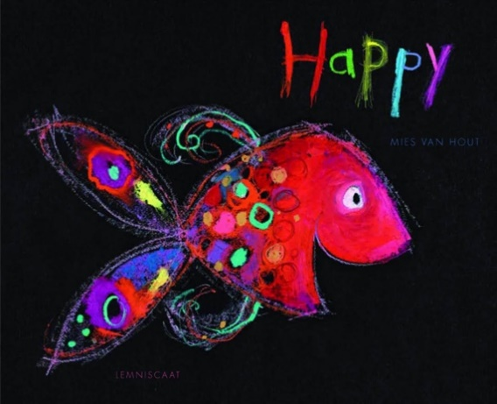
https://www.youtube.com/watch?v=EKi9QpNzBDs (Read aloud version)

Have students create their own “emoti-fish” to display an emotion / or to display a fish that represents their understanding of happiness.

Place emphasis on the eyes and what they express, as well as the shape of the mouth. Also engage students in conversations about the connection between colours and feelings.
We used black construction paper and pastels to create the following images.
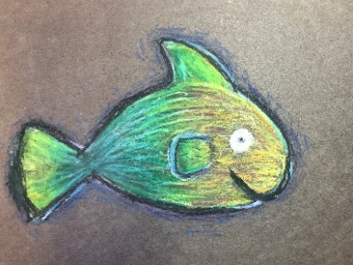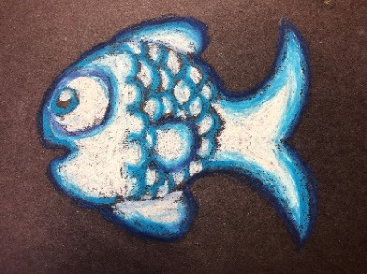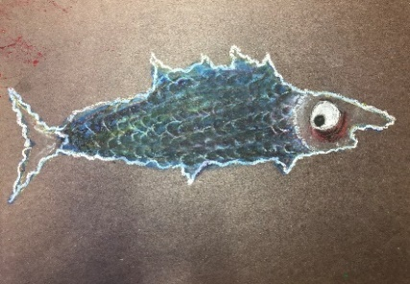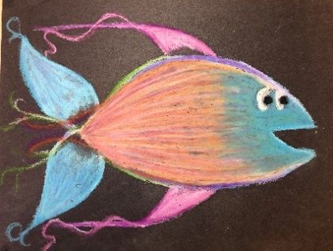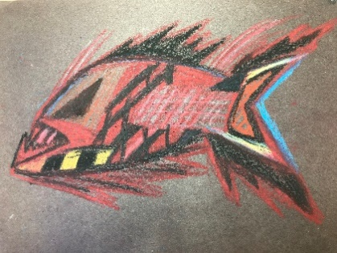

Overall objectives:
Awareness of what happiness looks like / feels like.
Help students to recognize the value of happiness.
Develop a shared understanding that everyone is entitled to their happiness.

Explore the concept of “Happiness.”
What does happiness feel like?
What are some of the ways we can observe happiness? What does happiness look like?
What are examples of things that make you feel happy?
What can other people do or say that contributes to your happiness?
What are some things that you can do that contribute to other people’s happiness?

Extend with My Heart Fills with Happiness by Monique Gray-Smith

Using cameras / devices, or drawings have students create a gallery of facial expressions.

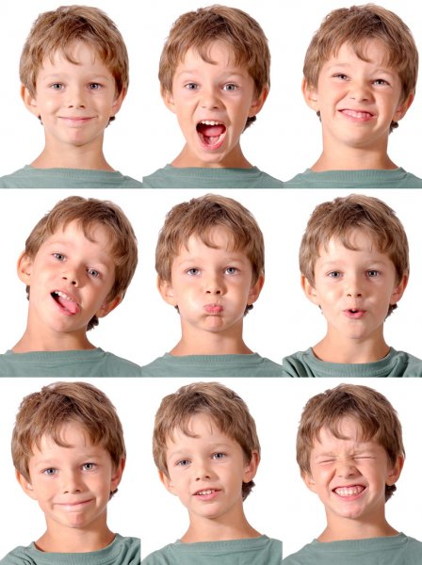

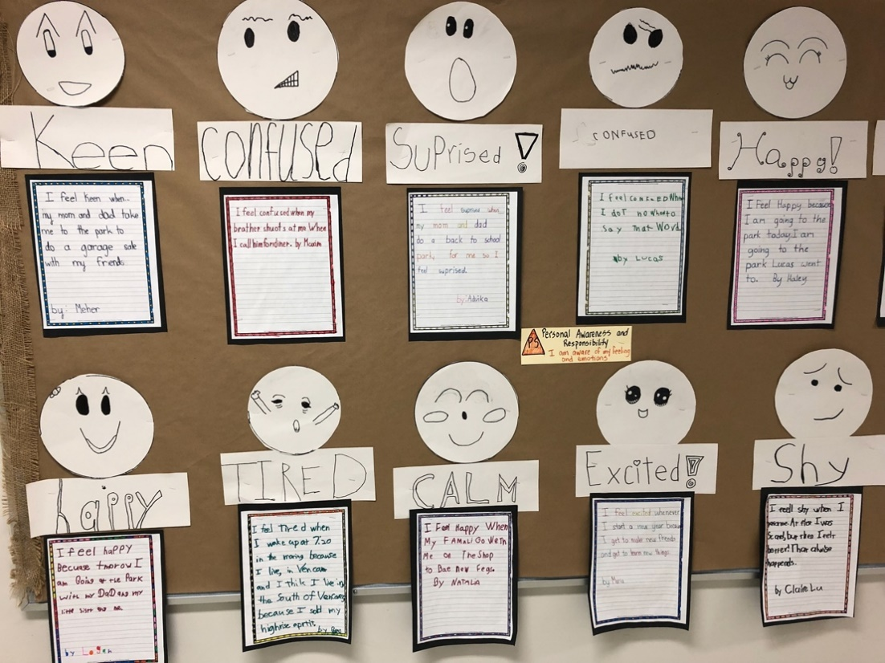

Consider what makes you feel certain ways:
Books to use to explore feelings characters experience:

Beatrice Doesn’t Want To by Laura Numeroff
Dazzling Travis by Hannah Cormona Dias
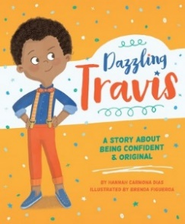  ISBN: 9780997608564 | Dazzling Travis  By Hannah Carmona Dias  Told in verse form, this story follows Dazzling Travis’ playful explorations of sports, dance, colour, superheroes, costumes, roles, and dolls. He encounters judgement by those who aren’t comfortable with him not subscribing to a distinct masculine or feminine set of preferences. Travis overcomes this by asserting his identity and exuding confidence.  Includes short descriptions of famous people who also struggled with acceptance because of gender non-conformity or being otherwise regarded as different: including Coco Channel, Langston Hughes, and Seth, a former student of the author, who inspired the story. | Suitable for all grades.  Provides opportunities to discuss:  - Freedom to explore preferences  - Freedom of expressing one’s true self  - Identity and the aspects that contribute to it  - Stereotypes about masculinity / femininity  - Unique qualities, special talents and special interests  - Vulnerability and resiliency  - Responding to bullying  - How to be assertive

Dino Duckling by Alison Murray
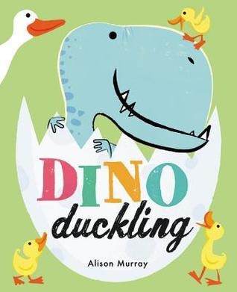  ISBN: 978-0-316-51313-5 | Dino Duckling  By Alison Murray  An updated, charming and humourous rendition of the “Ugly Ducking.” Dino Duckling is clearly different from his siblings. Even as an egg, it was clear that Dino was different. Dino has difficulty fitting in and doing all the typical duckling activities, he and his family are taught many skills and values, including to celebrate differences. Despite the difficulties of being different, Dino’s family sticks by him and adjusts their routines and plans to ensure he remains a valued member of his family. | Suitable for all grades. Highly appealing for primary grades.  - Provides opportunities to discuss unique family dynamics or structures  - Demonstrates how families stick together and work out problems together  - Places emphasis on celebrating differences

Big Boys Cry by Jonty Howley
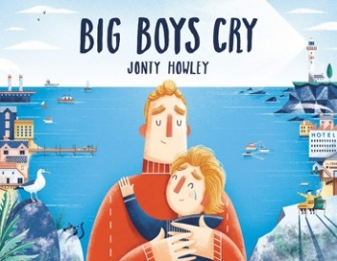  ISBN: 9781524773205 | Big Boys Cry  By Jonty Howley  Levi is afraid to head off to his first day of school, and his dad advises that “big boys don’t cry.” Levi’s observations throughout the day, concluding with reconnecting with his dad when he arrives home, lead him to a renewed understanding about tears. | Suitable for all grades  Provides opportunities to discuss:  - Emotional responses / dealing with feelings  - Observing and interpreting other people’s feelings  - Preconceptions about masculinity and vulnerability  - Empathy  - The impact of declarations like “Boys don’t cry” and how they can perpetuate misconceptions about healthy masculinity

The Boy and the Bindi by Vivek Shraya
Tommy Can’t Stop by Time Federle

Keith Haring: The Boy Who Just Kept Drawing by Kay. A Haring
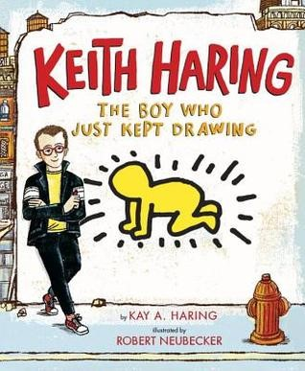  ISBN: 978-0-525-42819-0 | Keith Haring: The Boy Who Just Kept Drawing  by Kay A. Harding  illustrated by Robert Neubecker  A charming story about real life, world-renowned artist, Keith Haring, who simply loved to draw. He drew on any surface he could find. He didn’t limit his drawings to canvasses or museums. He insisted on drawing huge public murals so that everyone could enjoy the images. | Suitable for all grades.  - A good inspiration tool for a study of art forms and where inspiration comes from.  - Could be a good outlet for developing understandings about the role of art and social justice / social issues  - Students would be able to imitate Keith’s iconic simple line drawing forms.  - includes additional non-fiction information about Keith’s life experiences, including his diagnosis and death from AIDS, as well as how he used proceeds from his artwork to generate activism and awareness about AIDS.  - might be a useful tool around December 1st to acknowledge World Aids Day.  - This book could be combined with Todd Parr’s books for a study of simple yet distinctive art styles

A Day in the Life of Marlon Bundo by Kelly Twiss

Jamie is Jamie: A book About Being Yourself and Playing Your Way by Afsaneh Moradian
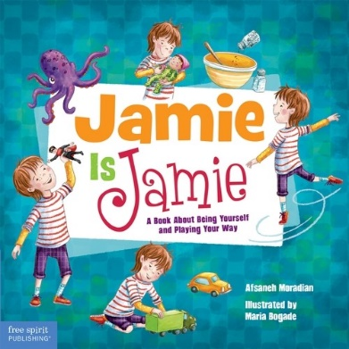  ISBN: 978-1-63198-139-5 | Jamie is Jamie: A Book About Being Yourself and Playing Your Way  By Afsaneh Moradian  Jamie has recently moved into a new neighbourhood and begins school as the new kid. In Jamie’s classroom, Jamie is interested in fixing toy cars, spinning like a ballerina, caring for a crying doll, and playing with action figures. Some of the other kids question whether or not Jamie can participate based on some preconceptions about which activities are stereotypically masculine or feminine. | Suitable for all grades  Provides opportunities to discuss:  - Preferences  - Inclusion  - Stereotypes about play and toys  - Playing imaginatively and cooperatively  - Choosing happiness  - Respecting others

Identity –
What are the things that make you who you are?

Explore the meaning of / origin of names.

The Name Jar by Yansook Choi
Thunder Boy Junior by Sherman Alexie
Alma and How She Got Her Name by Juana Martinez-Neal
I Don’t Know What to Call My Cat by Simon Philip

Sentence Starters
My name is….
My ____________________ gave me my name.
My family calls me …
My friends call me …
My name comes from the ___________________ language.
It means …
I like my name because ….
My name makes me feel …

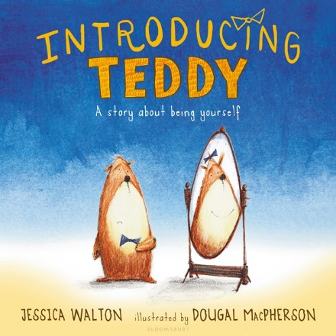

“Introducing Teddy: A Gentle Story About Gender and Friendship” by Jessica Walton
Classroom visit to a Grade 1 Classroom
By Bryan Gidinski

Big ideas:
Kindergarten – Grade 2
- Language and story can be a source of creativity and joy.
- Stories and other texts help us learn about ourselves and our families.
- Everyone has a unique story to share.
- Through listening and speaking, we connect with others and share our world.

Curricular Competencies
- Use developmentally appropriate reading, listening, and viewing strategies to make meaning
- Engage actively as listeners, viewers, and readers, as appropriate, to develop understanding of self, identity, and community
- Recognize the importance of story in personal, family, and community identity
- Use personal experience and knowledge to connect to stories and other texts to make meaning
- Recognize the structure of story

Developing Understandings
- A person’s appearance can change.
  - Sometimes the change is subtle or superficial
  - Sometimes the change is more profound
- People are entitled to be called by the name they identify with
  - When people identify the name they want to be called, it is respectful to use it
- How to be a good friend

I started by introducing myself and asking if students had seen me around the school. I talked about how sometimes when they see me I might look different. I asked them to brainstorm ways they might notice that I looked different. Suggestions that were generated were wearing a hat one day, wearing different shoes, getting a haircut, etc.

Some possible differences:
- Wearing different clothing
- Changing hair styles
- Gaining or losing weight
- Having a visible injury (wearing a cast, or bandage, or having a bruise,
- Getting sunburnt
- Differences in beard (clean shaven, stubble, trimmed beard, fuller beard)

I talked about how sometimes they might see me and one day I might have a full beard. On other days, I would have no beard. And on other days I might have something somewhere in between. I elaborated on how sometimes when I've had a beard for a while, it gets kind of fuzzy, and when I shave it off, people don't always recognize me because I look different, but they are always able to recognize that I'm still the same person in the end.

Understanding: regardless of the physical appearance, I am still the same person.

I then spoke to students about my name. I had been introduced as Mr. Gidinski, and I explained to them that most people call me Mr. G. I also shared with them that my friends call me Bryan. I used this to illustrate that I have 3 names, and that names are important. I asked them how they would know what they should call me, to which they responded, “we could just ask you what you wanted us to call you.” We all want to be addressed by the name that is most comfortable. Kids gave examples of how they had two names. Someone shared their first name and then their middle name. Another shared that his name was Benjamin but he preferred to be called Ben. The young trans student identified that she had used a different name last year. In each scenario, students were asked how to determine which name to call someone, to which the simple answer was “we call someone the name they ask us to call them.”

Reasons someone might have more than one name:
- a new immigrant who changed their name
- has a first name, middle name(s), and a last name
- has a nickname
- gets referred to by their last name
- changes name to match their spouse

Understanding: When someone shares their name, it is respectful for us to use the name they ask us to use.

We talked about how to be a good friend and talked about things that good friends do (sharing, playing together, talking to each other, being silly together, etc). Then I shared the book, which touched on names, a character's appearance, and friendships, pausing to ask questions to clarify the understandings and emphasize how the activities at the end mirror the activities at the beginning of the story.

The story can be deconstructed on a number of levels of sophistication depending on the developmental level of students, and on topics relevant to the social dynamics in the classroom.

In more advanced classrooms, it can be a springboard for conversations about:

1) Non-binary understandings of gender.

2) Deconstructing stereotypical gender roles: Errol plays with his Teddy, hosts tea parties. Ava rides a scooter, and builds a robot.

They, She, He: Easy as ABC by Maya and Matthew Gonzalez
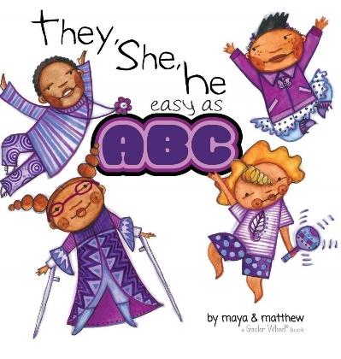  ISBN: 9781945289170 | They, She, He: Easy as ABC  By Maya and Matthew Gonzalez  This alphabet book that explores pronouns introduces a series of characters, highlighting dance moves that they enjoy. A simple statement using their name and their pronouns may help students become familiar with the importance of honouring pronouns. | Suitable for Grades 1+  Provides opportunities to discuss:  - The concept of what a pronoun is and the importance of honouring a person’s pronouns  - Gender roles and stereotypes (some characters are depicted in ways that are gender non-conforming)  - Could be used to connect to PHE content and movement, inviting students to create the dances positions or movements depicted

Families
Who are the members of our families?
What are the names of our family members?
What makes a family a family? / What are the characteristics of a family?
What makes my family happy?
How can a family grow?
How do we take care of / look out for / support each other in a family?

The Family Book by Todd Parr
A Family is A Family is A Family by Sara O’Leary
Families, Families, Families by Suzanne and Max Lang

When Aidan Became a Brother by Kyle Lukoff
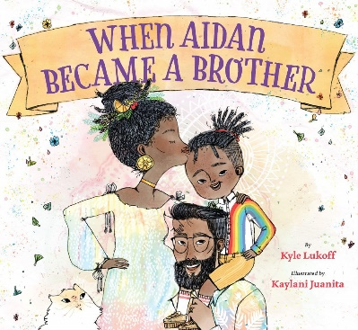  ISBN: 9781620148372 | When Aidan Became a Brother  By Kyle Lukoff  This poignant story features Aidan, a young, transgender child, who is excited about welcoming a new baby into the family. Taking his role as a new big brother seriously, he worries about how the baby will be perceived and wants to ensure that the baby will be welcomed and feel comfortable becoming their authentic self. | Suitable for Grades 3+  Provides opportunities to discuss:  - Identity and the exploration of it / becoming one’s authentic self  - Being part of a family / roles within a family / evolving family dynamics  - Acceptance, belonging, and valuing diversity  - Stereotypes about gender / gender roles and how they are constructed and reinforced  - Simple understandings about transgender identities  - Compassion, empathy, and caring for others  - Communicating feelings

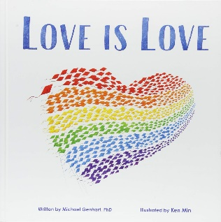  ISBN: 978-1-939775-13-9 | Love is Love  By Michael Genhart  This gentle story explores the concept of discrimination with regard to family members who are gay. It begins with a young boy being harassed because he wore a t-shirt with a rainbow in honour of his two dads. He is told that his shirt is gay and that his family isn’t real. | Suitable for all grades  Provides opportunities to explore and discuss:  - Similarities and differences  - Acceptance and belonging  - What makes a family a family  - Discrimination / Bullying  - Pride  - Love

“I am From” poems as a tool to explore identity.
Alternatively, students can create an Identity Book like:

A Book About Ethan and his Super Powers by Christine Michailides
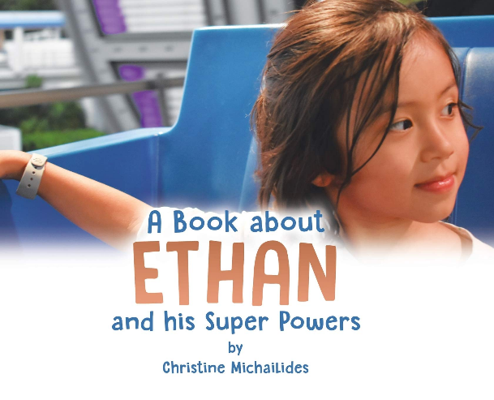

Typical Topics that are explored in the context of “I Am From Poems.”
Foods
Activities
Home
Customs / Traditions / Special Events

How we express our identity
Explore preferences / favourites:
Does the same thing make each of us happy?

Foods
What are your favourite foods?
What foods most remind you of your family?

Salma The Syrian Chef by Danny Ramadan
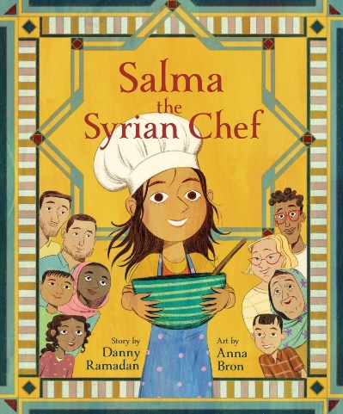  ISBN: 9781773213750 | Salma The Syrian Chef  By Danny Ramadan  Newcomer Salma wants is to make her mama smile again. Between English classes, job interviews and missing Papa back in Syria, Mama always seems busy or sad. A homemade Syrian meal might cheer her up, but Salma doesn't know the recipe, or what to call the vegetables in English or where to find the right spices! Luckily, the staff and other newcomers at the Welcome Centre are happy to lend a hand — and a sprinkle of sumac. With creativity, determination and charm, Salma brings her new friends together to show Mama that even though things aren't perfect, there is cause for hope and celebration | Suitable for  Provides opportunities to explore and discuss:  - Identity  - Acceptance and belonging  - Diversity surrounding race, culture, and language  - Immigration/Refugees  - Community  - Problem solving & resiliency  - Love, friendship, the meaning of home

Inquiry re:
Peanut Butter – preference / anaphylaxis
Cilantro – genetic predisposition to like or dislike

Favourite Clothing / Sense of Comfort
Victor’s Pink Pyjamas by Laura Alary

An inquiry activity featuring Victor’s Pink Pyjamas

Engage students in a conversation about colours and how they might be perceived as being masculine or feminine / as being “girlish” or “boyish.

A suggested activity to spark this conversation…
Collect paint swatches from a home renovation or paint store.
Ask students to categorize them as options for painting 1) a girl’s room, 2) a boy’s room, 3) a room for anyone.
Get students to reflect on why they’ve made particular choices.
Consider “ownership” of colours and how these ideas might be “constructed” or “influenced.”

Read:
Victor’s Pink Pyjamas by Laura Alary

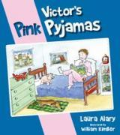  ISBN: 9781770645714 | Victor’s Pink Pyjamas  By Laura Alary  Illustrated by William Kimber  Victor’s favourite pair of pyjamas accidentally go through the wash with a pair of red socks, turning his comfortable, white pyjamas pink. Victor refuses to abandon his cozy pyjamas regardless of their new tint. Victor’s father, concerned he will be ridiculed because of the feminine colour, insists he needs replace them. But Victor, is quick to defend his pyjamas, and provides some thoughtful reasoning to reject the (masculine or feminine) stereotypes that we often attach to colours. | Suitable for all grades.  Provides opportunities to explore creative thinking around a topic or problem  Allows for some thoughtful investigation of masculine or feminine stereotypes that are attached to colours  Prompts some conversation around how we treat others and the idea of being able to assert yourself  Provides examples of how to provide logical support for a position or perspective

Discuss perceptions of the colour pink.

Using a Venn Diagram and paint. **This lesson and the accompanying examples come from K/1 teacher, Breanne Sumpter, at Chaffey-Burke. She paired the story “Victor’s Pink Pyjamas” with “Pink” by Lynne Rickards to engage students in these conversations.
Colour one of the circles red.
Colour the other circle white.
Highlight how pink is formed by the overlapping portions of the circle (similar to how Victor’s pyjamas result in their pink colour)
**You may experiment with which paints will most effectively create this effect, as well as the timing of application (i.e. ensuring one colour is still wet when the second is applied and determining whether the result is influenced by whether red is applied first or second). You could choose to use this to develop understandings about scientific / experimental inquiry if you are interested in devoting the time and broadening the learning experience.

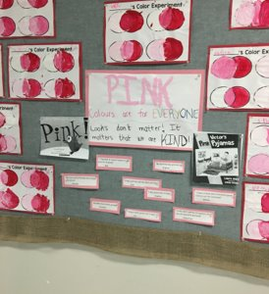
Prompted by the stories “Pink” and “Victor’s Pink Pajamas,” Students engage in conversations about what colours are typically considered “boy” colours and which are considered “girl” colours. ​
​
Students explore how pink is made by combining red and white. ​
​
The overall learning objectives are:​
- colours belong to everyone​
- wear what makes you comfortable and happy​
- the most important thing is to be kind to others​

Extend or revisit understandings with the story Pink is For Boys by Robb Pearlman
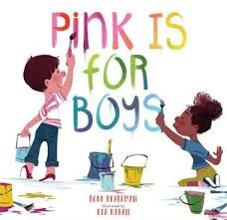  ISBN: 978-0-7624-6247-6 | Pink is For Boys  By Robb Pearlman  A clever series of illustrations that capture how colours are for everyone, using simple examples of situations and circumstances where boys and girls are enjoying experiences that might be associated with certain colours. | Suitable for all grades  Opportunities to discuss:  - Stereotypes about colours  - Preconceptions about perceived masculinity or femininity  - Equality and acceptance / withholding judgment  - Inclusion and belonging  - Imaginative play

Comfort
What does it mean to be comfortable?
What are some things that make us comfortable?
Think about a piece of clothing that makes you comfortable?
What if you weren’t allowed to wear it?

Mary Wears What She Wants by Keith Negley
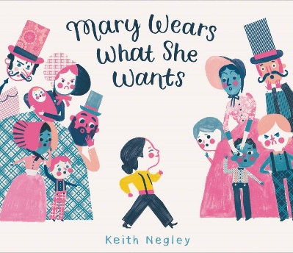  ISBN: 9780062846792 | Mary Wears What She Wants  By Kevin Negley  This charming story was inspired by Dr. Mary Edwards Walker, one of the first American women known to defy gender norms by wearing pants instead of dresses. It follows Mary’s insistence on wearing pants, her struggle with reactions of her community, and includes a short biography of Mary and her accomplishments. | Suitable for Grades 2+  Provides opportunities to explore and discuss:  - Gender expectations and stereotypes  - Individuality  - Standing up for what you believe in  - Human Rights and Gender Equality  - Thinking critically about and forming valid arguments for a position

What Riley Wore
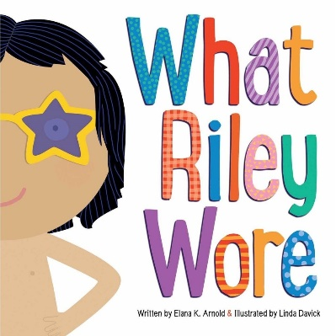  ISBN: 9781481472609 | What Riley Wore  By Elena K. Arnold  This clever story follows Riley as Riley dons a series of outfits for a variety of contexts. The clothing selected in each scenario helps Riley feel comfortable and themselves. | Suitable for all grades  Provides opportunities to discuss:  - recognizing and appreciating differences / withholding judgement  - individual preferences  - freedom of expression  - what makes a person feel safe / comfortable / powerful  - how ideas about gender and how it is expressed are constructed and reinforced  - being open to friendships / qualities of good friends  - avoiding making assumptions about gender (the story provides an opportunity to practice referring to Riley without imposing gender on the character)

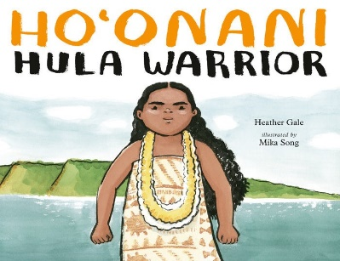  ISBN: 9780735264496 | Ho’onani: Hula Warrior  By Heather Gale  Ho’onani has difficulty seeing herself as either “girl” or “boy.” Her teacher encourages her to audition to participate in the performance of a traditional Hula chant – roles that are typically reserved for boys. | Suitable for all grades  Provides opportunities to discuss:  - Gender expression / feelings of connectedness to either masculine or feminine identities (or to neither, or to both)  - Avoiding placing limitations on people’s passion or potential, particularly because of perceived gender roles or expectations  - Dealing with fears  - The importance of support from family members or the impact of lacking that support

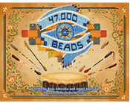  ISBN: 9780987976383 | 47,000 Beads  By Koja Aderyoha and Angel Aderyoha  Peyton’s Auntie Eyota notices Peyton has become reluctant to participate in dance ceremonies because she is not comfortable in her regalia. Auntie Eyota seeks guidance, from an elder, L, who helps to educate her family and to create a situation where Peyton is more comfortable and feels the freedom to participate in dances. | Suitable for all grades  Provides opportunities to discuss:  - The complex aspects of identity  - Gender expression  - Concept of Two-Spiritedness in Indigenous communities  - Kindness / Empathy / Dealing with difficult feelings  - Supportive communities / supporting a family member  - Seeking understanding instead of judging or fearing differences or the unknown

Explore expectations / stereotypes
Beautiful by Stacy McAnulty
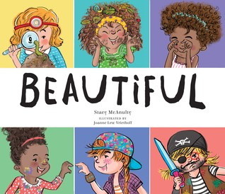  ISBN: 978-0-7624-5781-6 | Beautiful  By Stacy McAnulty  Illustrated by Joanne Lew-Vriethoff  A colourful book that subtly demystifies some of the stereotypes that exist about girls and beauty. Though the words tend to reinforce some of the stereotypes, the images challenge some of the existing stereotypes and provide some positive representations of things like girls enjoying science themed activities (having smart style), and engaged in sports (moving gracefully). | Suitable for all grades.  - Provides opportunities to explore and discuss some of the stereotypes about the expectations we typically have of girls

Except When They Don’t by Laura Gehl
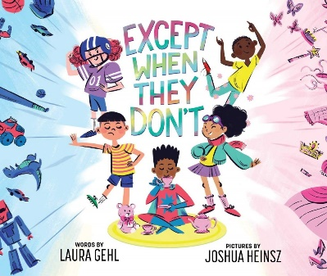  ISBN: 9781499808049 | Except When They Don’t  By Laura Gehl  Told in verse, this narrative gently challenges some stereotypically gendered norms, by listing messages like “Girls perform to fairy songs. / Boys play football all day long. / Boys yell, “Boo! and run away. / Girls like kittens and ballet. / Except when they don’t.” Strategic use of illustrations helps to deconstruct some of the perceived gender norms and communicate that it’s okay to like what you like, or to play how you want to play. | Suitable for all grades  Provides opportunities to discuss:  - Concept of preferences  - What makes you happy  - Freedom to make choices and to explore and play with the things that make you happiest  - Allowing others to be themselves  - Preconceptions about gender expression  - Where ideas about femininity and masculinity come from / Social construction of masculinity and femininity

The X-Files: Earth Children are Weird by Chris Carter
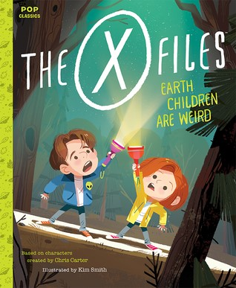  ISBN 978-1-59474-979-7 | The X-Files: Earth Children are Weird  Based on Characters by Chris Carter  Illustrated by Kim Smith  A clever reinvention of the X-Files characters as children, which features the two children having a back yard sleepover. Mulder constantly panics, reacting to things that happen and leaping to supernatural conclusions, while Scully reveals rational, scientific explanations for what they experience. | Suitable for all grades.  - A novel way of discussing character attributes, gender roles, and stereotypes

Authenticity – Being You
Red: A Crayon Story by Michael Hall

Where Oliver Fits by Cale Atkinson
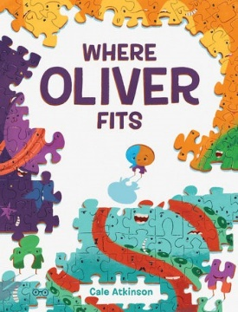  ISBN: 978-1-101-91907-1 | Where Oliver Fits  By Cale Atkinson  A dynamic story about Oliver, a puzzle piece trying to find the place in which he fits. He struggles with rejection, attempting to reinvent himself to find the place he belongs. A fun, and relatable story about the choices and challenges we face on our journey to becoming our authentic selves. | Suitable for all grades  Provides opportunities to explore and discuss:  - Similarities and differences  - Individual identity and the various factors that contribute to each person’s uniqueness  - Concepts of belonging and inclusion  - Seeking connection within communities  - Concepts of authenticity and conformity

Bad Dog by Mike Boldt
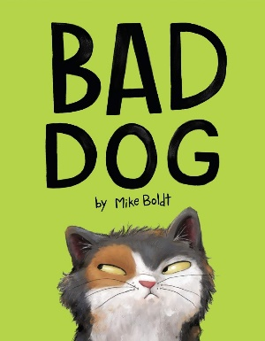  ISBN: 9781984847973 | Bad Dog  By Mike Boldt  A young girl is excited to receive a pet dog for her birthday that she names Rocky. She is quickly disappointed that Rocky does not behave as she expects dogs to. Ultimately, she comes to the conclusion that Rocky would make a really good cat. | Suitable for all grades  Provides opportunities to explore and discuss:  - Similarities and differences  - Appreciating unique skills and talents  - Perception of others based on preconceptions  - Concepts of authenticity and conforming to expectations

Inclusion and Belonging

It’s Okay to Be Different by Todd Parr
We Are All Wonders by R.J. Palacio
Same, Same But Different by Jenny Sue Kostecki-Shaw
We Are All Dots: A Big Plan for a Better World by Giancarlo Macri and Carolina Zanotti

All Are Welcome by Alexandra Penfold
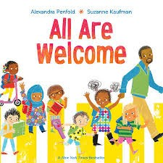  ISBN:978-0-525-57964-9 | All Are Welcome  By Alexandra Penfold and Suzanne Kaufman  An inviting narrative about a community where all are welcome. The story has simple text, in rhyming verse, that addresses several aspects of diversity from clothing, to cultural origin and identity, to foods that are enjoyed, to special talents, to family composition. The illustrations are colourful and playful and provide opportunities for students to see a diverse representation of members of a school community. | Suitable for all grades  Provides opportunities to discuss:  - Similarities and differences  - Diversity  - Individual identity and the various factors that contribute to each person’s uniqueness  - Concepts of belonging and inclusion  - How one contributes to a community  - Unique talents

Share the picture book. Invite students to recognize different representations of people in the images. There is significantly more material to work with in the images than the actual text.
What do you notice about the people in the pictures?
How many different kinds of people do you notice?
Which people are like you? Which people are different from you?
What do you see that reveals things about the identities of the characters shown?
How should each of the characters be treated by the others?

Bullying / Exclusion

The Wall: A Timeless Tale by Giancarlo Macri and Carolina Zanotti
Why does the king send away all the people that didn’t look like him?
What is the problem in excluding people who aren’t like you?

Select a story that explores someone being harassed or bullied. Identify how a character was treated, and what motivated others to treat the character that way.
Consider:
- Oliver Button is A Sissy by Tomie DePaola
- Hooway for Wodney Wat – Helen Lester
(I happened across this readers’ theatre script if you wanted to incorporate drama into your exploration of the topic
http://www.timelessteacherstuff.com/readerstheater/WodneyWat.pdf)
- Nerdy Bird Tweets by Aaron Reynolds
- Sissy Duckling by Harvey Fierstein

Discuss possible solutions to bullying.
- What can we do if we find ourselves a target of bullying?
- Who can help us?
- What can we do if we observe someone else being bullied?
- How can we help?
- How can we prevent bullying?

Discuss the roles of “bully,” “bullied,” and “bystander” Consider the role of “upstander.” Develop understandings about what it means to be an ally.

Share: Super Manny Stands Up by Kelly DiPucchio

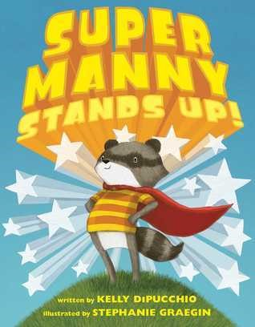  ISBN: 978-1-4814-5960-0 | Super Manny Stands Up!  By Kelly DiPucchio  Illustrated by Stephanie Graegin  Manny feels empowered to battle unsavory sea creatures, zombie bears, and evil clouds when he dons one of his colourful capes. With each cape he wears he declares he is fearless, strong, brave, powerful or invincible. He applies this positive self-talk when faced with how to deal with a bully picking on one of his vulnerable classmates. | Suitable for all grades.  - Fosters some conversation around positive self identity and positive self-talk  - Provides some context for discussing the role of an upstander

Say Something By Peter Reynolds
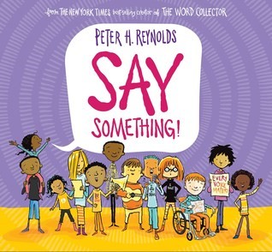  ISBN: 978-0-545-86503-6 | Say Something  By Peter H. Reynolds  An inspirational book that encourages readers to find their voices and “Say Something.” | Suitable for all grades.  Provides opportunities to discuss  - Voice / Confidence  - Passions  - Justice / injustice  - Bully / Bullied / Bystander / Upstander  - Authenticity and creativity  - Ways to utilize voice  - Safety

I Didn’t Stand Up by Lucy Falcone
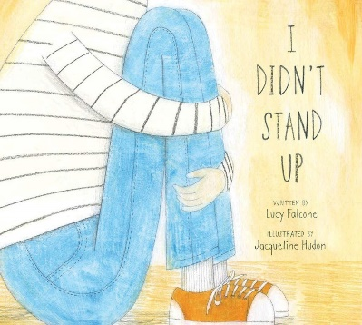  ISBN: 9781988347066 | I Didn’t Stand Up  By Lucy Falcone  Inspired by the poem, “First They Came” by Martin Niemoller, this picture book explores different reasons that people get targeted for bullying, and encourages students to 1) empathize with people who are different, and 2) stand in solidarity with others in the face of mistreatment. | Suitable for Grade 3+  Provides opportunities to discuss:  - Identity and the aspects that contribute to it  - Opportunities to talk about vulnerable or marginalized identities (race, ability, country of origin, religion, gender, sexuality, body image, etc.)  - Accepting differences  - Responding to bullying  - Allyship / Standing together

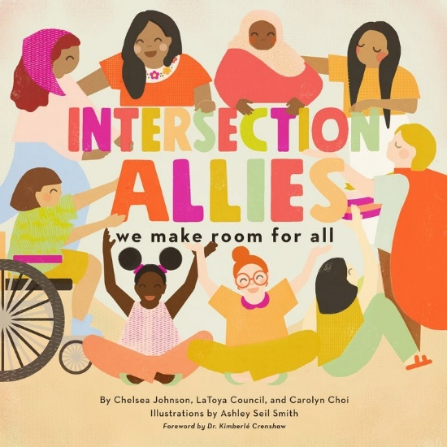  ISBN 978-1-948340-08-3 | Intersection Allies  By Chelsea Johnson, LaToya Council and Carolyn Choi  A playful, but sophisticated text that explores the different identities that influence our experiences in the world. Its message is regardless of how we are perceived, everyone deserves to be treated fairly and respectfully. “Where there’s room for some, we make room for all. Friends can be allies no matter how small.” | Suitable for Grades 4+ (can be used with younger grades for the visuals as they provide diverse representations of identities, but has some sophisticated content that might be too advanced for younger readers)  Provides opportunities to explore and discuss:  - Acceptance, friendship, loyalty  - Concepts of allyship / Being an ally  - Environmental stewardship  - Identity and the intersectionality of factors like race, religion, citizenship, class, age, gender, size, and skin colour contribute to each person’s experience in the world – and the differences this may equate to

Discuss diversity, and acceptance of all types of people. Discuss choosing kindness and maintaining the dignity of people we interact with.

What happens when the things that make us happy are different than what makes another person happy? (ex: I like to work in an environment that is very quiet / my friend likes a busy environment with music playing)

Consider Rights and responsibilities
What is a right? What is a responsibility?

What happens if someone interferes with our rights?
What happens if we interfere with someone else’s rights?

What if we accepted that “EVERYONE is entitled to their happiness.”
If we want to the freedom to experience the things that make us happiest, then we should respect that other people should have the freedom to have their happiness too.

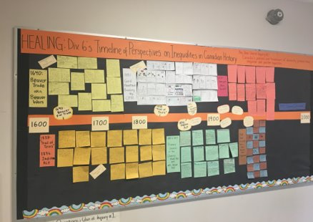
Grade 4/5 – Social Studies / Language Arts​
​
Timeline of Perspectives on Inequalities in Canadian History.​
​
Students investigate historical events where groups of people were discriminated against or mistreated. Examples of historical events include The Indian Act, Fur Trade, Building of the CPR Railway, Japanese Internment, Anti-Asian Riots, Residential Schools, and the treatment of members of the LGBTQ community.

Ghost’s Journey: A Refugee Story by Robin Stevenson
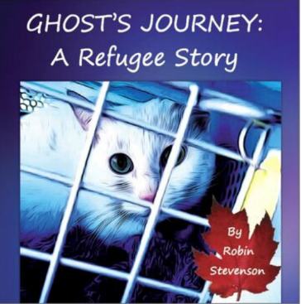  ISBN 978-1-7753019-4-3 | Ghost’s Journey: A Refugee Story  By Robin Stevenson  This gentle story, told from Ghost’s perspective, documents the journey of a pair of gay men and their cat, Ghost, who travel to Vancouver, seeking refugee status after their safety is jeopardized back home in Indonesia.  Stevenson provides information about the charitable organizations that enabled the characters to move to Canada and live their lives freely. | Suitable for Grade 3+  Provides opportunities to discuss  - Different kinds of families  - Definitions of what it means to be a refugee, and the process of immigration  - Human Rights, including differences in how LGBTQ+ people are treated or regarded in different countries  - Impressions of humans and their experiences from the perspective of an animal / pet

Problem Solving.
Determine a problem solving process to be used.
Consider a variety of problems, you can apply the process by examining problems that occur in stories – particularly where characters might see things differently
Summary of skills extracted from elaborations regarding B.C. Social Studies Curricular Competencies (Grades 3 – 7):
Use Social Studies inquiry processes and skills to ask questions; gather, interpret, and analyze ideas; and communicate findings and decisions
Ask relevant questions to clarify and define a selected problem or issue
Demonstrate a willingness to use imagining and predicting in relation to a selected problem or issue
Generate a variety of responses to a specific problem or issue
Consider advantages and disadvantages of a variety of solutions to a problem or issue
Individually, or in groups, design a course of action to address a problem or issue, and provide reasons to support the action

Grade specific elaborations relevant to Problem Solving within: Use Social Studies inquiry processes and skills to ask questions; gather, interpret, and analyze ideas; and communicate findings and decisions.
Grade 3
Ask relevant questions to clarify and define a selected problem or issue.
Make predictions in relation to a selected problem or issue.
Grade 4
Identify and clarify a selected problem or issue (e.g., provide details; state reasons, implications).
Create a plan of action to address a chosen problem or issue.
Grade 5
Summarize information and viewpoints about a problem or issue.
Select ways to clarify a specific problem or issue (e.g., discussion, debate, research, reflection).
Develop a plan of action to address a selected problem or issue:
Individually, or in groups, design a plan of action to address a problem or issue (e.g., fundraising campaign, clothing or food drive, letter writing to a politician, editorial in school or community newspaper, petition).

From the Social Responsibility Competency Profiles

2. Solving problems in peaceful ways

Students identify and develop an appreciation of different perspectives on issues; they generate, use, and evaluate strategies to resolve problems.
sample “I” statements
I can solve some problems myself and can identify when to ask for help.
I can identify problems and compare potential problem-solving strategies.
I can clarify problems, consider alternatives, and evaluate strategies.
I can clarify problems or issues, generate multiple strategies, weigh consequences, compromise to meet the needs of others, and evaluate actions.
1) Begin lesson by playing the video clip:
Stuck on an Escalator
https://www.youtube.com/watch?v=Kq65aAYCHOw

2) Establish a “Problem Solving Model” to use in deconstructing the video and the problem it depicts. I used this Simple 5 Step process for Solving Problems from encourageplay.com

IDENTIFY THE PROBLEM
Kids need to be able to first identify the problem they are having. Sometimes kids will identify one thing as the problem, but it really turns out to be something else. Make sure you understand the situation and clarify the specific problem.
GENERATE IDEAS
They need to be able to generate several ideas for solving an issue. Not all of them will work, but you’re not trying to pick out ones that will and won’t work during this step. Right now, it’s just about generating ideas.
EVALUATE IDEAS
Here’s where you go through and figure out which ideas are ones to try and which ones to leave behind.
DECIDE ON A SOLUTION AND TRY IT
Pick an idea for solving the problem and give it a try.
DID IT WORK?
After you’ve tried to solve the problem, check in to see if it worked. If it did, awesome! If it didn’t, just go back and pick another solution that you thought of during the “Evaluate Ideas” step and see if that works.

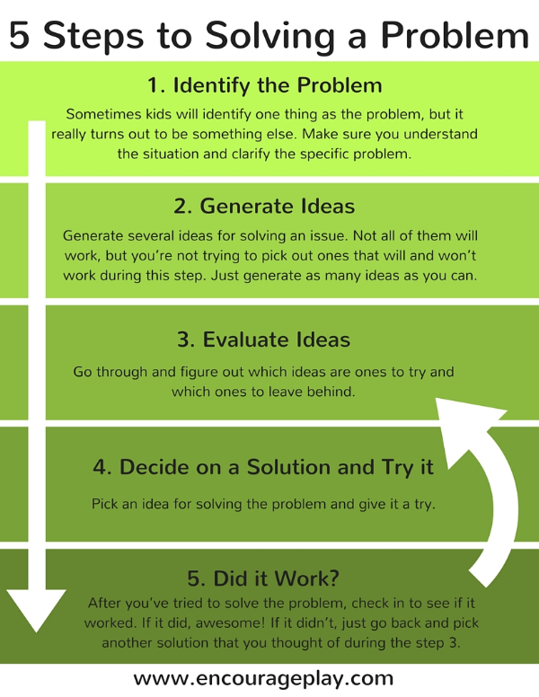

3) Once students are familiar with the problem solving process, use the video:
How Two Moms Took on Trolls to Support an LGBTQ Kid
https://www.youtube.com/watch?v=IY-kQtI2hY4

You can either play the full video and then reflect on the experiences depicted. Or consider, chunking portions to allow for meaningful conversation, and active strategizing of solutions.

Pause at 1:19
Define the context. Identify the problem.
What was going on?
What was the problem that the moms featured in the video felt the need to address?
How did the problem become a problem?

Generate Ideas (Brainstorm Solutions)
What possible solutions can you brainstorm?

Evaluate Ideas
Consider which strategies or solutions might best address the problem. Consider the likely outcomes of the various solutions. What are some risks involved in implementing different solutions?

Continue playing video.
Decide on a solution and try it. / Did it work?
Which solution did they choose?
What was the outcome?
How did the actual outcome compare to the expected outcome?
How might other solutions have changed the outcome?

Some additional clips to provide context or extend upon the problem solving scenario:

News Article about the controversy generated by the scheduling of the reading of “I am Jazz” at an elementary school.
https://www.youtube.com/watch?v=jB0dIiNhlfA

Jazz Jennings Reading “I Am Jazz.”
https://www.youtube.com/watch?v=BF5D2lsPfsU

