Primary Lesson Plan – Families are Different, Families are the Same
Jennie Thorner (K/1 Teacher, Chaffey-Burke Elementary)
Curricular Links:
https://curriculum.gov.bc.ca/curriculum/social-studies/k
https://curriculum.gov.bc.ca/curriculum/social-studies/k
Competency Links:
Critical Thinking
https://curriculum.gov.bc.ca/competencies/critical_thinking
Personal and Social
https://curriculum.gov.bc.ca/competencies/ppci
Resources:
Different? Same! - Heather Tekavec and Pippa Curnick
Heather Has Two Mommies - Lesléa Newman
A Family Is a Family is A Family - Sara O’Leary
Stella Brings the Family 0 Miriam B. Schiffer
It’s Okay to Be Different – Todd Parr
And Tango Makes Three – Justin Richardson

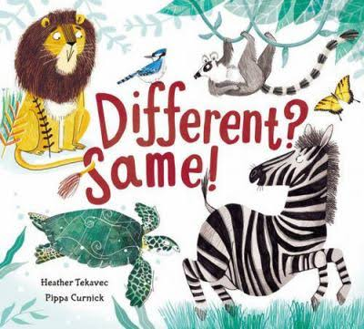

- Have students generate brainstorms of their family members.
- Students draw and label the members of their family doing the child’s favourite activity(ies).
- Group finished illustrations of student families into combinations where some have obvious similarities, and others have obvious differences.
- Read portions of the picture book; Different? Same! by Heather Tekavec and Pippa Curnick. Have students identify differences, and then ask them to examine similarities between the groups of images.
- Play “Different? Same” game. Use the illustrations of families previously created by students as the source material. Students identify differences and similarities they observe.
- Record examples of responses on chart paper:
- Have students “Gallery Walk” with their illustrations held in front of them. Their objective is to find a similarity between their family and the family of every other student they encounter.
Families are:
Different | Same

We begin by brainstorming the names of the people we live with. The list is usually of family members, and is both nuclear (parents, siblings) and non-nuclear (aunts, uncles, cousins, grandparents, etc). I ask the class to then draw and label a picture of our families doing the child’s most favourite activities together.
Before the next lesson – I group the pictures by some similarities and some differences – looking for pictures with connections (doing the same activity, same number of children, etc.). During the next lesson, we begin by reading most of the story “Different? Same!”. I read about 4-5 examples in this story to get the class thinking of looking for similarities instead of differences.
Then, I ask for two volunteers to play the “Different? Same!” game with the pictures from the day before. We note the differences at first, but then we talk about the similarities. We write down on observations on chart paper entitled, “Families are” and have a column for “different” and a column for “same”.
Expected beginning observations are usually concrete – the number of people, the colour of hair, the activity – but if the students need more prompting, I ask about what the families are doing and how they feel about the activities, “How do you feel when you are with your family?” and look for common words (fun, loving, kind, “mostly good but my brother is annoying” type) comments. I ask the students to gallery walk the room with their picture in front of them. They need to find a similarity between their families with each friend they meet.

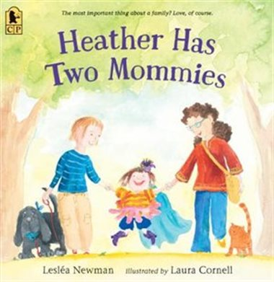
- Read “Heather Has Two Mommies” by Lesléa Newman.
- Discuss: What are similarities between Heather’s family and their own families.
- Make Connections back to “Families Are: Different / Same” chart from the previous series of lessons.
- Emphasize that the most important thing about families is that they love and support each other.
- Add “the most important thing about families is that they love each other.”
- Display the chart and understandings in a prominent place/
- Revisit when reading related titles (i.e. A Family is a Family is a Family, Stella Brings the Family, It’s OK to be Different, Tango Makes Three, etc…)
Families are:
Different | Same
The most important thing about families is that they love each other.

The next lesson, I read “Heather Has Two Mommies”. We talk about the similarities between Heather’s family and their own. Then we talk about the differences. We reiterate the message that the most important thing about a family is that they love each other and take care of each other. We share the Different? Same! Chart we created as a class, with a special line added at the bottom – “the most important thing about a family is that they love each other” for display.
I continue to share books about different kinds of families during the unit, including “A Family is a Family is a Family,” “Stella Brings The Family,” “It’s OK to Be Different,” and “And Tango Makes Three.”

