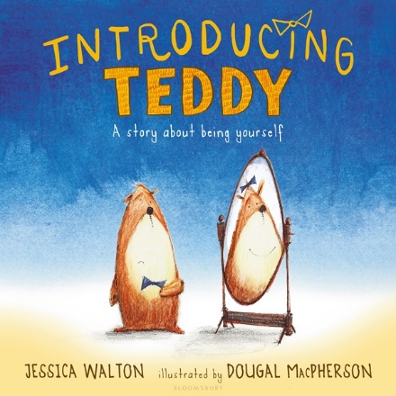

“Introducing Teddy: A Gentle Story About Gender and Friendship” by Jessica Walton
Classroom visit to a Grade 1 Classroom
By Bryan Gidinski

Big ideas:
Kindergarten – Grade 2
- Language and story can be a source of creativity and joy.
- Stories and other texts help us learn about ourselves and our families.
- Everyone has a unique story to share.
- Through listening and speaking, we connect with others and share our world.

Curricular Competencies
- Use developmentally appropriate reading, listening, and viewing strategies to make meaning
- Engage actively as listeners, viewers, and readers, as appropriate, to develop understanding of self, identity, and community
- Recognize the importance of story in personal, family, and community identity
- Use personal experience and knowledge to connect to stories and other texts to make meaning
- Recognize the structure of story

Developing Understandings
- A person’s appearance can change.
  - Sometimes the change is subtle or superficial
  - Sometimes the change is more profound
- People are entitled to be called by the name they identify with
  - When people identify the name they want to be called, it is respectful to use it
- How to be a good friend

I started by introducing myself and asking if students had seen me around the school. I talked about how sometimes when they see me I might look different. I asked them to brainstorm ways they might notice that I looked different. Suggestions that were generated were wearing a hat one day, wearing different shoes, getting a haircut, etc.

Some possible differences:
- Wearing different clothing
- Changing hair styles
- Gaining or losing weight
- Having a visible injury (wearing a cast, or bandage, or having a bruise,
- Getting sunburnt
- Differences in beard (clean shaven, stubble, trimmed beard, fuller beard)

I talked about how sometimes they might see me and one day I might have a full beard. On other days, I would have no beard. And on other days I might have something somewhere in between. I elaborated on how sometimes when I've had a beard for a while, it gets kind of fuzzy, and when I shave it off, people don't always recognize me because I look different, but they are always able to recognize that I'm still the same person in the end.

Understanding: regardless of the physical appearance, I am still the same person.

I then spoke to students about my name. I had been introduced as Mr. Gidinski, and I explained to them that most people call me Mr. G. I also shared with them that my friends call me Bryan. I used this to illustrate that I have 3 names, and that names are important. I asked them how they would know what they should call me, to which they responded, “we could just ask you what you wanted us to call you.” We all want to be addressed by the name that is most comfortable. Kids gave examples of how they had two names. Someone shared their first name and then their middle name. Another shared that his name was Benjamin but he preferred to be called Ben. The young trans student identified that she had used a different name last year. In each scenario, students were asked how to determine which name to call someone, to which the simple answer was “we call someone the name they ask us to call them.”

Reasons someone might have more than one name:
- a new immigrant who changed their name
- has a first name, middle name(s), and a last name
- has a nickname
- gets referred to by their last name
- changes name to match their spouse

Understanding: When someone shares their name, it is respectful for us to use the name they ask us to use.

We talked about how to be a good friend and talked about things that good friends do (sharing, playing together, talking to each other, being silly together, etc). Then I shared the book, which touched on names, a character's appearance, and friendships, pausing to ask questions to clarify the understandings and emphasize how the activities at the end mirror the activities at the beginning of the story.

The story can be deconstructed on a number of levels of sophistication depending on the developmental level of students, and on topics relevant to the social dynamics in the classroom.

In more advanced classrooms, it can be a springboard for conversations about:

1) Non-binary understandings of gender.

2) Deconstructing stereotypical gender roles: Errol plays with his Teddy, hosts tea parties. Ava rides a scooter, and builds a robot.

