Exploring Phobias
By Bryan Gidinski
bryangidinski@gmail.com

English Language Arts
Big ideas:
Grades 4 – 5: Using language in creative and playful ways helps us understand how language works.
Grades 6 - 7: Developing our understanding of how language works allows us to use it purposefully.
Grades 8 - 9: People understand text differently depending on their worldviews and perspectives.

Grades 4 – 9: Questioning what we hear, read, and view contributes to our ability to be educated and engaged citizens.

Inquiry Objective: Students will investigate a specific phobia.

Ex: arachnophobia – irrational fear of spiders

They will
- Define the words phobia and fear (establish the difference between a fear and a phobia)

- Select a specific phobia and identify what it is the irrational fear of

- Research the reactions (both physical and emotional) of a person experiencing exposure to their phobia

- Draw a caricature of a person reacting to the item they are phobic too. Drawings should include labelling of physical reactions, and the definition of the phobia.

- Outline a “treatment plan” for how to overcome the phobia

As a class, share phobias, definitions, and caricatures.

List definitions which typically have the stem “irrational fear of………”
Add Homophobia,Transphobia, Biphobia if they haven’t been surfaced already (possibly include Islamophobia, xenophobia, depending on how broad you want the conversation to be).
Typical stem changes to “extreme fear or hatred of….” or “prejudice towards…”
Explore the differences regarding the definitions.

Use caricature depictions to discuss reaction to LGBTQ identities. Do we typically have these exaggerated reactions to LGBTQ people? How do we know whether to react (or not) to someone we encounter?

Consider if someone had “arachnohomophobia.” What would this look like? How would they behave? What would they have to do in order to different between something they wouldn’t fear and something they would.

Discuss “treatment plans” for phobias. What specific steps can be taken to overcome phobias? What strategies or therapies can be applied?

Brainstorm steps to overcome homophobia, transphobia, biphobia [Islamophobia, xenophobia]

https://www.helpguide.org/articles/anxiety/phobias-and-irrational-fears.htm
http://www.fearof.net/

Some helpful definitions:
phobia: an exaggerated usually inexplicable and illogical fear of a particular object, class of objects, or situation; (https://www.merriam-webster.com/dictionary/phobia); an extreme or irrational fear of or aversion to something (https://en.oxforddictionaries.com/definition/phobia)
fear: a distressing emotion aroused by impending danger, evil, pain, etc., whether the threat is real or imagined; the feeling or condition of being afraid (www.dictionary.com/browse/fear)
caricature: a drawing that makes someone look funny or foolish because some part of the person's appearance is exaggerated. : someone or something that is very exaggerated in a funny or foolish way. (https://www.merriam-webster.com/dictionary/caricature)
homophobia: dislike of or prejudice against homosexual people (https://en.oxforddictionaries.com/definition/homophobia)
transphobia: dislike of or prejudice against transsexual or transgender people (https://en.oxforddictionaries.com/definition/transphobia)
Student samples (Grade 6/7)

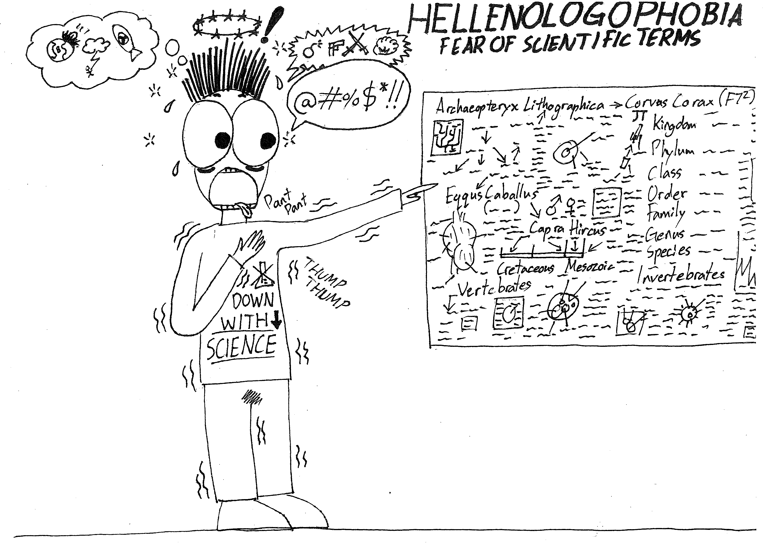

Hellenologophobia - The irrational fear of Greek (or Latin) words, or complex scientific terminology.
www.yourdictionary.com/hellenologophobia

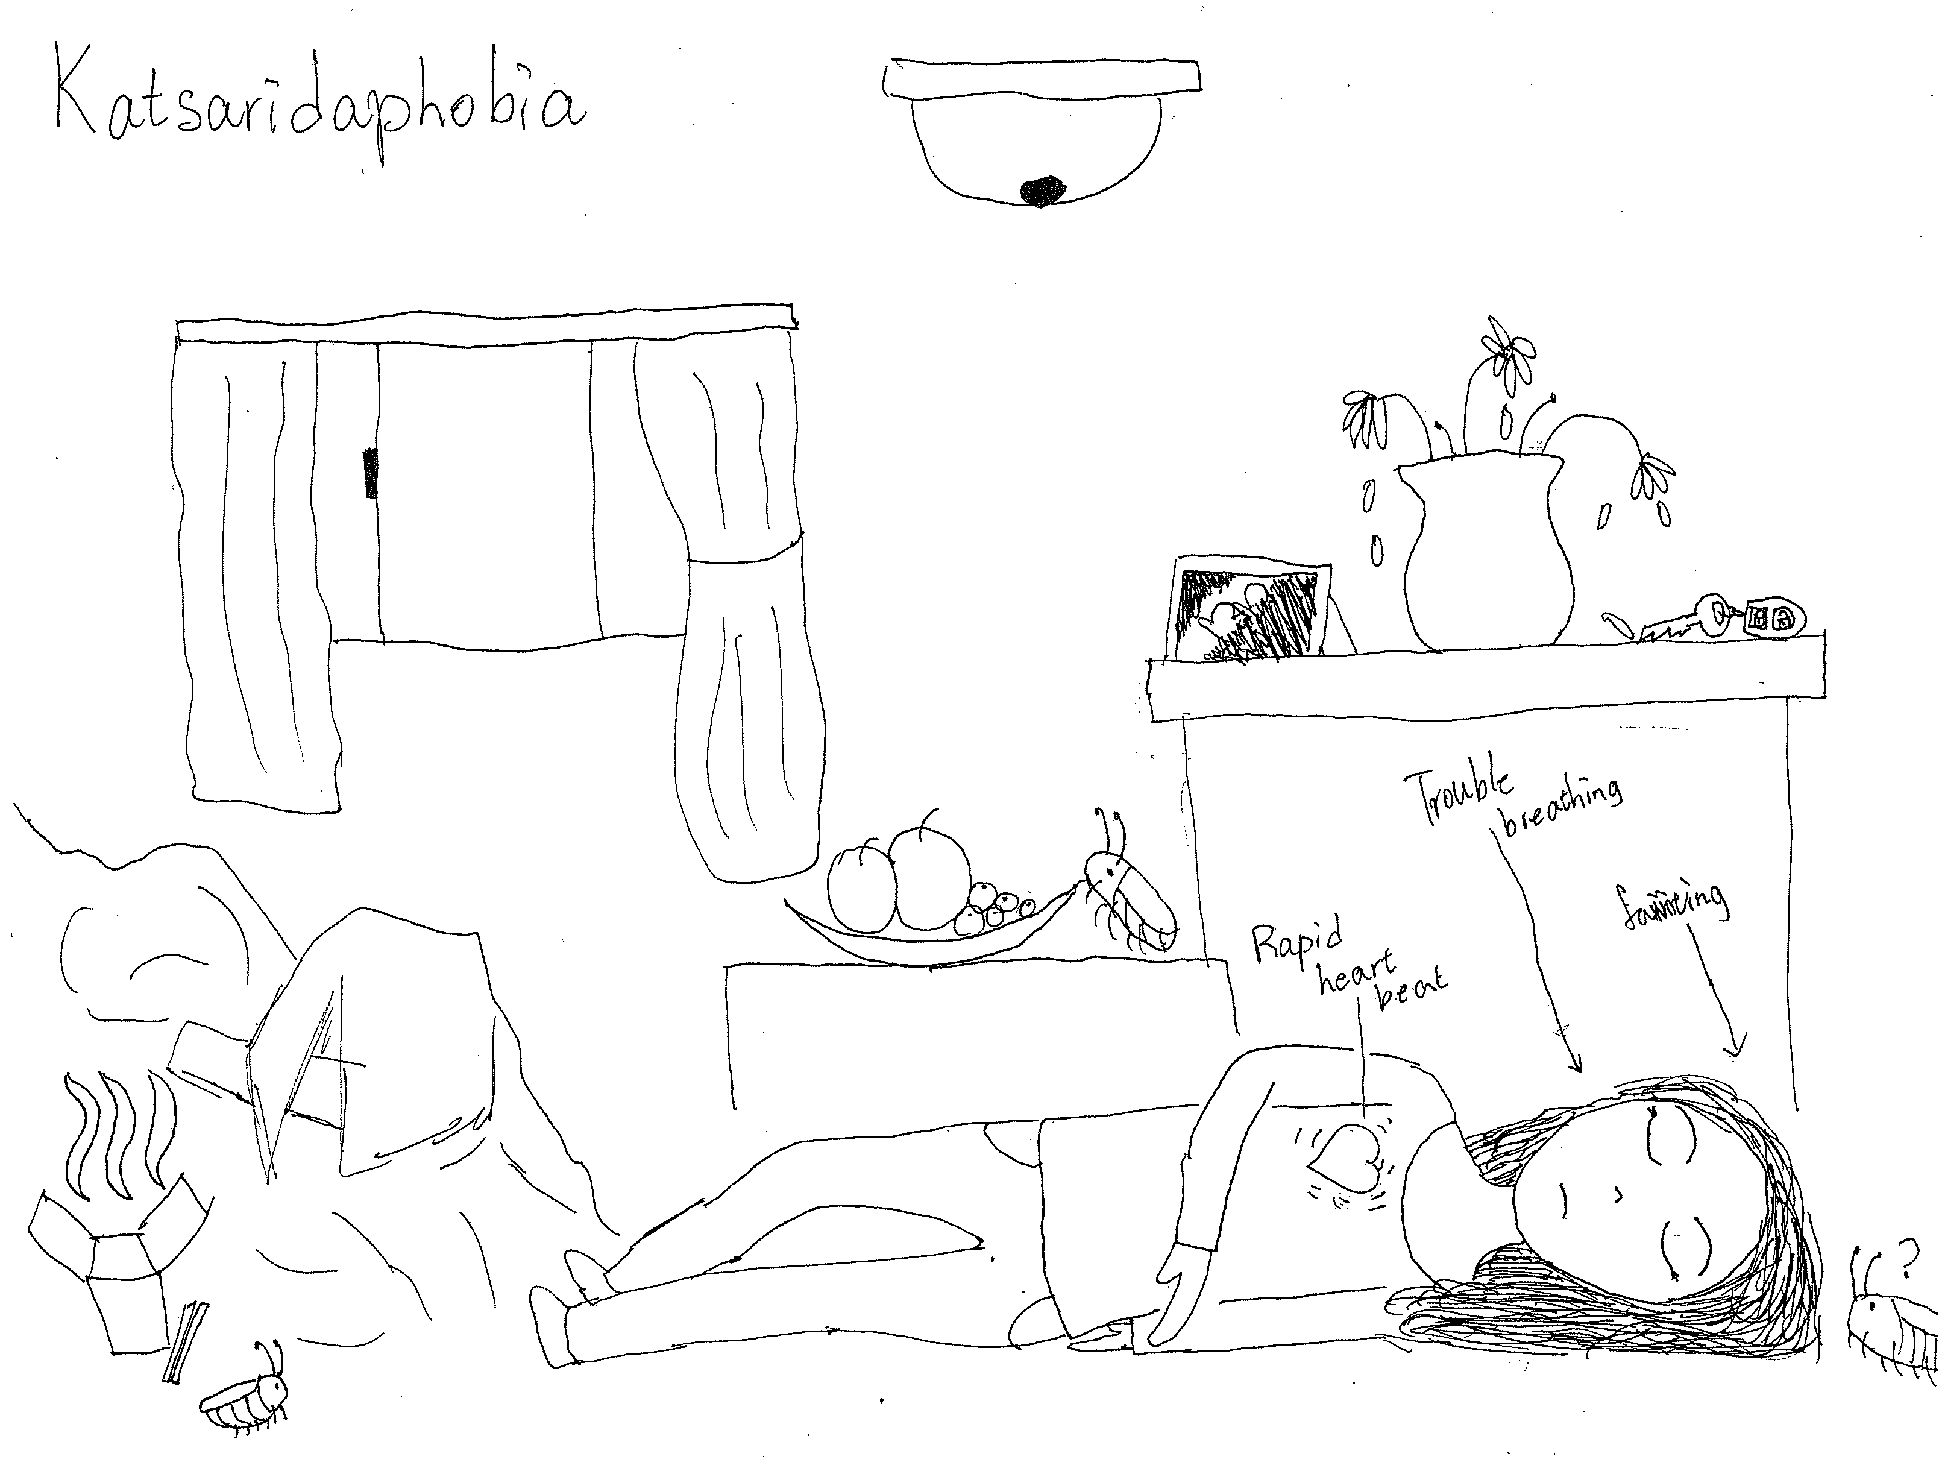
Katsaridaphobia is the morbid and irrational fear of cockroaches.
http://mostcommonphobias.com/katsaridaphobia-fear-phobia-cockroaches/
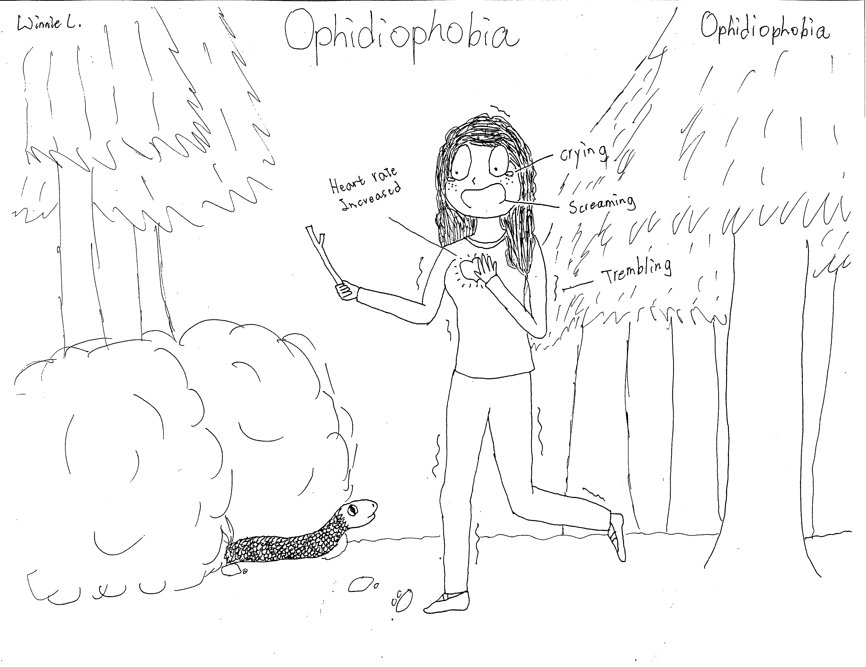
Ophidiophobia or ophiophobia is a particular type of specific phobia, the abnormal fear of snakes. It is sometimes called by a more general term, herpetophobia, fear of reptiles and/or amphibians.
https://en.wikipedia.org/wiki/Ophidiophobia

