Design a Logo for Universal Washrooms
By Bryan Gidinski
bryangidinski@gmail.com

Applied Design, Skills and Technologies: Particularly relevant to the Entrepreneur & Marketing Objectives and Possibly with regard to Media Arts (depending on how students are generating and manipulating the images).
Grades 4-5: Designs can be improved with prototyping and testing
Grades 6-7-8: Design can be responsive to identified needs.
Grade 9: Social, ethical, and sustainability considerations impact design.
Learning Tasks:
1) Analyze design features (i.e. colour, imagery, simplicity, contrast, symbolism, scale, how intuitive the design is – how easy is it to recognize what it intends to communicate)
https://www.graphicsprings.com/blog/view/the-5-most-important-things-to-know-about-designing-a-logo
https://www.webdesignerdepot.com/2009/06/12-essential-rules-to-follow-when-designing-a-logo/

Examine familiar logos:
https://image.flaticon.com/sprites/share/packs/174834-social-media-logos.png
https://www.freevector.com/nhl-hockey-logos

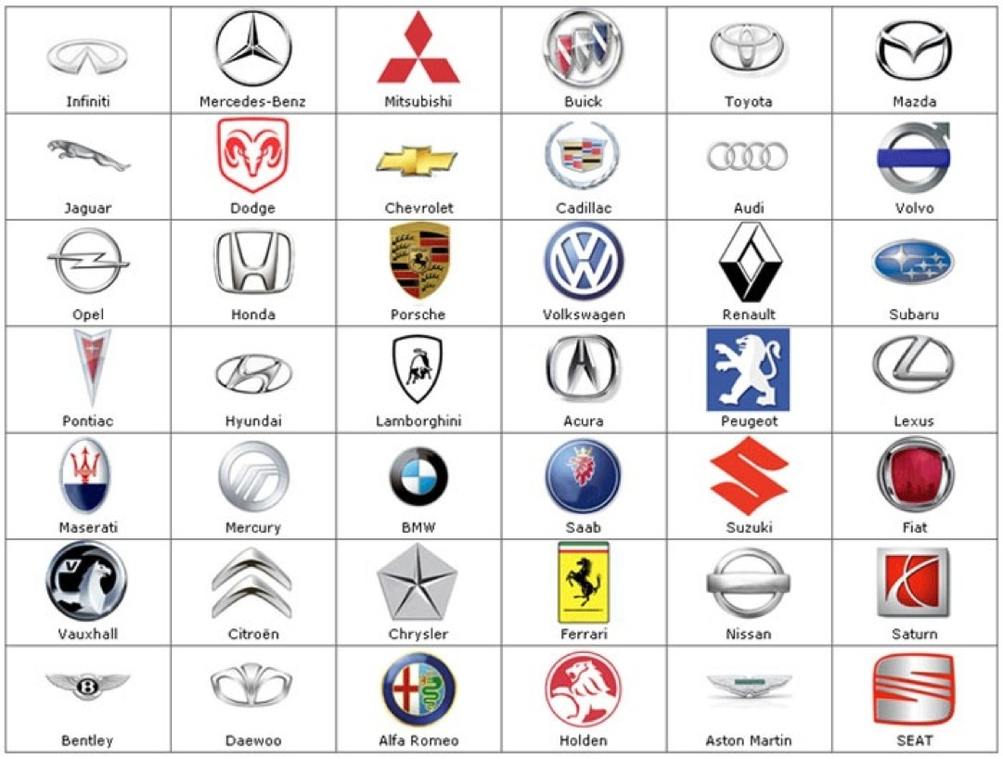
https://i.pinimg.com/originals/2a/91/82/2a9182a0f3474630120868b1ac3504f2.jpg

2) Develop understandings about what Universal Washrooms are, and why they are important.
- Single stall washrooms with locking mechanism
- Inclusive, private, accessible
3) Brainstorm reasons someone would choose to use a universal washroom. Consider who needs access to universal washrooms.
These videos can be helpful in creating the context for understanding the need for gender neutral / universal washrooms.
Ivan Coyote (TEDX - Vancouver
We All Need a Safe Place to Pee
“If I could change the world tomorrow, to make it easier for me to navigate, the very first thing I would do is blink and create single-stall gender-neutral bathrooms in all public places.”
https://www.youtube.com/watch?v=wUKAVcj9NVA (12:16 mins)
An animated / abbreviated version of the same Ivan Coyote speech
https://vimeo.com/172375271 (2:19 mins)

4) Group students into design teams (3 – 5 students). Invite them to design a logo for a universal washroom. **It is helpful if students are familiar with the concept of non-binary gender. The Gender Unicorn Graphic (http://www.transstudent.org/gender) can be a useful graphic to help illustrate this point
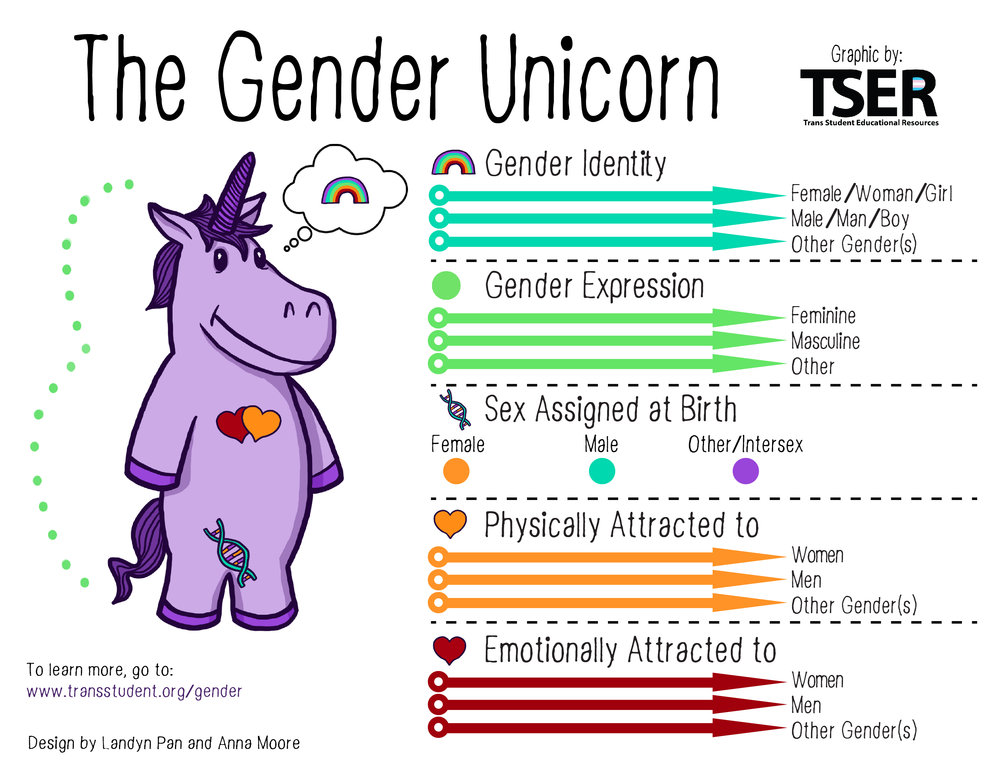
Provide some objectives to reinforce design understandings about logos
- Strategic use of colour (It can be easier to limit design palette to black and white. It allows for high contrast, distinctive graphics and can be copied easily on a conventional copier)
- Simplicity
- Intuitive (Can the user easily interpret its intended meaning?)
- Inclusivity (Does it communicate that anyone may use the space?)
5) Draft and audition graphics. Circulate and provide feedback. ** It is helpful to challenge them to think beyond binary representations of gender in accomplishing the design objectives. Students are encouraged to brainstorm and develop more than one design concept.
6) Students “pitch” their designs to the class. Feedback by the “Client” (this can include teacher and/or peer feedback) is given, and students revise and polish their designs.

Students can practice giving constructive criticism on designs created by graphic artists.
Designers from a variety of design companies were asked to create a symbol to indicate gender-neutral washrooms.
https://www.fastcompany.com/3063488/we-asked-6-designers-to-recreate-gender-neutral-bathroom-icons (1:00 mins)

Possible extension activity: Article that shows some of the most memorable icon brand logos, as well as their evolution over time. Consider how designs might have to adapt or change at some point in the future.
http://www.complex.com/style/2013/03/the-50-most-iconic-brand-logos-of-all-time/
Student Samples (Grade 6/7)