Practically Perfect Poetry – From Brainstorm to Form

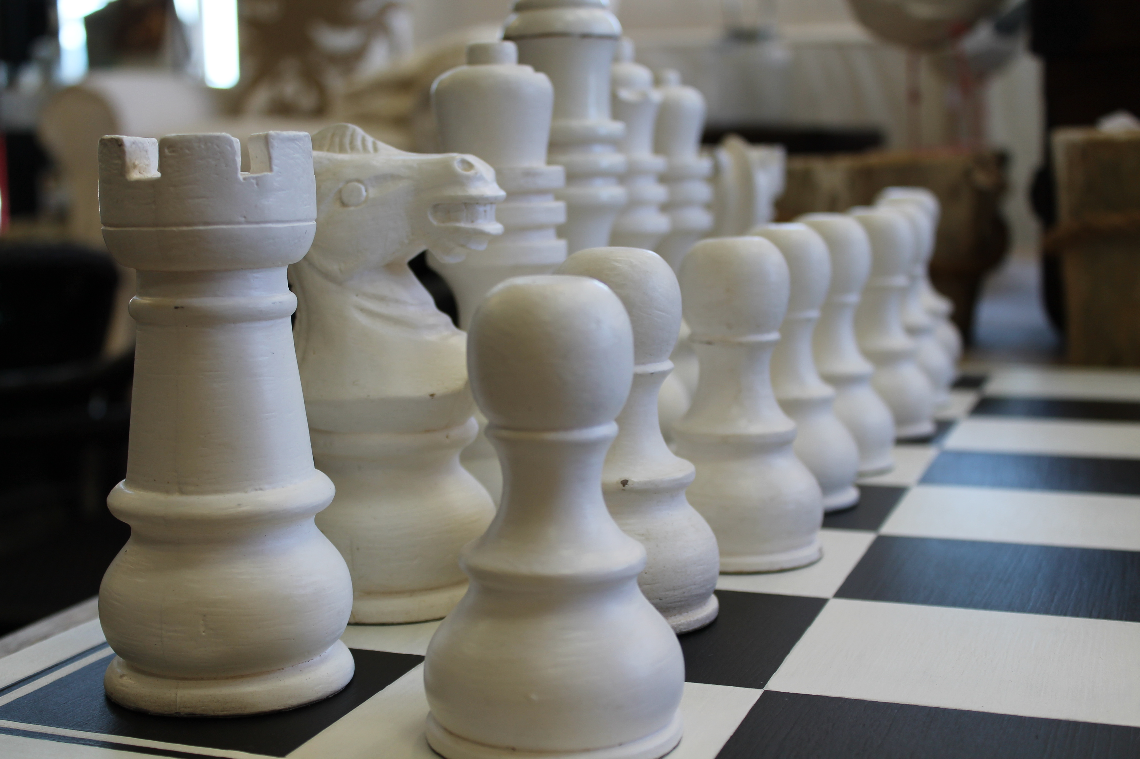

Presented by:
Bryan Gidinski

Bryan Gidinski, BA., MEd.
Burnaby, B.C.
604-434-8747

lostboysconsulting.ca

e-mail: bryangidinski@gmail.com

Available for school-based, or district professional development. Please contact for availability and rates.

Practically Perfect Poetry –
From Brainstorm to Form

A key philosophical understanding that I want students to develop regarding writing is that the primary role of the writer is to create images. In poetry, this concept is extended into the idea of trying to evoke the senses in powerful ways.

One of my key objectives in engaging students in writing, particularly in writing poetry, is to get students to become comfortable experimenting with language. I want them to be playful with language, to become comfortable with substitution, to be intuitive about what works and what doesn’t, and to be able to justify their selections. Someone who can reword and re-envision their ideas is someone who demonstrates potential to find the most powerful way to express something rather than to simply express something with the first words that come to mind.

I have experienced frustration with teaching poetry forms where I introduced a particular framework (i.e. a Diamante poem with its particularly rigid structure) and observed students complete poems that met the requirement of the structure, but that lacked passion or meaning. They weren’t particularly worthy of feedback (and in some cases of evaluation) because of the arbitrary nature of the form. Students were very content to simply fill in the required types of words as if they were completing a Mad Libs sheet. The ideas tended to be superficial, the language uninventive. So I’ve looked for ways to transform the experience students have with poetry.

Now, as with story writing, I spend more time on pre-writing strategies that really develop ideas and then ask students to find the best ways to convey them. This workshop hopes to convey how starting with brainstorming and asking students to develop ideas and images before working with the various forms can lead to more engagement with poetry, more experimentation with language and more powerful writing.

You will be asked to brainstorm feelings and images of comfort. You are asked to consider those experiences that make you feel content and safe. Some simple examples are things like a cup of hot chocolate on a cold day.

Examples I like to use to try to encourage more creative and deeper thinking about these types of experiences and to illustrate the kinds of ideas I want them to generate:
- The feeling of slipping your feet back into your own shoes after wearing skates for an hour…
- Holding my cat against my chest, with her head tucked in under my chin, as she purrs like an outboard motor…
- The way my mom used to flip my pillow to the “cold side” when I was sick in bed, craving relief from a fever…
- Another example I like to use is a memory I have of my dog. As a child I recall that my dog used to lie in the hallway near the front door all the time and I used to wonder why he chose such a random spot. One day, I lay down on the floor next to him, almost nose to nose and just stared into his eyes. What I suddenly became aware of was why he chose that spot. It was the spot where the midday sun streamed through the window and he lay basking it the warmth of it.

The more illustrative and personal the examples, the closer students are to creating powerful poetry.

As students develop their brainstorms, I circulate and try to tease out details.
If they give an example like “a warm blanket,” I try to get them to explore if that is a blanket that has some significance (i.e. a quilt someone made for them, is it a particular blanket or will any blanket do?, can they think of a particular example of a specific time when that was particularly comforting?)

I get them to work on extensive brainstorms so that they have lots of material to choose from when it comes to developing their poetry. On the next page, you have four questions that I ask students to consider from the material they have accumulated in their brainstorm. And then, I ask them to experiment. Many will have had some experience with a variety of forms of poetry, but I simply request that they play with combinations of words and ideas to get things that “sound cool” and evoke the senses. Many will draft clever and thoughtful examples of free verse that they don’t even realize are effective poetry.

Once they’ve had ample opportunity to experiment with the language and to share aloud, and listen to a variety of examples, I post several examples of poetry forms around the classroom and ask them to further experiment, considering which forms best convey their ideas, which forms are better suited for a single idea, which are better suited to multiple images, which ask for simplicity, which ask for complexity. The development of the purposes of different forms becomes almost intuitive in this process.

During this experimental process, I “introduce” or revisit concepts like metaphors, similes, alliteration, onomatopoeia, and rhythm to supplement their understandings and share various examples of poems.

The culminating task is to create an anthology of poetry for assessment, keeping in mind that a key piece of the assessment is the process in which they engage.
Imagery I want to capture:
____________________________________________________________________________________________________________________________________________________________________________________________________________________________________________________________________________________________________________________________________________________________________________________________________
____________________________________________________________________________________________________________________________________________________________________________________________________________________________________________________________________________________________________________________________________________________________________________________________________
____________________________________________________________________________________________________________________________________________________________________________________________________________________________________________________________________________________________________________________________________________________________________________________________________

Feelings I want to capture.
How do I want my reader to feel?
____________________________________________________________________________________________________________________________________________________________________________________________________________________________________________________________________________________________________________________________________________________________________________________________________

Descriptive words / phrases I want to use. Phrases that sound cool.
____________________________________________________________________________________________________________________________________________________________________________________________________________________________________________________________________________________________________________________________________________________________________________________________________
____________________________________________________________________________________________________________________________________________________________________________________________________________________________________________________________________________________________________________________________________________________________________________________________________
____________________________________________________________________________________________________________________________________________________________________________________________________________________________________________________________________________________________________________________________________________________________________________________________________

Ideas I might need to make transitions between.
How do I make the ideas fit together?
____________________________________________________________________________________________________________________________________________________________________________________________________________________________________________________________________________________________________________________________________________________________________________________________________
____________________________________________________________________________________________________________________________________________________________________________________________________________________________________________________________________________________________________________________________________________________________________________________________________

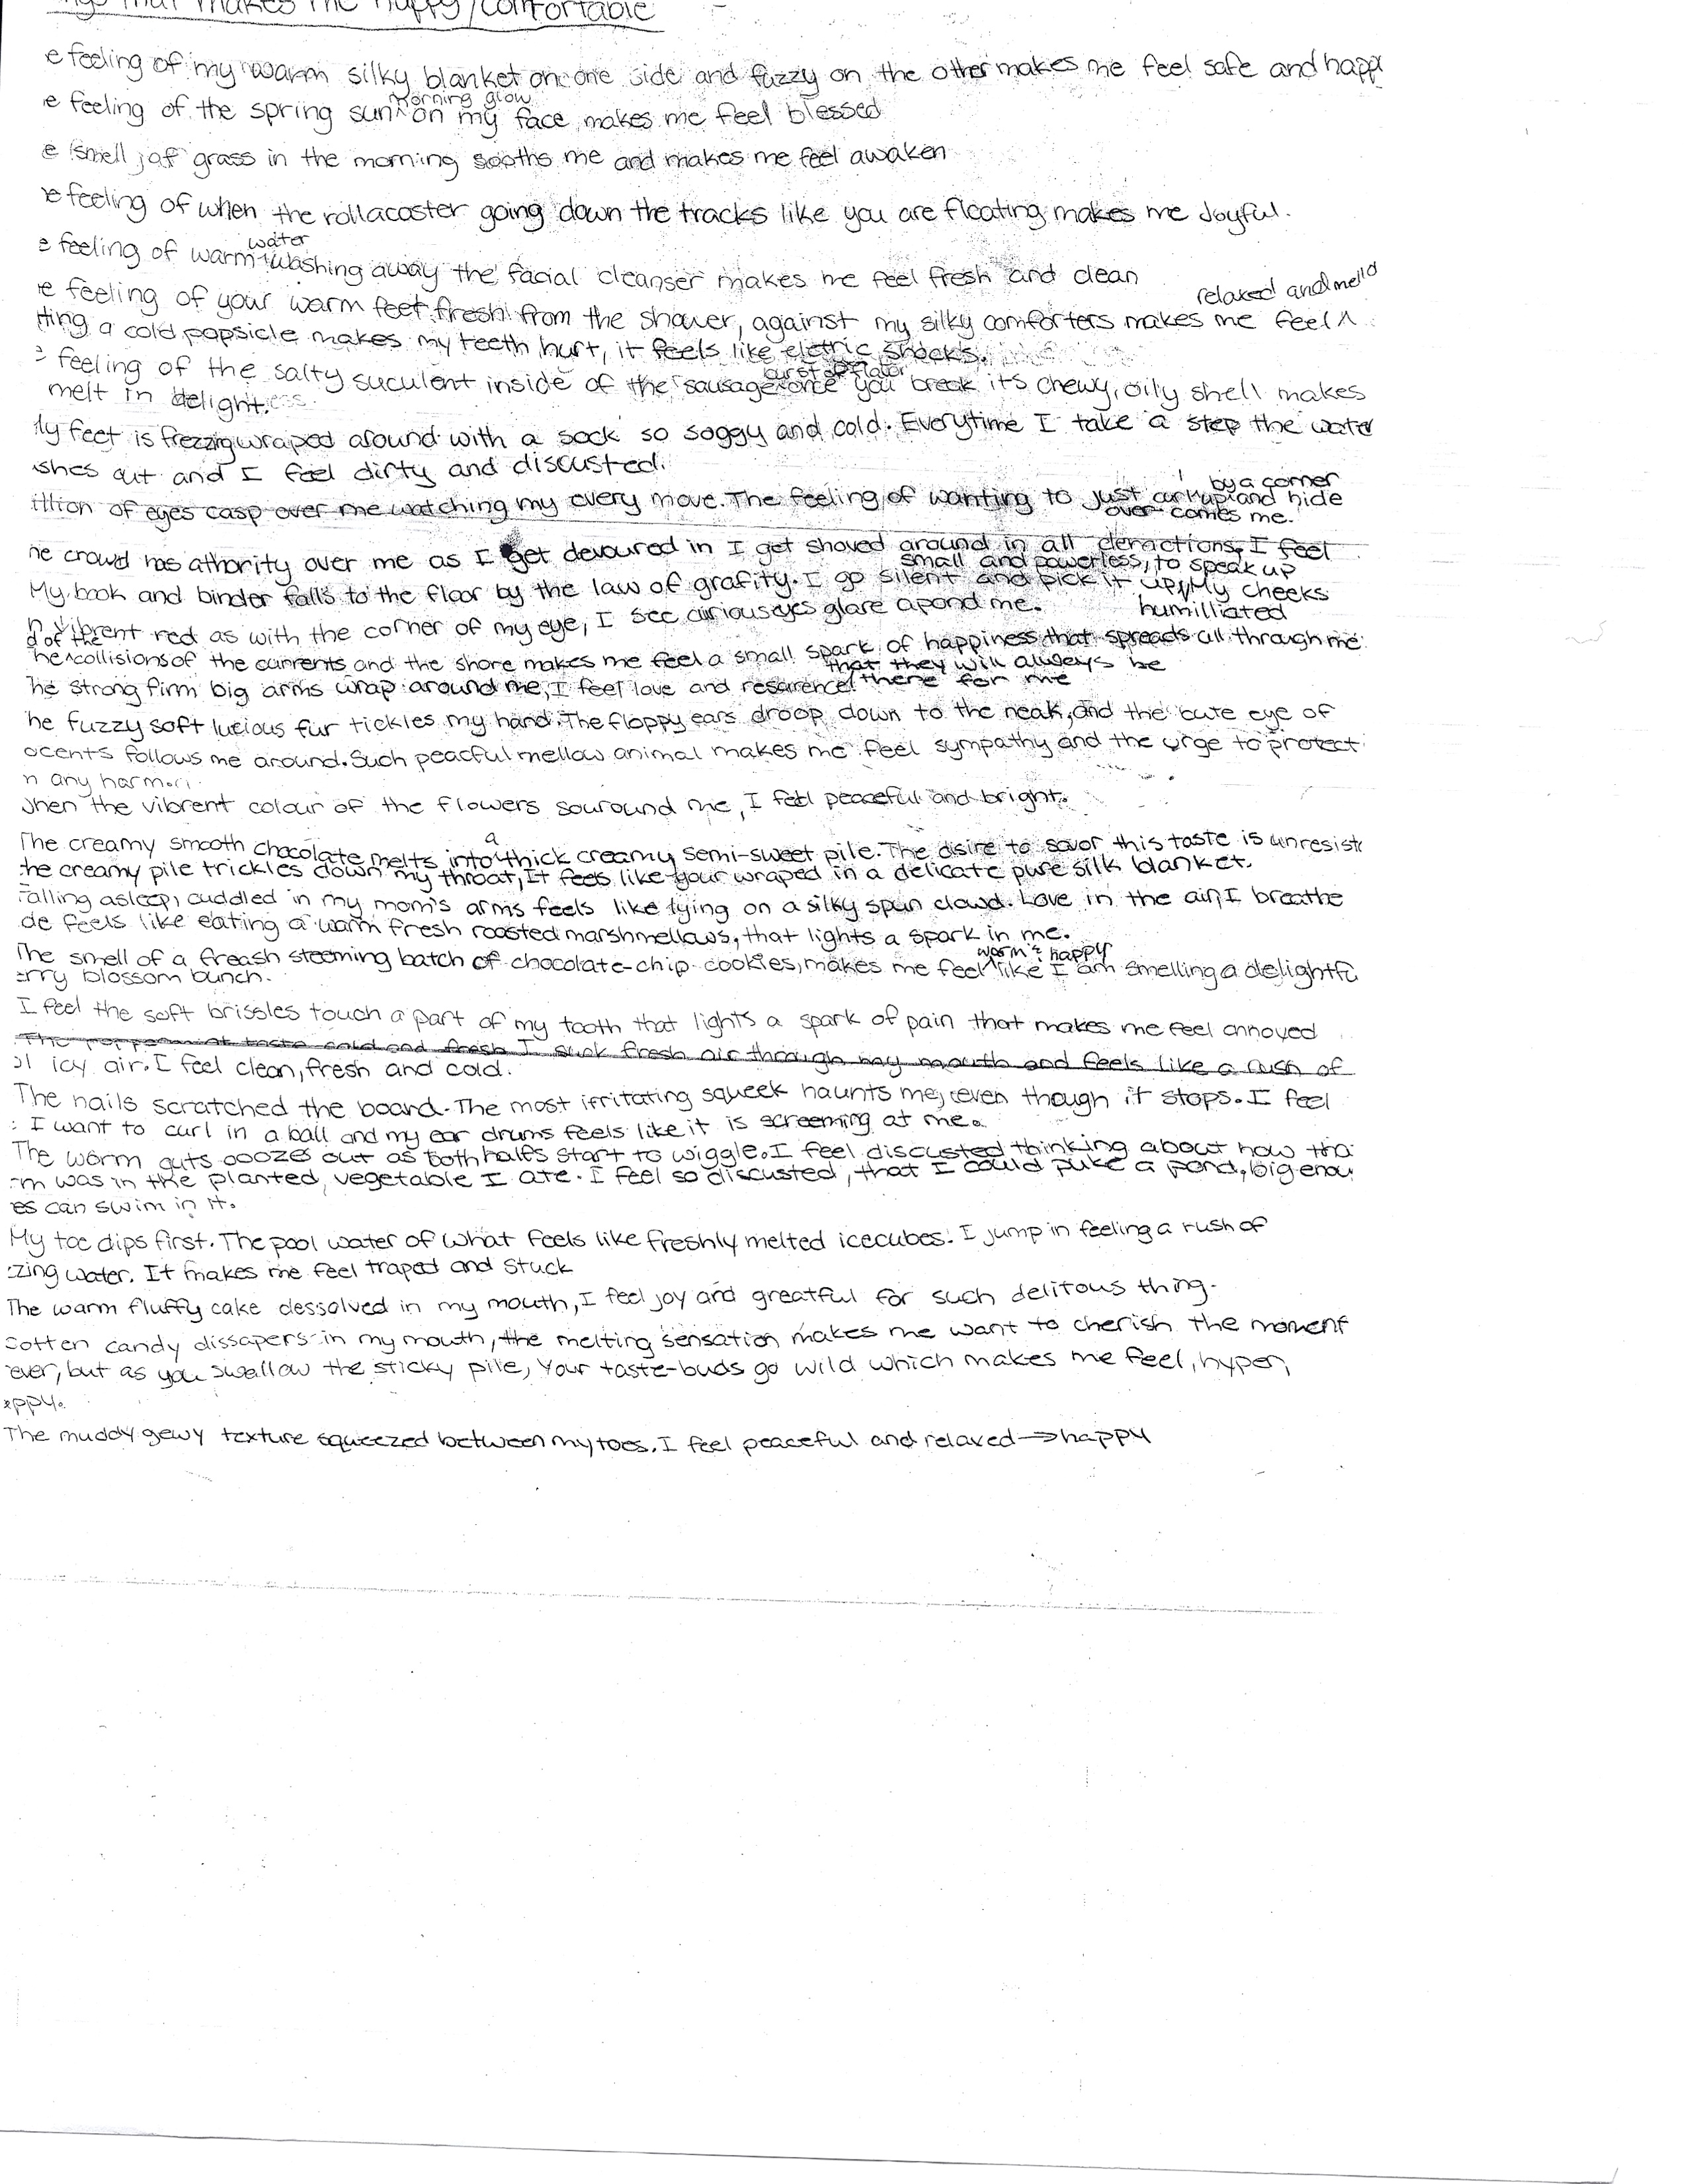
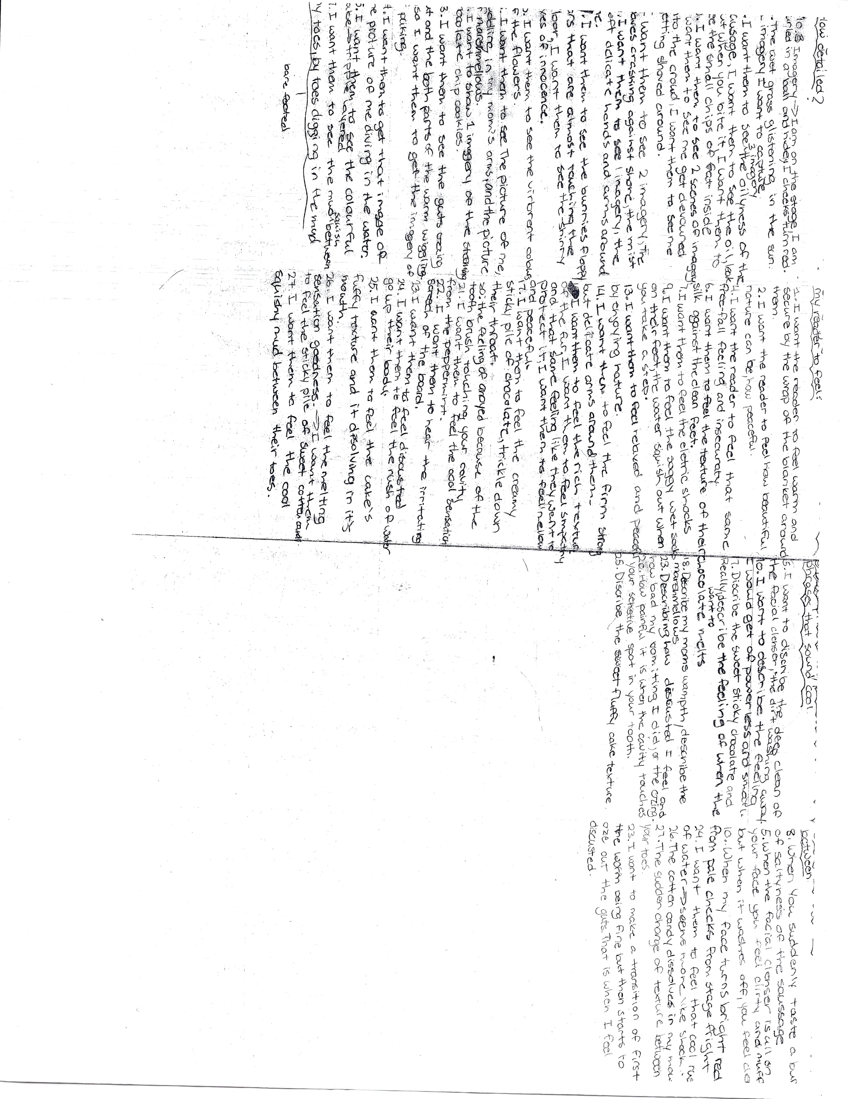
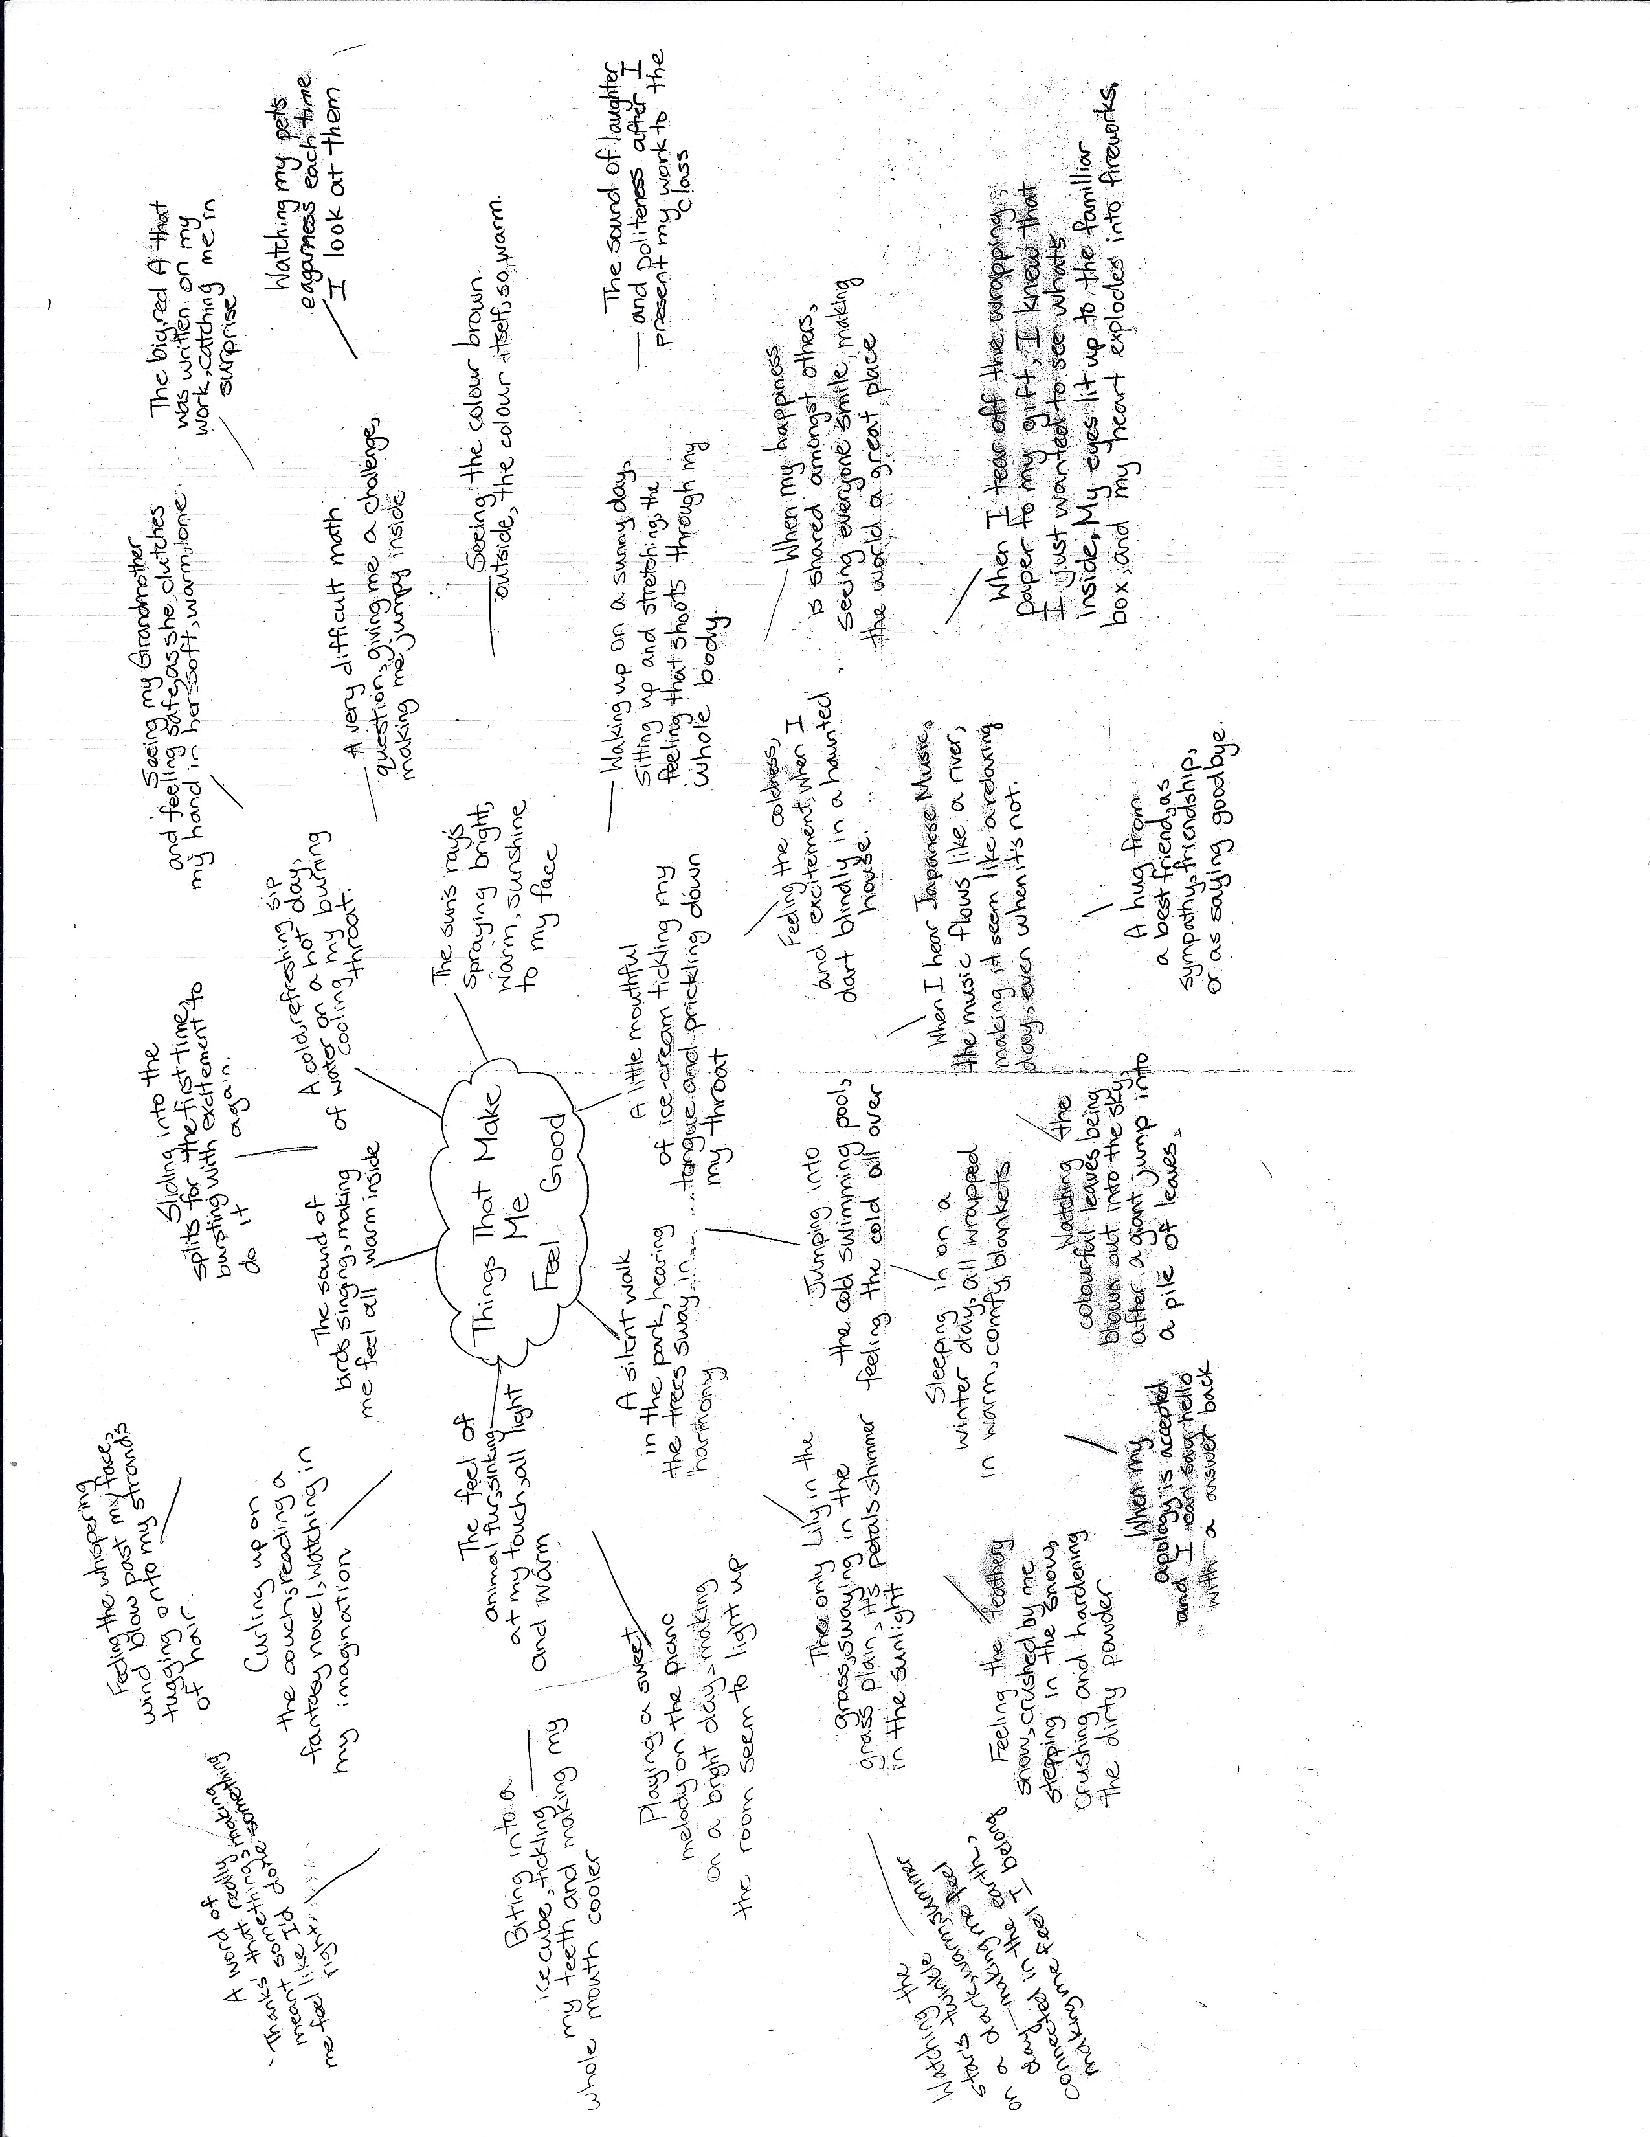
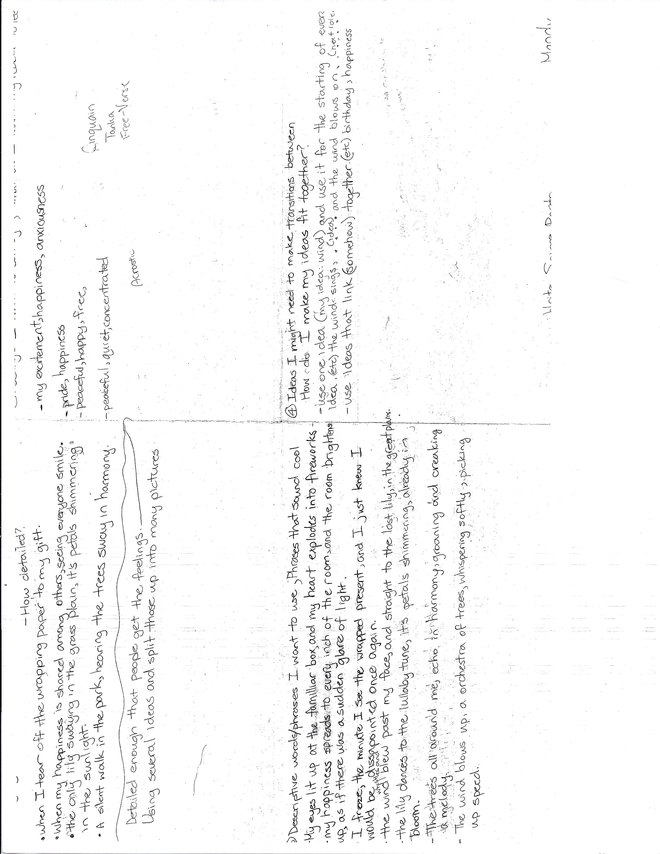
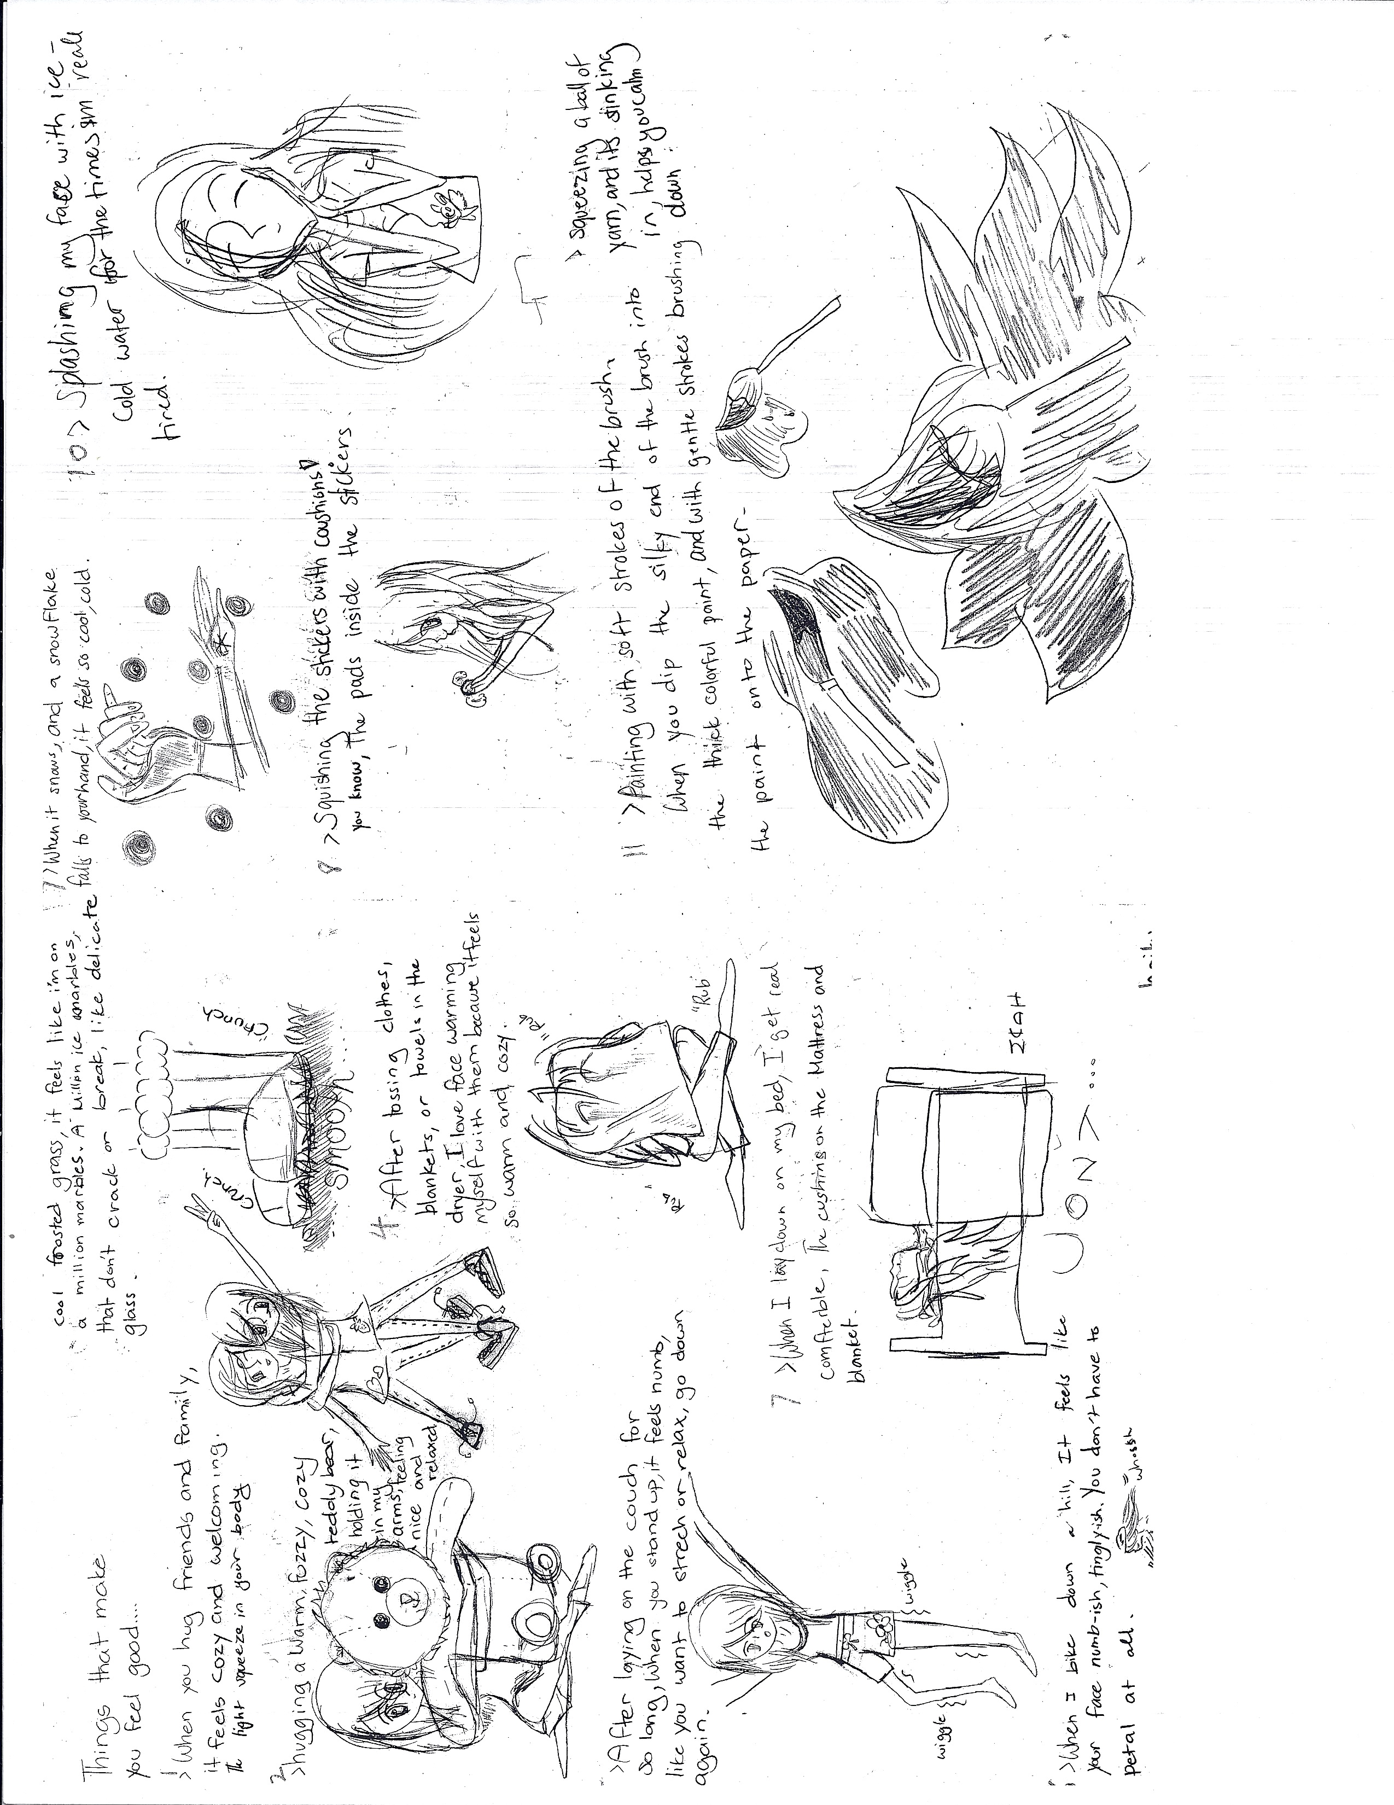
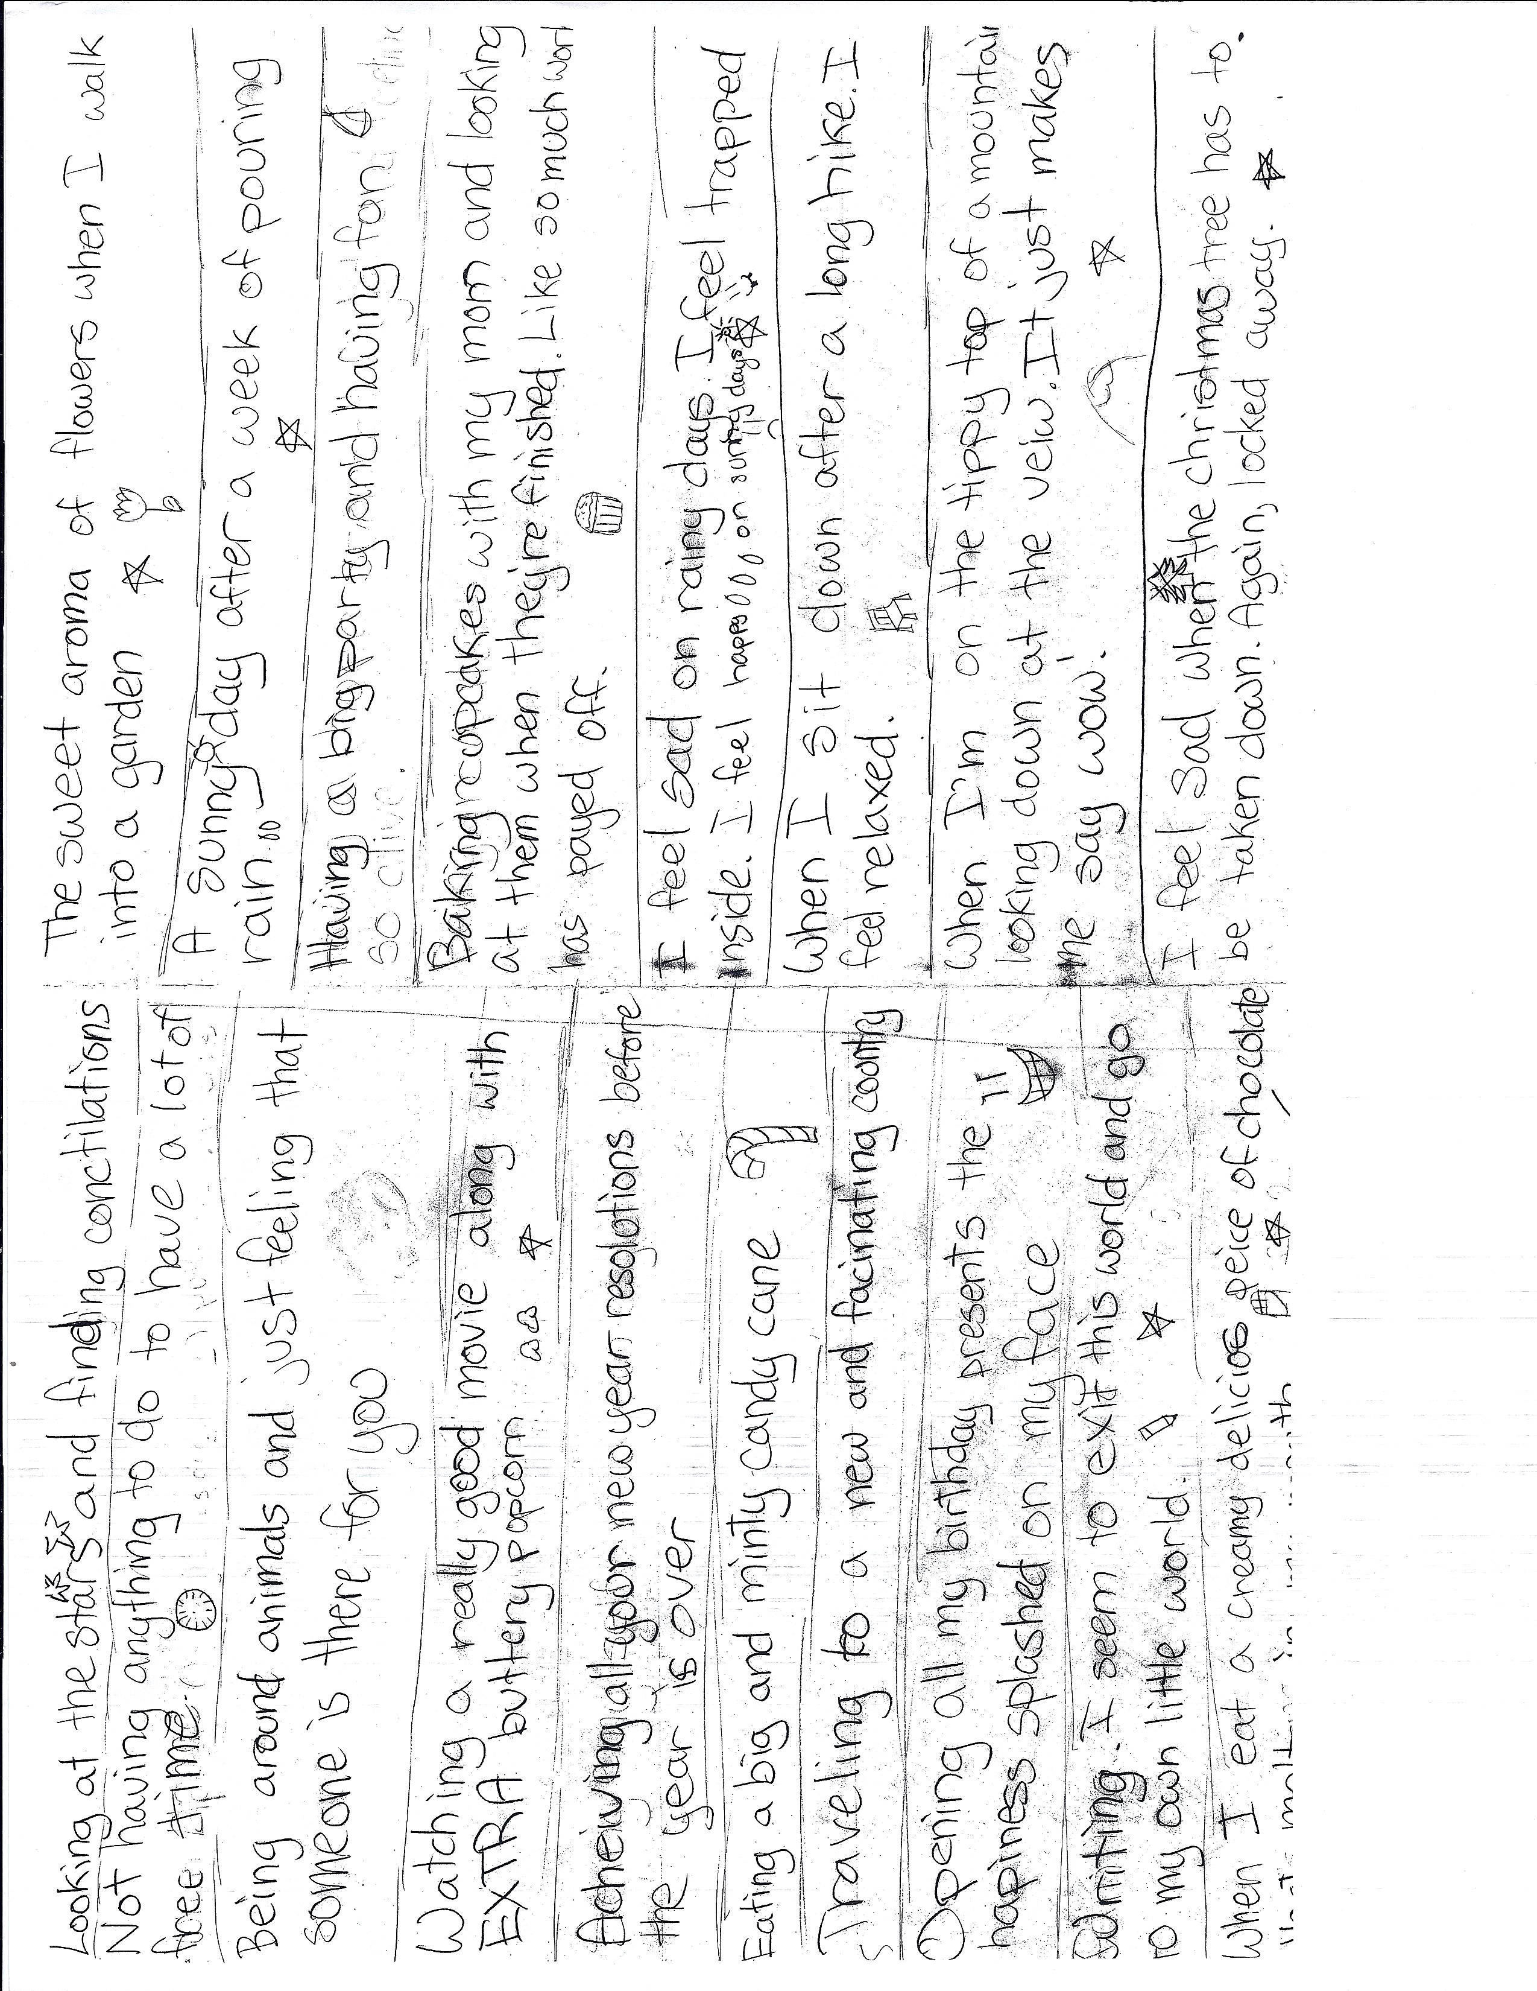
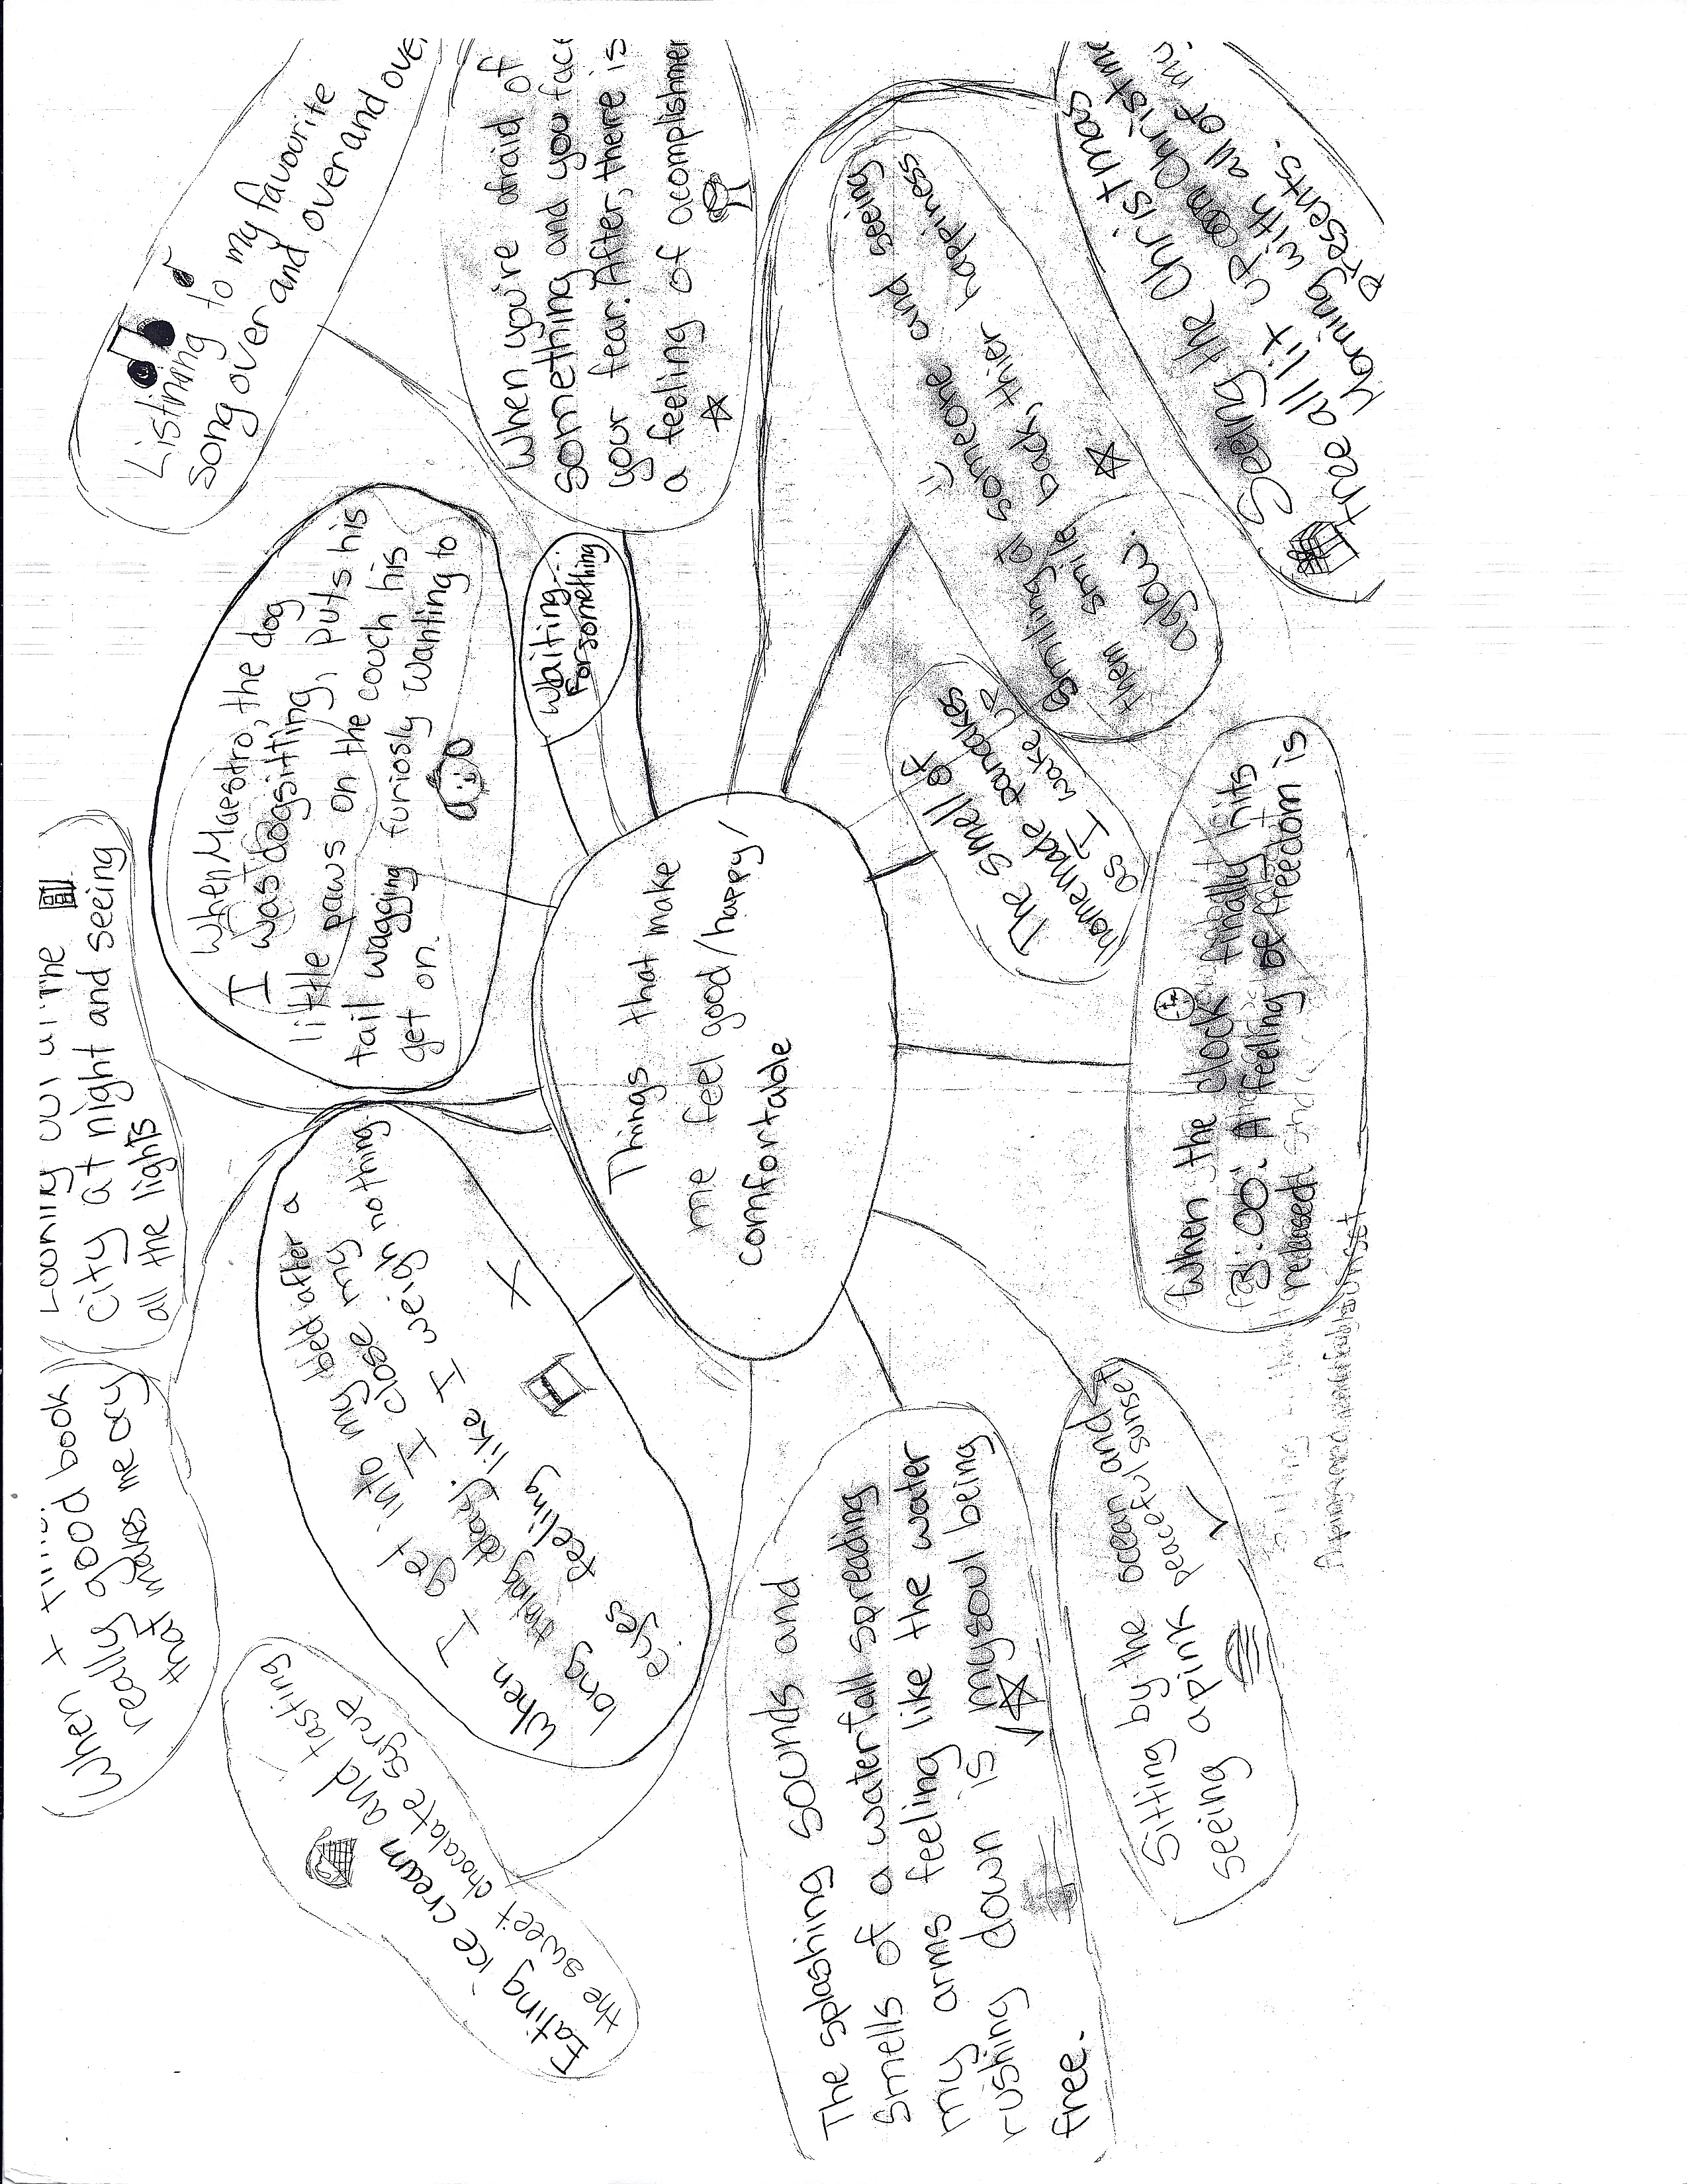
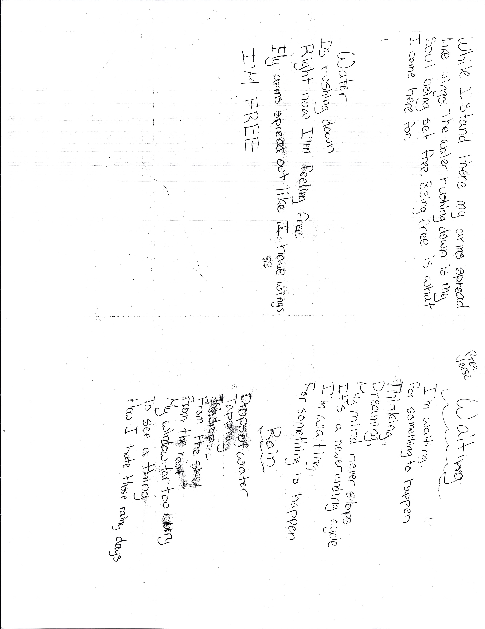
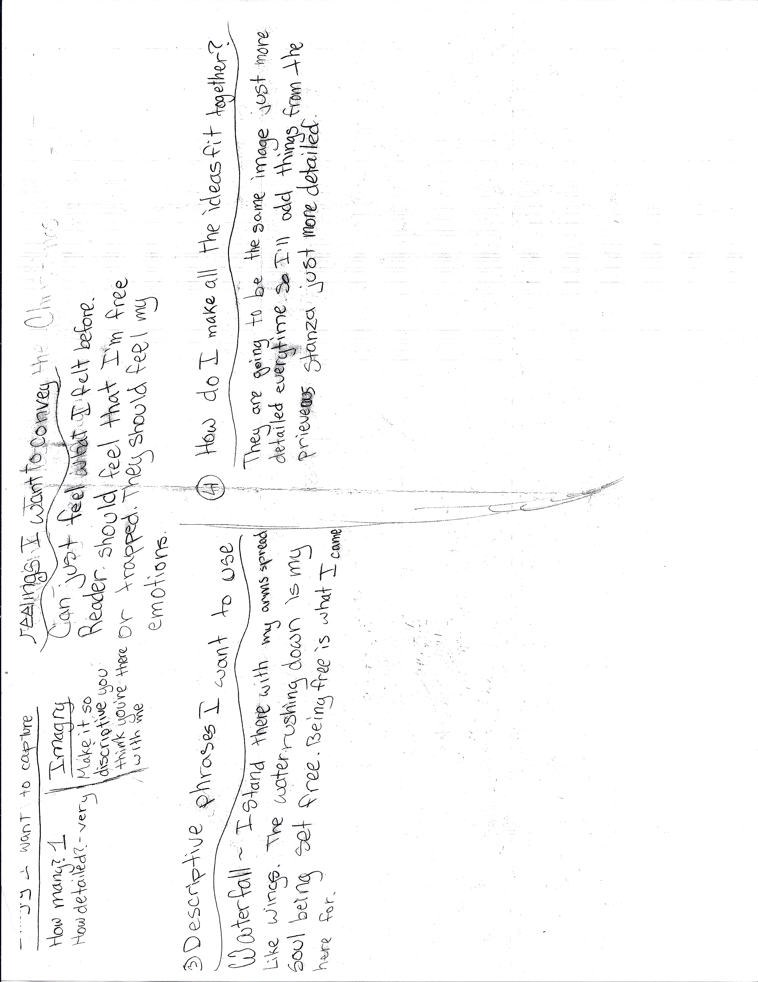

Forms of Poetry / Types of Poems:
http://www.poemofquotes.com/articles/poetry_forms.php

Ballad: http://www.ehow.com/how_2074438_write-ballad.html

Blank Verse: https://www.youngwriters.co.uk/types-blank-verse

Canzone: http://www.webexhibits.org/poetry/explore_obscure_canzone_make.html

Concrete poem: http://www.ehow.com/how_4750927_write-concrete-poem.html

Free Verse: http://www.ehow.com/how_2071669_write-free-verse.html

Haiku: https://writingcooperative.com/how-to-write-haiku-fa5fe7792661

Ode: https://penandthepad.com/write-ode-16706.html

Limerick: http://www.poetryteachers.com/poetclass/lessons/limerick.html
http://www.poetry4kids.com/blog/lessons/how-to-write-a-limerick/

Sonnet: http://www.writing-world.com/poetry/print/sonnet.shtml
http://www.ehow.com/how_3335_write-sonnet.html

Terza Rima: https://www.youngwriters.co.uk/types-terza-rima

Triolet: http://www.writing-world.com/poetry/triolet.shtml

Villanelle: http://www.writing-world.com/poetry/villanelle.shtml

How to Write an Ode

By Maria Magher
eHow Contributor
An ode is a poem written in tribute to a person, a place, a thing or even an idea. Examples include "Ode to the West Wind" by Percy Bysshe Shelley and "Ode on a Grecian Urn" by John Keats. Odes are an approachable poetic form for writers of all levels since they do not have to rhyme, nor do they have to maintain any format for meter or structure. The poem's theme is what defines it.
Choose Your Subject
- The subject of your ode can be anything, ranging from actual items to intangible ideas. One of the most famous odes is William Wordsworth’s “Ode: Intimations of Immortality from Recollections of Early Childhood.” The only criteria for your ode is that you should be commemorating or offering tribute to the subject or idea. Odes are positive, but they can also take on a more serious and dignified tone beyond simple praise. An ode is written in a single voice, typically from the perspective of the poet.

Write a Horatian Ode
- If you choose to adopt a formal structure for your ode, the Horatian ode is the easiest to write. The Horatian ode has a more reflective tone, and is written to be read rather than performed. The only rule for writing a Horatian ode is that it must have repeating stanzas. The format for those stanzas is up to you. Therefore, if you choose a rhyme scheme of abab and a meter of iambic pentameter, you must repeat that rhyme and meter in each stanza you write. You can include as many stanzas as you like, though most odes are at least four stanzas.

Write a Pindaric Ode
- The Pindaric ode is a bit more difficult to write because it has a more rigid structure. This style of ode was written to be performed -- usually sung by a chorus. A Pindaric ode begins with a strophe, a stanza with two pairs of rhyming lines. The lines do not have to be couplets, so they can have a rhyme scheme like abab or abcb. The stanza is followed by the antistrophe, which has the same meter but a different rhyme scheme. The strophe and antistrophe are known as the "turn" and "counterturn," and they are also marked by a change in tone. The Pindaric ode ends with the epode, which has a different rhyme pattern and offers a conclusion or moral.

Revise for Language
- Once you write the draft of your ode, you can revise it for language. Whether you or not you chose to adopt a formal rhyme scheme or meter, you will need to conform to the language conventions of the ode, which call for dignified language that shows admiration for the subject. Read your poem for content first, ensuring that it shows the importance of your subject, as well as your own appreciation for it. Then eliminate any casual word choice and revise for precision.

How to Write Free Verse
By Kori Morgan
eHow Contributor

Free verse poetry lacks the rhythmical regularity or consistent rhyme scheme of other poetic forms. However, in free verse, poets use elements like figurative language, diction and line breaks in fluid ways to portray the poem's theme. Through creative, strategic word selection and structure, you can create a free verse poem that will move your readers.
Create Meaningful Line Breaks
- While form-based poetry often breaks its lines according to specific syllables or rhyming words, free verse poems make use of enjambment, where a sentence continues to develop over the course of several lines rather than stopping at the end of a single line. This creates tension for readers by allowing the lines to push them through the poem, often leading to meaningful words that conclude the thought. For example, the first two sentences of Matthew Arnold's poem "Dover Beach" actually spans five lines, forcing readers to keep moving forward to get the full picture of the poem's setting. Experiment with where to end the lines of your poem to create different effects.

Use Speech and Sound Devices
- Form-oriented poetry depends on rhyme and rhythm patterns to establish the foundation of its voice. By contrast, the rhythm of free verse poetry usually comes from how the author uses everyday speech patterns and sound devices. Using repeated sounds can help create the world of the poem's subject for readers; in Walt Whitman's "After the Sea-Ship," for example, Whitman uses repeated words and frequent use of wh sounds to mimic the experience of being at sea: "After the Sea-Ship -- after the whistling winds; After the white-gray sails ...." Incorporating the rhythm of daily conversation, such as contractions and slang, into your poem can have the same effect. Langston Hughes' poems, such as "The Weary Blues," often use dialect to depict the atmosphere of his work set in Harlem.

Utilize Figurative Language
- Making use of figurative language, imagery designed to evoke the senses, can add emotional resonance and reality to your poetry. The most common types of figurative language are similes, which make a direct comparison between two different things using the words "like" or "as," and metaphors, which make the same comparisons without these words. For example, Carl Sandburg uses a metaphor in "Fog" when he writes, "The fog comes on little cat feet." While this line could still work with a simile by reading "The fog is like little cat feet," the choice of a metaphor results in a more concise, fluent image of a foggy city street. Experiment with these techniques to find surprising images for portraying your topic.

Make the Form Fit the Content
- Free verse poetry is as much about how you use the space on the page as it is the words you put on it. Pay attention to line length. Because free verse poems lack the prescribed syllable requirements of many formal styles, it's your job as the poet to use the lines in a way that visually and emotionally depicts the subject. For example, longer lines can cause readers to linger on the words and meaning being developed, while shorter lines can increase the poem's suspense and tension. You can also create a concrete poem, where the visual layout of the piece mimics the theme or subject, a technique frequently used by poet e.e. cummings, who also rarely used capital letters.

How to Write a Ballad
By Cara Batema
eHow Contributor

Ballad poems originated with the European folk tradition -- a storytelling practice in which narratives were passed down orally and the lyrics often were accompanied by music. These works were found in print starting during the Renaissance, and eventually the form evolved as a favored form in the 19th century. Ballads tend to be narrative poems that tell romantic, tragic or heroic stories.
Driving the Plot
- Ballads are usually plot driven, so before you start writing, think about an event you want to write about. This event can be a personal story or one you find from history. Samuel Taylor Coleridge’s famous ballad “Rime of the Ancient Mariner” is about a cursed sailor on a ship during a storm, while Edgar Allan Poe’s “Annabel Lee” is about a woman the speaker loves. Consider outlining your story, so you can ensure it follows a plotline that states a problem and resolves it.

Determining a Rhyme Scheme
- While ballads vary greatly in rhyme schemes and structure, they do have particular tendencies, such as using four-line stanzas called quatrains and rhyming the second and fourth lines of a stanza. One common rhyme scheme for ballads is ABCB. Poe’s “Annabel Lee” uses six-line stanzas, following a rhyme scheme of ABCBDB, and eight-line stanzas, again rhyming every other line. The last four lines of the poem, however, are two rhyming couplets, or two lines that rhyme. Poe likely used this rhyme technique to punctuate the end of the poem. You can choose to begin writing and see where you can place rhymes, or select a common rhyme scheme, like ABCB, and stick to it. Also decide whether you wish to write in quatrains or vary six- and eight-line stanzas, as Poe does in “Annabel Lee.”

Using Structure
- Since ballads originated in an oral tradition often set to music, these poems frequently use repeated lines or entire stanzas, much like a chorus to a song. “The Cruel Mother,” by an anonymous poet, repeats the lines “Fine flowers in the valley” and “And the green leaves they grow rarely” as the second and fourth lines of every stanza. Repetition conveys an important idea or theme to the reader. One other structural item to consider is the poem’s meter. In the English tradition, the first and third lines have four accented syllables, and the second and fourth lines have three stresses. If you write in iambs, which are made of one unaccented followed by an accented syllable, you would alternate lines of eight and six syllables, as found in the famous ballad “Barbara Allen.”

Pulling the Reader In
- Originally meant for audiences to hear once and remember, ballads usually use simple language. You could open your poem with a statement using the word “you” to draw the reader into the story. Since the ballad is a narrative poem, use dialogue where appropriate. When you finish a first draft, read your poem aloud to sense if it has a lilting, musical quality. Revise it as necessary to make it feel similar to a song.

How to Write a Canzone

Structural elements.
The canzone resembles a sonnet in the way it unveils its subjects, but there are several structural differences. In fact, when studying canzone through its century of popularity, early prototypes of the sonnet are evident. Certainly, the canzone led Francesco Petrarch to his creation of one of three basic sonnet forms.
While the typical sonnet is fixed at 14 lines, a canzone stanza can range from seven to 20 lines. Furthermore, a canzone runs from one to seven stanzas, and has a variety of rhyme schemes. Most canzone lines contain 10 or 11 syllables, but these too can vary. Because the canzone is not as fixed as a sonnet, it is often easier to write.

Flexible rhyming scheme.
To write a canzone, it’s helpful to work with the syllable scheme developed by Dante Alighieri in his wonderful chapbook of sonnets, ballata, and canzone, La Vita Nuova (The New Life). In "Canzone 1," he creates a 14-line, sonnet-length stanza with 10-syllable lines:
Ladies that have intelligence in love,
Of my own lady I will speak with you;
Not that I hope to count her praises through,
But telling what I may, to ease my mind.
And I declare that when I speak thereof
Love sheds such perfect sweetness over me
That if my courage failed not, certainly
To him my listeners must be all resigned.
Wherefore I will not speak in such large kind
That mine own speech should foil me, which were base;
But only will discourse of her high grace
In these poor words, the best that I can find,
With you alone, dear dames and damozels:
'Twere ill to speak thereof with any else.
Dante’s abbcdeeccffcgg rhyme scheme is rather complicated, but canzone writers never settled on a fixed rhyme scheme. You can use any rhyme scheme you’d like; for simplicity’s sake, rhyming couplets might work best. Most importantly, remember that canzone is a lyrical form; the more melodious it feels streaming from your pen, as in a song, the more authentic your presentation will be. That is why subjects such as nature, love, changing seasons, and personal portraits have historically made great canzones.

Dante’s recipe.
The beauty of this poem is that, consciously or not, Dante has crafted subliminal instructions for writing a canzone! To paraphrase him, the recipe is as follows:
First two lines: Define your subject and how you will speak with the reader.
Ladies that have intelligence in love,
Of my own lady I will speak with you;
Second two lines: Convey the central theme, question, or conflict.
Not that I hope to count her praises through,
But telling what I may, to ease my mind.
Third set of lines (broken into a quatrain): Convey your mood, sentiment, and stance.
And I declare that when I speak thereof
Love sheds such perfect sweetness over me
That if my courage failed not, certainly
To him my listeners must be all resigned.
Fourth set of lines: Elaborate on the direction of this and the following stanzas, further embedding the purpose of the poem in the reader’s mind.
Wherefore I will not speak in such large kind
That mine own speech should foil me, which were base;
But only will discourse of her high grace
In these poor words, the best that I can find,
Closing couplet: Whether you’re writing one, five, or seven stanzas, bring a close to the stanza and leave an opening for further development.
With you alone, dear dames and damozels:
'Twere ill to speak thereof with any else.
If you’re not quite prepared to work with the rigidity of the sonnet, the canzone is a flexible form that will still allow you to work a more rigid musicality of language. Try keeping your syllable counts as consistent as possible, and the end line rhymes will flow right into your reader’s ear.

Poetic Forms: The Villanelle
by Conrad Geller
One traditional form of poetry that can be fun to write, is technically easy compared to the most challenging forms, and often surprises the poet with its twists and discoveries, is the villanelle.
Villanelles have been around for at least three hundred years. Its name derives from the Italian villa, or country house, where noblemen went to refresh themselves, perhaps dally with the locals, and imagine that they were back to nature. It seems to have grown out of native songs, with their frequent refrains and complex rhyming.
The first thing you need for a villanelle is a pair of rhyming lines that are the heart of your meaning. Here are the two key lines from The House on the Hill, by E. A. Robinson:
They are all gone away
There is nothing more to say.
Now put an unrhymed line between these two, to make a three-line stanza:
They are all gone away,
The House is shut and still,
There is nothing more to say.
The next stanza begins with a line that rhymes with the basic couplet, a line that rhymes with the middle line you added, and (this is the key to this form) the first line of the couplet repeated:
Through broken walls and gray
The winds blow bleak and shrill:
They are all gone away.
The next stanza has a first line rhyming with "away" and "say," followed by a line rhyming with "still," and then the second line of the couplet repeated:
Nor is there one today
To speak them good or ill:
There is nothing more to say.
You see how the two lines of the base couplet become more and more meaningful with each repetition. That is why the success of the form depends so much on the careful selection of the couplet.
The poem then goes on this way for a total of five three-line stanzas, alternating the two base lines, and ends with a sixth stanza that adds the second line of the stanza one more time:
Why is it then we stray
Around the shrunken sill?
They are all gone away.
And our poor fancy-play
For them is wasted skill:
There is nothing more to say.
There is ruin and decay
In the House on the Hill:
They are all gone away,
There is nothing more to say.
Beautiful,as the gloomy atmosphere deepens with each repetition.
Here is another, much lighter villanelle by a more contemporary poet, Sondra Ball. Her subject is the villanelle itself, and the form is strictly adhered to, though she does allow herself some irregular rhymes:
Musical and sweet, the villanelle,
like light reflected in a gentle rhyme,
moves to the ringing of a silver bell,
its form creating soft and tender spells.
Like the singing of distant silver chimes,
musical and sweet, the villanelle
flows through the heart, and builds a magic spell
from sunlight and from shadows, and, sublime,
moves to the ringing of a silver bell.
It never arcs into the sharp loud yell
of vast pipe organs. Soft its climb.
Musical and sweet, the villanelle,
like a tiny and translucent shell
catching sunlight in the summer time,
moves to the ringing of a silver bell.
Soft and gentle, tender and so frail,
like light pouring through petals of the lime,
musical and sweet, the villanelle
moves to the ringing of a silver bell.
(reprinted by permission
Notice, too, that in this form poets can choose longer or shorter lines. Robinson's poem has three beats to a line, while Ball's has the more traditional five (ta-DUM, ta-DUM, ta-DUM, ta-DUM, ta-DUM).
This hardy and flexible poetic form has had a resurgence in the last hundred years. Probably the best of the poems produced during this time is Dylan Thomas's reflection on the death of his father, Do Not Go Gentle into That Good Night. And for good measure it's probably one of the best poems of the twentieth century of any kind, period:
Do not go gentle into that good night,
Old age should burn and rave at close of day;
Rage, rage, against the dying of the light.
Though Wise men at their end know dark is right,
Because their words had forked no lightning they
Do not go gentle into that good night.
Good men, the last wave by, crying how bright
Their frail deeds might have danced in a green bay,
Rage, rage against the dying of the light.
Wild men who caught and sang the sun in flight,
And learn, too late, they grieved it on its way,
Do not go gentle into that good night.
Grave men, near death, who see with blinding sight
Blind eyes could blaze like meteors and be gay,
Rage, rage against the dying of the light.
And you, my father, there on the sad height,
Curse, bless me now with your fierce tears, I pray.
Do not go gentle into that good night.
Rage, rage against the dying of the light.

Poetic Forms: The Triolet
by Conrad Geller

In the Golden Age of lyric poetry, about five hundred years ago, as the French Middle Ages slipped toward the Renaissance, poetic forms tended to become more and more tests of raw skill, like the NBA's Slam-Dunk Contest. A poet needed as many as thirty-six rhyme words for some of the more monstrous concoctions. Compounding the difficulties were the riddles, puns, and acrostics that were supposed to be imbedded in the verses.
Most of those poetic types are mercifully only museum pieces now, as more modern poets began to emphasize imagery and feeling over technique. But there is one of those old French forms, the oldest and simplest of them all, that deserves a look from the contemporary poet: the triolet.
Going back at least to the thirteenth century, triolets are short, usually witty poems, just perfect for tucking into a box of candy or some flowers. Its name comes from the repetition of the key line three times (French "tri"). A similar form, the rondeau, means "round poem" and also refers to the key feature of repetition (we all know, "Row, row, row your boat", which is still referred to as a "round").
Of the triolet's eight lines, the first line is used three times and the second line is repeated once. So the requirement for rhyme words is easy, and the eight lines really come down to only five different ones--easier than it seems at first. Let's look at an example (Triolets, though very popular during several periods on the Continent, have not abounded in English poetry, so my examples are coming immodestly from my own pen.):
It's best to begin a triolet with a statement or observation, something like this:
You have to write a triolet
If you would make your name immortal.
The third line rhymes with the first:
To get a form that's fit and set
Then you repeat the first line, so the first four lines are
You have to write a triolet
If you would make your name immortal.
To get a form that's fit and set;
You have to write a triolet.
Next, write another line that rhymes with the first line. Here you should change the viewpoint or add another idea:
From free verse all you ever get
(now a rhyme with the second line):
Is just another yawn or chortle.
You are finished, except for repeating the first two lines. Here is the whole simple poem:
You have to write a triolet
If you would make your name immortal.
To get a form that's fit and set.
You have to write a triolet.
From free verse all you ever get
Is just another yawn or chortle.
You have to write a triolet
If you would make your name immortal.
Here are a couple more, more conventionally on the subject of love:
I loved you, and will love again
If all the circumstance is right.
I am the faithfullest of men.
I loved you, and will love again.
Just re-create, by word or pen,
That lake, those trees, that starry night
I loved you. I will love again
If all the circumstance is right.
I feel with wonder and surprise
The hard, hard softness of your touch;
Then your bright, swift, and careful eyes
I feel with wonder and surprise.
Enough, for rage is sure to rise
If once again, and then not much,
I feel with wonder and surprise
The hard, hard softness of your touch.
Simple but elegant, isn't it? And just the thing to show the recipient of your gift or card that you cared enough to play with language just for him/her. Sure you can do it.

Poetic Forms: The Sonnet
by Conrad Geller

The sonnet is like the legendary camel which, having put its nose into the tent to keep it warm, soon makes himself at home. Originally an Italian import, it has become the most popular, almost the standard form in English, with thousands of published examples produced by practically every major and minor poet since before Shakespeare.
Everyone should write at least one sonnet in a lifetime.
Sonnets are fourteen-line poems, period. They exist in every line length, with every rhyme scheme imaginable, or with no rhyme scheme at all. The more or less standard sonnets, however, fall into two types: Italian and Shakepearean.
Of these, let's work with the more popular, more elaborate, and at least formally more difficult form. The Italian sonnet was popularized by the Italian poet Petrarch in the fourteenth century, when he wrote a whole bunch of them about his hopeless love for Laura (she seems to have been married). Hopeless lovers have imitated him ever since.
Italian, or Petrarchan, sonnets are usually written with a long line of five beats (da-DUM, da-DUM, da-DUM, da-DUM, da-DUM). They break down into one eight-line stanza, that tells an experience or expresses a thought or feeling, and a six-line stanza, that contrasts with, resolves, or comments on the first part.
The eight-line stanza, called an octave, uses two rhyme words. The first line rhymes with the fourth, fifth, and eighth lines; the second with the third, sixth, and seventh. Confused? Here is the octave of a sonnet by the best sonneteer of the twentieth century, Edna St. Vincent Millay:
What lips my lips have kissed, and where, and why,
I have forgotten, and what arms have lain
Under my head till morning; but the rain
Is full of ghosts tonight, that tap and sigh
Upon the glass and listen for reply,
And in my heart there stirs a quiet pain
For unremembered lads that not again
Will turn to me at midnight with a cry.
See? "Why" rhymes with "sigh," "reply," and "cry"; "lain" rhymes with "rain," "pain," and "gain."

So now she has expressed her feeling (Loneliness? Regret?) In the six-line finale (the sestet), she is going to make the feeling more vivid still by resorting to a comparison of her situation with that of a tree in winter which, cold and abandoned, seems to have only a faint, nonspecific sense of loss:
Thus in the winter stands the lonely tree,
Nor knows what birds have vanished one by one,
Yet knows its boughs more silent than before:
I cannot say what loves have come and gone,
I only know that summer sang in me
A little while, that in me sings no more.
Note the rhyming here is "tree" (line 1) rhyming with "me" (line 5); "one" (line 2) rhyming (imperfectly) with "gone" (line 4); and "before" (line 3) rhyming with "more" (line 6). We could represent that using the scheme abcbac. Actually, that's trickier than most sestets. The usual is either abcabc, ababab or, if the poet wants a summarizing last two lines, ababcc.
Does that seems too hard? I estimate that probably a million sonnets are written nowadays worldwide, by poets young and old, of all possible levels of skill. Why not you?
A bigger question is, why bother? Well, you can't know how satisfying, how pleasant, and even how liberating the sonnet can be until you try one. Millay, in a sonnet about writing a sonnet, puts it best, as usual:
I will put Chaos into fourteen lines
And keep him there; and let him thence escape
If he be lucky; let him twist, and ape
Flood, fire, and demon--his adroit designs
Will strain to nothing in the strict confines
Of this sweet Order, where, in pious rape,
I hold his essence and amorphous shape,
Till he with Order mingles and combines.
Past are the hours, the years, or our duress,
His arrogance, our awful servitude:
I have him. He is nothing more than less
Than something simple not yet understood;
I shall not even force him to confess;
Or answer. I will only make him good.

How to Write a Sonnet
By Cara Batema
eHow Contributor

Choosing a Form
- Since the sonnet is a relatively strict type of poem to write, you should first decide what kind of sonnet you want to write. The Petrarchan sonnet follows a rhyme scheme of ABBAABBA -- where all "A" lines and all "B" lines rhyme with each other -- for the octave and CDECDE or CDCDCD for the sestet, where matching letters stand for rhymes at the last word in each line. A Shakespearean sonnet uses the rhyme scheme ABAB CDCD EFEF GG. The Spenserian sonnet uses quatrains and a couplet, but it follows the scheme ABAB BCBC CDCD EE. You can even choose to make up your own rhyme scheme while maintaining a 14-line poem.

Getting the Idea
- Consider the subject matter of your poem and stick to one concept. Many traditional sonnets are about love and nature; you can follow this traditional approach or write about any idea you have. Sonnets also tend to state a problem, question, argument or observation, and the latter half or end of the poem brings clarification or a counterargument to the initial statement.

Writing Iambic Pentameter
- Using iambic pentameter without it sounding forced can be difficult. Read some sonnets first to get an idea of the meter and the musical nature of the rhythm. To start, write what comes out naturally, focusing on the rhyme scheme. Edit the lines later to put them in iambic pentameter. Consider monosyllabic words, which can be accented or unaccented, depending on their position in the phrase. You can break the meter, but meter breaks should relate to some important event or idea in the sonnet; this technique gives attention to that point in the sonnet.

Focusing on the Turn
- The most important part of a sonnet is the turn, or volta. The turn answers the question, provides a counterargument, summarizes the rest of the poem or brings a surprise or clarification to the poem's opening idea. In Shakespeare’s sonnet “My Mistress’ Eyes,” the first 12 lines express how the speaker’s mistress does not look like the beautiful images he describes, but the final two lines admit his love is rare and incomparable. The Shakespearean sonnet places the turn in the final couplet, while the Petrarchan sonnet puts it around lines eight or nine, near the start of the sestet. Analyze some sonnets to get an idea of where to place the turn.

Revising Your Work
- Even if you work with the structure on your first draft, revision is key to making your poem the best it can be. Read the poem aloud and focus on the rhythm and meter. Fix any places that aren’t in iambic pentameter. Find lines that could use enjambment -- a technique that carries the phrase to the next line to avoid all end-stopped lines. Check your work for concrete imagery, and avoid generalizations or overly abstract thoughts.

Welcome to Young Writers' free Poetry Glossary

What is a Terza Rima Poem?
A terza rima is an Italian form of poetry first used by Dante Alighieri.
A terza rima consists of stanzas of three lines (or tercets) usually in iambic pentameter. It follows an interlocking rhyming scheme, or chain rhyme. This is where the middle of each stanza rhymes with the first and last line of the following stanza. There is no set length to this form, as long as it follows the pattern as follows:
ABA
BCB
CDC
DED
With the last stanza as a couplet rhyming with the middle line of the previous stanza. In this case, EE.

An example of a Terza Rima Poem
Spring
(A) New life begins to spring to life in spring
(B) Green shoots appear in the April showers
(A) Birds migrate back home and rest tired wings
(B) Summer brings green fields full of bright flowers
(C) Paddling pools and ice creams all around
(B) The sun shines fiercely with all its powers
(C) Autumn sends leaves tumbling to the ground
(D) The sun sinks lower leaving longer nights
(C) Conkers and acorns waiting to be found
(D) Winter is a time for Halloween frights
(E) Snow on the ground and Jack Frost's ache
(D) Celebrations filled with festive delights
(E) As winter ends the new year starts to make
(E) New life begins to spring to life and awake.

Welcome to Young Writers' free Poetry Glossary

What is a Kyrielle Poem?

A Kyrielle poem is structured so that all the lines have eight syllables and each stanza of four lines ends in a refrain. It takes on a rhythmical form very much like a rhyming couplet.

What is the structure of a Kyrielle Poem?
A Kyrielle poem is made up of 4 lined stanzas of eight syllables each. The capital being the refrain:
aabB
ccbB
ddbB
eebB

An example of a Kyrielle Poem
Pollution
Pollution rising in the sky, | a8
People wear masks as they walk by, | a8
It's about time to turn the bend, | b8
For all this pollution to end.. | B8
Animals are losing their homes, | c8
To make way for buildings with domes, | c8
What message do we have to send, | b8
For all this pollution to end. | B8
We're all guilty we must confess, | d8
Guilty of making such a mess, | d8
It's time for action, find a friend, | b8
For all this pollution to end. | B8
If we don't act the world won't last, | e8
Breathing fresh air will have long passed, | e8
This is the message that I send, | b8
For all this pollution to end. | B8

Welcome to Young Writers' free Poetry Glossary

What is a Blank Verse Poem?
A blank verse is a poem with no rhyme but does have iambic pentameter. This means it consists of lines of five feet, each foot being iambic, meaning two syllables long, one unstressed followed by a stressed syllable.

The Structure of a Blank Verse Poem
Five feet of iambic syllables -
Sounding du DUM du DUM du DUM du DUM du DUM
Each foot making the verse sound like it has heart beat rhythm.
Each line has a set number of syllables see below:

An Example of a Blank Verse Poem
Furball Friend
Sweet pet by day, hunter by night. She sleeps,
she eats, she plays. My feet, caught in white paws.
She’s up the fence, watching her prey - a bird.
Poor thing, better run quick, ’cause watch, she’ll pounce!
She’ll sweetly beg for fuss, but don’t be fooled.
’Cause one minute she’ll purr and smile, then snap!
She’ll spit and hiss - and oh - surprise! A mouse.
He’s dead. A gift. Retracts her claws. Miaow!
Figure of eight between my legs, looks up
at me and purrs. The sound pulls my heartstrings.
Her big blue eyes like dinner plates - so cute.
Cunning she is, she knows I can’t resist.
Curling up tight, we sleep entwined as one.
Despite her quirks, I would not change a claw
of her. Cheeky Sammy: my snow-white queen.

How to Write a Limerick
by Bruce Lansky
To help your students get started, here's some helpful information about writing limericks. To begin, a limerick is a funny little poem containing five lines. The last words of the first, second, and fifth lines rhyme with each other (A), and the last words of the third and fourth lines rhyme with each other (B). Here's an example:
There was an old man from Peru, (A)
da DUM da da DUM da da DUM
who dreamed he was eating his shoe. (A)
da DUM da da DUM da da DUM
He awoke in the night (B)
da DUM da da DUM
with a terrible fright, (B)
da da DUM da da DUM
and found out that it was quite true. (A)
da DUM da da DUM da da DUM
When your students write a limerick, make sure that it has the same AABBA rhyme pattern. And make sure it also has the same Da DUM da da DUM da da DUM rhythm pattern. To make sure, recite your student's limerick, substituting "da" for all unaccented or unstressed syllables and "DUM" for all the accented or stressed syllables, as I have done above. If your students' poems don't have a similar rhythm pattern, then they will need to be adjusted.
Ideas for new limericks can come from almost anywhere. For example, your students could write about their city, state, country, or name. If one of your students is named Tim or Jim, he could write something like this:
A Clumsy Young Fellow Named Tim
A clumsy young fellow named Tim (A)
was never informed how to swim. (A)
He fell off a dock (B)
and sunk like a rock. (B)
And that was the end of him. (A)
Notice that the rhyme pattern (AABBA) and the rhythm pattern (da DUM da da DUM da da DUM) are identical to the patterns in the "Man From Peru" limerick.

How to Write a Limerick

What is a Limerick?
Limericks are one of the most fun and well-known poetic forms. No one knows for sure where the name “limerick” comes from, but most people assume it is related to the county of Limerick, in Ireland.
The reason limericks are so much fun is because they are short, rhyming, funny, and have a bouncy rhythm that makes them easy to memorize. In this lesson, I’ll show you how you can write your own limericks in just a few easy steps.

The Rules of Limericks
Limericks, like all poetic forms, have a set of rules that you need to follow. The rules for a limerick are fairly simple:
- They are five lines long.
- Lines 1, 2, and 5 rhyme with one another.
- Lines 3 and 4 rhyme with each other.
- They have a distinctive rhythm (which I’ll explain shortly)
- They are usually funny.

Rhyming a Limerick
The rhyme scheme of a limerick is known as “AABBA.” This is because the last words in lines 1, 2, and 5 rhyme. Those are the “A’s” in the rhyme scheme. The “B’s” are the last words of lines 3 and 4. Let me give you an example:
There was a young fellow named Hall
Who fell in the spring in the fall.
‘Twould have been a sad thing
Had he died in the spring,
But he didn’t—he died in the fall.
— Anonymous
Notice that the words, “Hall,” “fall,” and “fall” all rhyme. Those are the “A” words in the “AABBA” rhyme scheme. Also notice that “thing” and “spring” rhyme. Those are the “B” words in the rhyme scheme.

Limerick Rhythm
Now let’s take a look at the rhythm of the limerick. It goes by the complicated name “anapaestic,” but you don’t need to worry about that. What I want you to notice when you read or recite a limerick is that the first two lines and the last line have three “beats” in them, while the third and fourth lines have two “beats.” In other words, the rhythm of a limerick looks like this:
da DUM da da DUM da da DUM
da DUM da da DUM da da DUM
da DUM da da DUM
da DUM da da DUM
da DUM da da DUM da da DUM
The rhythm doesn’t have to exactly match this, but it needs to be close enough that it sounds the same when you read it. For example, using the limerick above about the fellow from Hall, if we emphasize the beats, it reads like this:
there WAS a young FELLow named HALL
who FELL in the SPRING in the FALL.
‘twould have BEEN a sad THING
had he DIED in the SPRING,
but he DIDn’t—he DIED in the FALL.
Let’s take a look at another famous limerick:
There was an old man of Nantucket
Who kept all his cash in a bucket;
But his daughter, named Nan,
Ran away with a man,
And as for the bucket, Nantucket.
— Anonymous
If you emphasize the beats when you read it, it comes out like this:
there WAS an old MAN of NanTUCKet
who KEPT all his CASH in a BUCKet;
but his DAUGHTer, named NAN,
ran aWAY with a MAN,
and AS for the BUCKet, NanTUCKet.

Some Limerick Tricks
There are two more things that you will notice when you read limericks:
- The first line usually ends with a person’s first name or the name of a place.
- The last line is usually funny.
Because the first line is usually the name of a person or place, writing the first line is the easiest part. You simply pick the name of a place or person – like “New York” or “Dave” – and write a line like this:
There once was a man from New York
Or
There was an old woman named Dave
Then go to your rhyming dictionary and start looking for rhymes like “cork,” “fork,” “pork,” “stork,” or “cave,” “gave,” “wave,” and so on to find more words to complete your limerick.
Once you’ve found some rhyming words, you’ll want to start thinking about a funny ending for your poem. I find it’s easiest to write lines 1, 2, and 5 first, and then to fill in lines 3 and 4 afterward. For example, I decided to write a limerick about someone from Seattle, so I started it like this:
A talkative man from Seattle
would spend his days speaking to cattle.
I then noticed that the word “prattle” rhymed with “cattle” and “Seattle” so I wrote the last line, like this:
She said, “Why it’s nothing but prattle!”
Finally, I went back and wrote lines 3 and 4 to complete the limerick:
A talkative man from Seattle
would spend his days speaking to cattle.
When asked what he said,
one old cow shook her head,
and replied, “Why it’s nothing but prattle!”
You’ll notice that I changed the last line after I wrote lines 3 and 4. I did this so the poem would make more sense. It’s okay to change your words at any time if it improves the poem.

Your Turn
Now it’s your turn to see if you can write a limerick of your own. Remember to follow these steps:
- Choose the name of a person or place and write the first line.
- Look in a rhyming dictionary for words that rhyme with your person or place name.
- Write line 2 and 5 to rhyme with the first line.
- Now write lines 3 and 4 with a different rhyme.
When you are done writing, read your limerick out loud to see if it has the right rhythm; three “beats” on lines 1, 2, and 5, and two “beats” on lines 3 and 4, as shown above. If not, see if you can rewrite some words to get the rhythm right.

Jack Y’s Poetry Portfolio
My Theme: Baseball

Untitled 1
[Limerick]
The ball hits the glove with a smack,
I savour the crack of the bat,
It’s a wonderful day,
To play this great game,
So all don your glove and your cap!

Baseball
[Free Verse]

A whiff of fresh trimmed grass,
Planting a spark of life in the
Deepest corners of my once inert body,
Causing a surge of undeniable urge,
To spread throughout me.
An urge to feel the soft, smooth leather
And the perfect seams, to grip the long
Aluminum shaft and stick my
Fingers into the almost forgotten cavernous
Holes of my baseball glove.
The urge to hear the booming
Yell of the umpire as he delivers
His unwavering call, and to
Savour the screams and cheers
Of the fans as they propel your team,
To a joyous victory.
The urge to run my fingers across the
Sand as I slide safely into home,
To hear the satisfying smack of a hard
Throw hitting its mark and burrowing
into
An open glove.
The urge,
To play ball.

The Hit
[Haiku]
The crack of the bat
Ringing out over the field
Peace, in its own way.

Untitled 2
[Triolet]

Oh baseball, what a wonderful game,
Bats balls and gloves can lead to such fun,
A possible road to fortune and fame,
Oh baseball, what a wonderful game,
Once you’ve started you won’t want to be done,
Oh baseball, what a wonderful game,
Bats balls and gloves can lead to such fun.

The at bat.
[Free Verse]

I slide my hand, slick with sweat,
Into the batting glove.
Stretching it over my hand,
Wiggling my fingers once, testing dexterity,
Before pulling the strap tight,
Sealing it with the familiar crunch,
Of worn Velcro.
Inhaling silently, I grab my helmet off the bench,
Clutching it momentarily in a trusting embrace.
Encasing my head in its protective shell.
Finally, I step out of the dugout,
Sweat forming on my lip,
As I once again relish the friendly rays,
Of the midday sun.
I clamp my hands around the handle of the bat,
Caressing the smooth metal,
Feeling power surge throughout my body,
As I take a practice swing.
As much as for fun, as for practice.
A spirited yell from the dugout arouses my senses,
Causing me to turn a deep, violent shade of crimson.
I return to the dugout,
A cloud of embarrassment hanging over me.
It wasn’t my turn to bat.

Untitled 4
[Pantoun]

I sit in the car, restless in wait,
It’s almost time for the game to begin,
Adrenalin’s pumping, my body feels great,
If lucks on our side, I’m sure we will win.

It’s almost time for the game to begin,
I grab my glove and run onto the field,
If lucks on our side, I’m sure we will win,
My thirst for victory is pure and quite real.

I grab my glove and run onto the field,
The ball races towards me with breathtaking speed,
My thirst for victory is pure and quite real,
Out after out, I help my team.

The ball races towards me with breathtaking speed,
Finding a home in my outstretched glove,
Out after out, I help my team,
I want to keep going, I can’t get enough.

Finding a home in my outstretched glove,
I make the last out, it’s time to go bat,
I want to keep going, I can’t get enough,
I step into the box and pull my bat back.

I make the last out and it’s time to go bat,
The ump yells ‘Play Ball!’ and the game can commence,
I step into the box and pull my bat back,
I swing, SMASH! the ball’s over the fence.

The ump yells ‘Play Ball!’ and the game can commence,
I sit in the car, restless in wait,
I swing, SMASH! The ball’s over the fence,
Adrenalin’s pumping, my body feels great.

ss

Untitled 3
[Free Verse]

The sun beats down,
Warmth.
Grip the bat tightly,
Reassurance.
Step into the batter’s box, stare the pitcher down,
Confidence.
Squint into the sun as the pitcher winds up,
Ready.
Eye on the ball,
Anticipate.
Swing with all my might,
Miss.
Shaking my head,
Anxious.
Back in the batter’s box,
Wary.
Pitch comes in,
Anticipate.
Swing,
Listen,
‘Crack!’
Run,
Slide,
Safe,
Stand up, hear the crowd roar,
Joy,
Happiness,
Baseball.
Stealing
[Sonnet]

I look over at coach and take the sign.
The steal is on I nod and take my lead.
To reach the next base I will need great speed.
I wait patiently for the perfect time.
To race off down the line, faster than light.
My wait is done; it’s time for me to leave.
I sprint away so fast I can’t be seen.
I slide, the ump yells safe, the base is mine.
A swelling pride expands inside my soul.
A triumph only I can understand.
For now that I have finally left my mark.
Upon the dusty line on which I ran.
I feel that I have now obtained control.
Over the perfect field, the trees, the park.

BASEBALL
[Acrostic]

Blue skies, light breezes, a cheerful sun.
All are quite happy, it’s peaceful today.
Soon the fields are alive with activity.
Everyone’s there, for baseball.
Bats, gloves, jerseys and hats lay in wait.
A cloud of fierce competition hangs over the emerald green grass and masterfully raked dirt.
Losses are forgotten, until the final inning has been played.
Love of the game, which shall never fade.

Ode to Baseball
[Ode]

Baseball.
If ever a game,
Was to be played,
Upon the fields of heaven,
Or another, godly place.
It would be that.
For no other contest,
Of knowledge, skill, and effort,
Is closer to goodliness,
Than the game of the bats and the balls.
Of gloves and caps,
Of helmets and jerseys,
Of stadiums and fields,
Of roaring crowds that fill the air
With their jubilant screams
Of motivation
And undeniable excitement.
One can only muse,
And ponder,
And think,
And question,
And hope,
And sit,
Among the throngs of people,
All forcing their way into the gleaming, majestic, glorious
Stadium.
Settling into the hard plastic seats,
Allowing their eyes,
To gaze in wonderment over the shimmering interior,
Of the ballplayers’ fortress.
Inhaling the bitter scent of fresh cut grass
Mingling with the savoury aroma of hot dogs,
Spitting grease and sizzling invitingly
On the grill.
Tasting the sickly sweet fibers of the brightly coloured
Cotton candy,
Sold by the vendors dressed in neon yellow,
As they circulate throughout the crowd.

But beyond the food,
Beyond the pristine field,
Beyond the lights that seem to bathe the entire world
In a blanket of silvery-white,
There are the players,
And the coaches,
The trainers,
Managers,
Umpires,
Cause what is a team without a manager?
A player without a coach?
A Game without officials?
Yes, baseball,
The perfect blend of;
Fun and serious competition,
Of rules and freedom,
Of spectators and players.
But baseball cannot be defined simply by those who partake in it.
Or the things they experience
Everything.

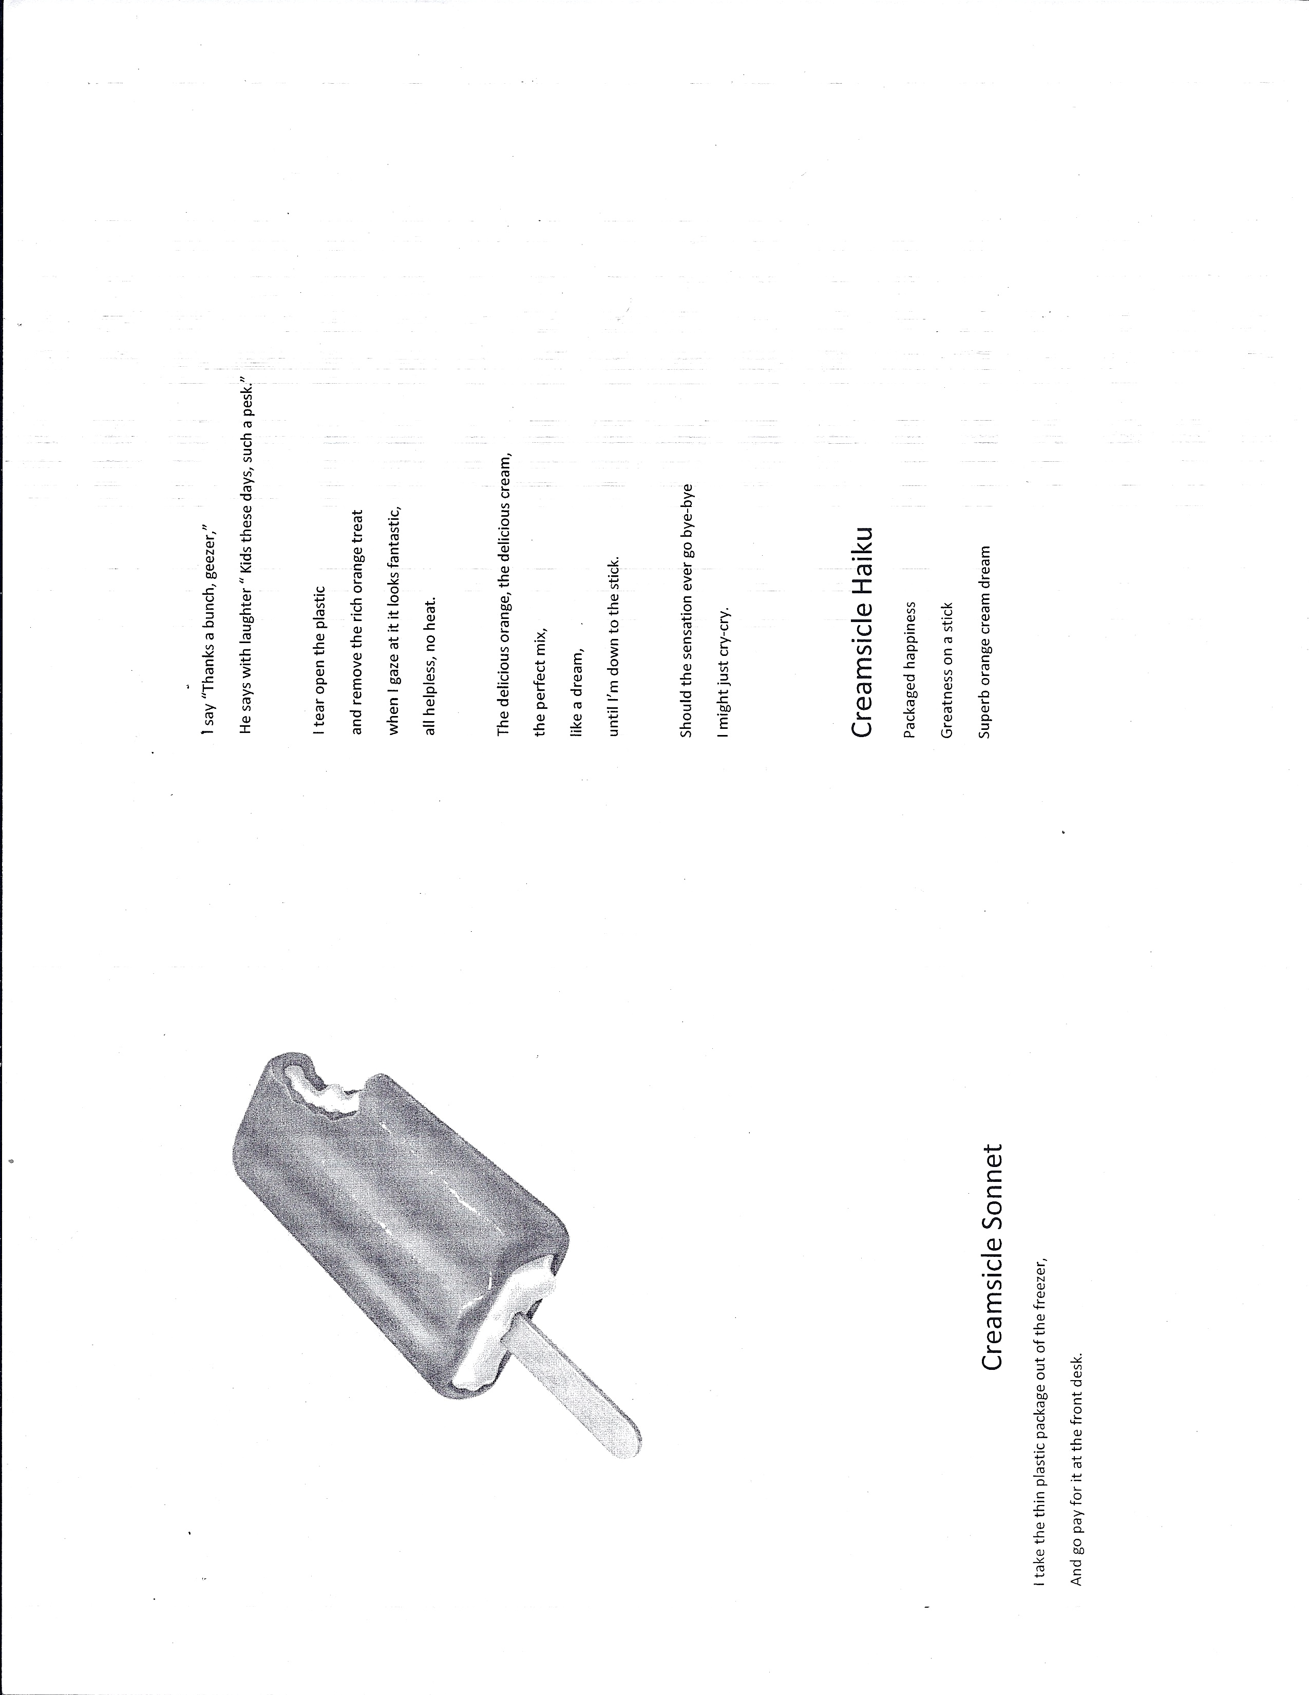
Everyone Loves to Play Baseball
(Kyrielle)

Coaches and players, all rejoice,
Not playing is an awful choice.
Hats, helmets gloves bats and a ball,
Everyone loves to play baseball.

No better way, to spend your day,
Than in the sun, playing this game.
If you join you will be enthralled,
Everyone loves to play baseball.

Ballpark’s alive with joyous fun,
You’ll be quite sad, once it is done.
Skinny and fat, the short and the tall,
Everyone loves to play baseball.

The blazing sun, the crystal sky,
Friends, family, enemies alike.
It’s fun for all, come one come all,
Everyone loves to play baseball.
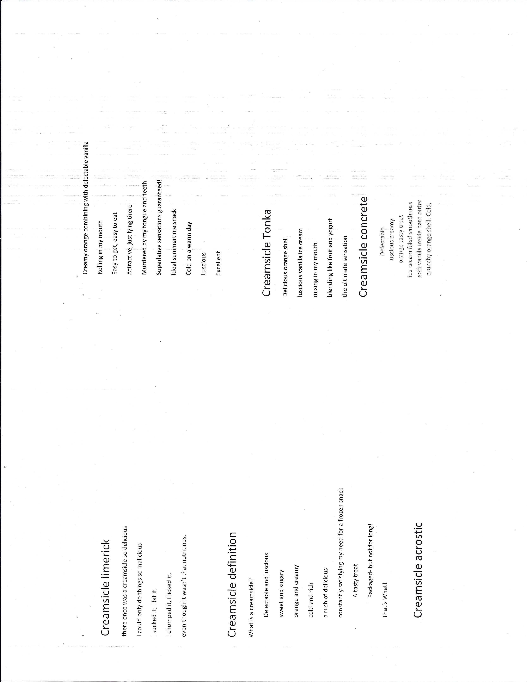
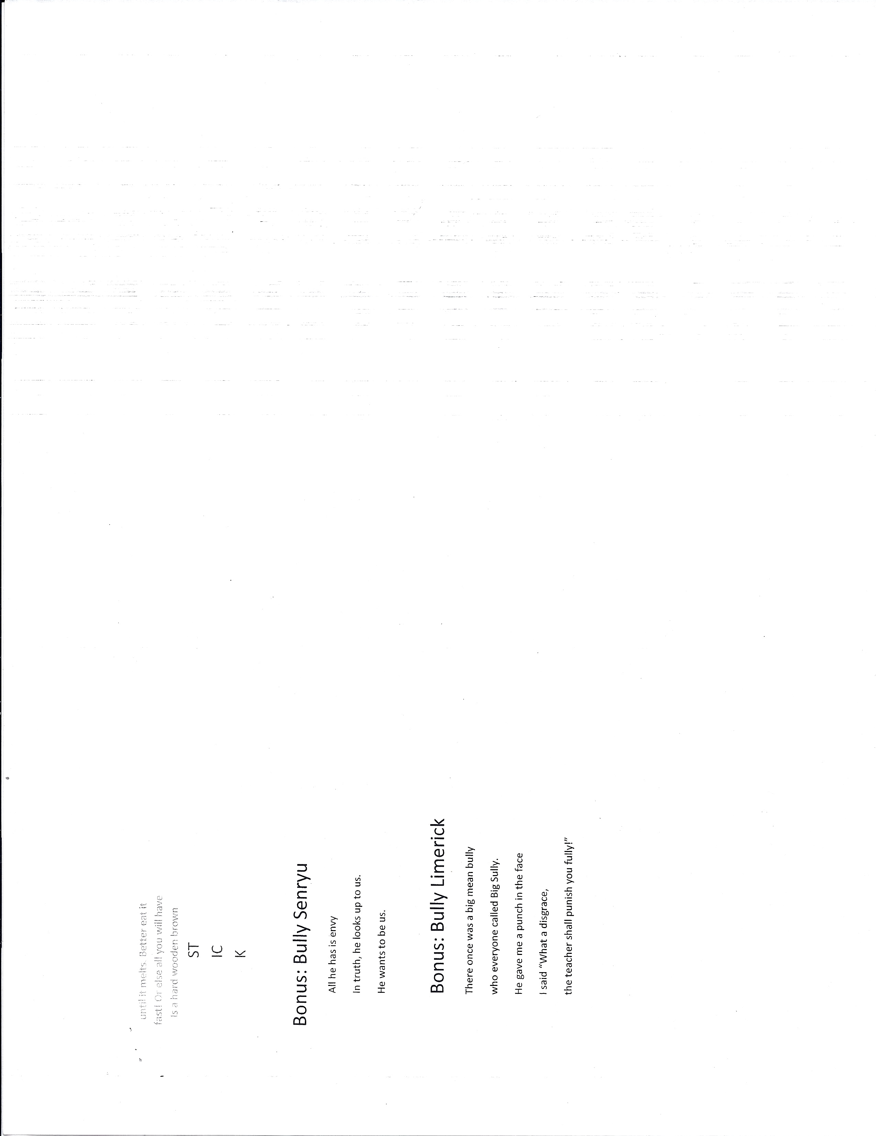
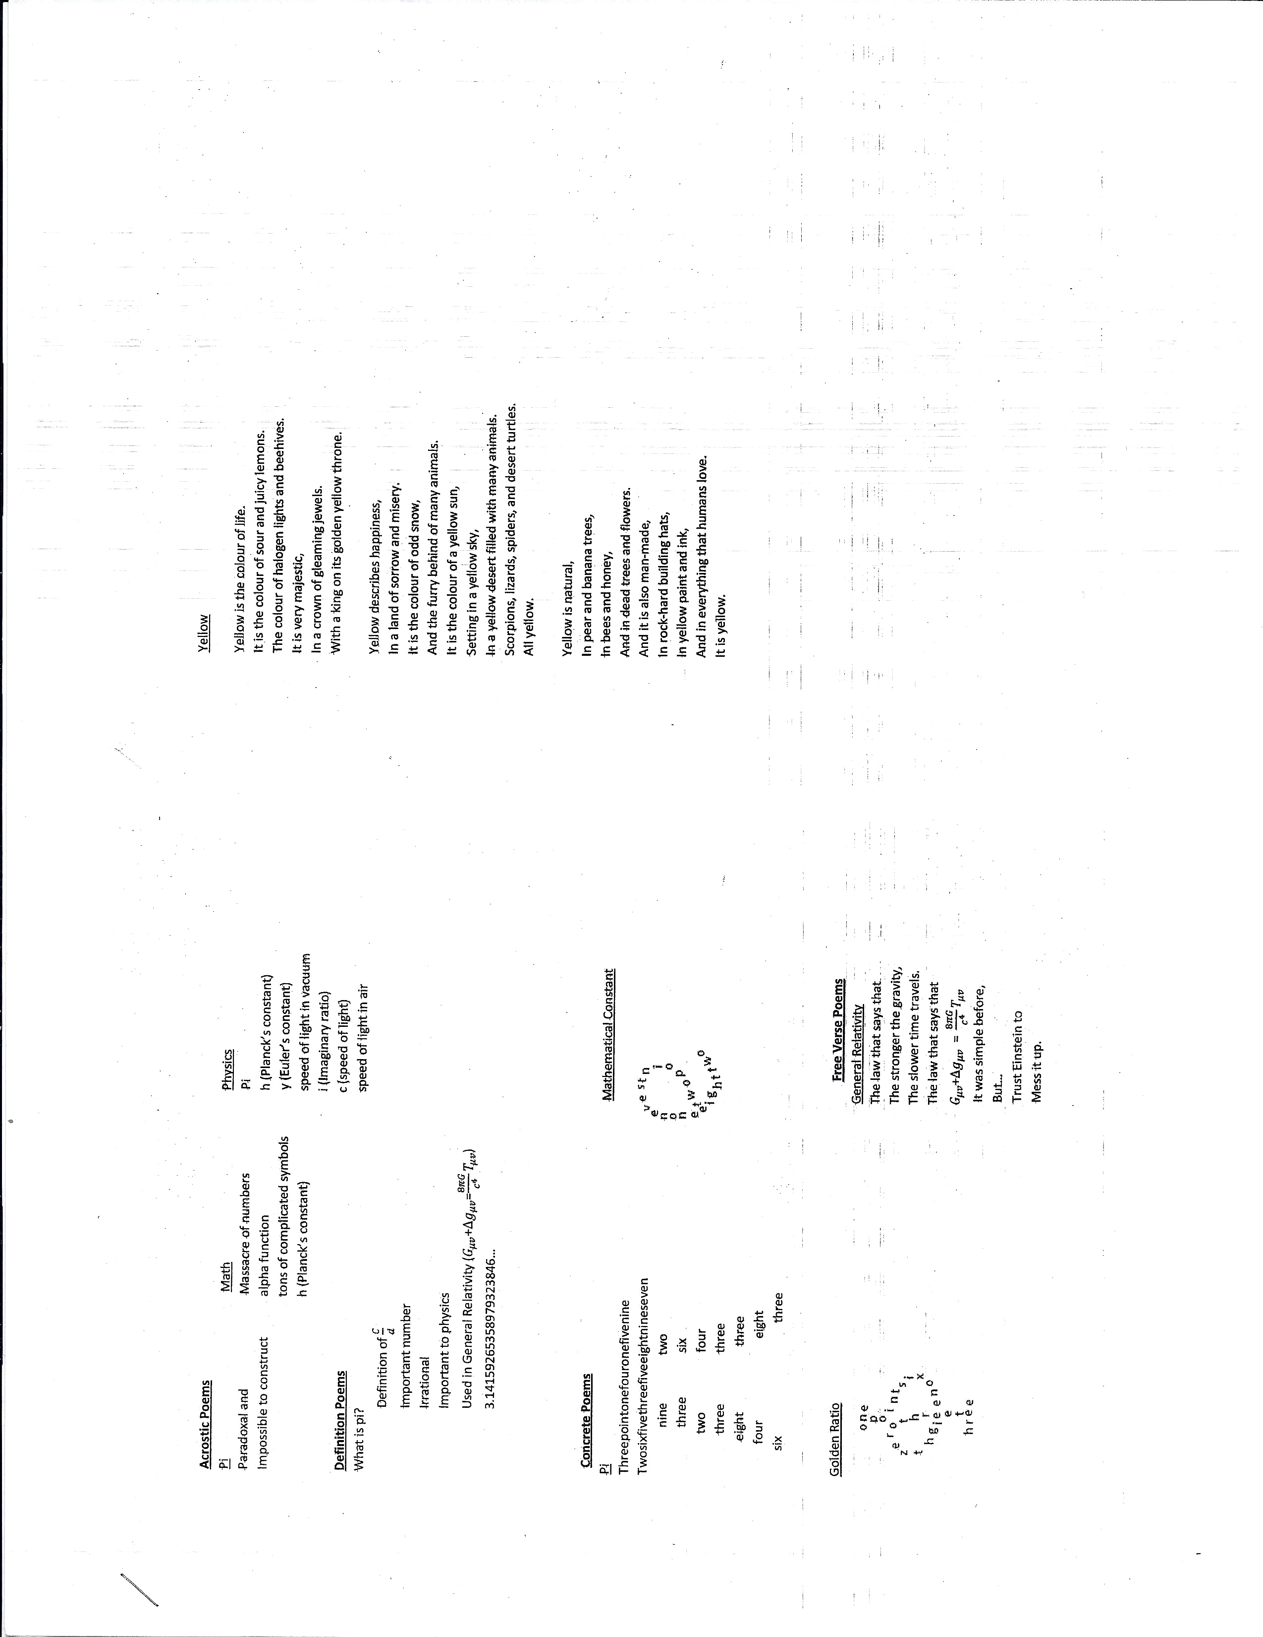
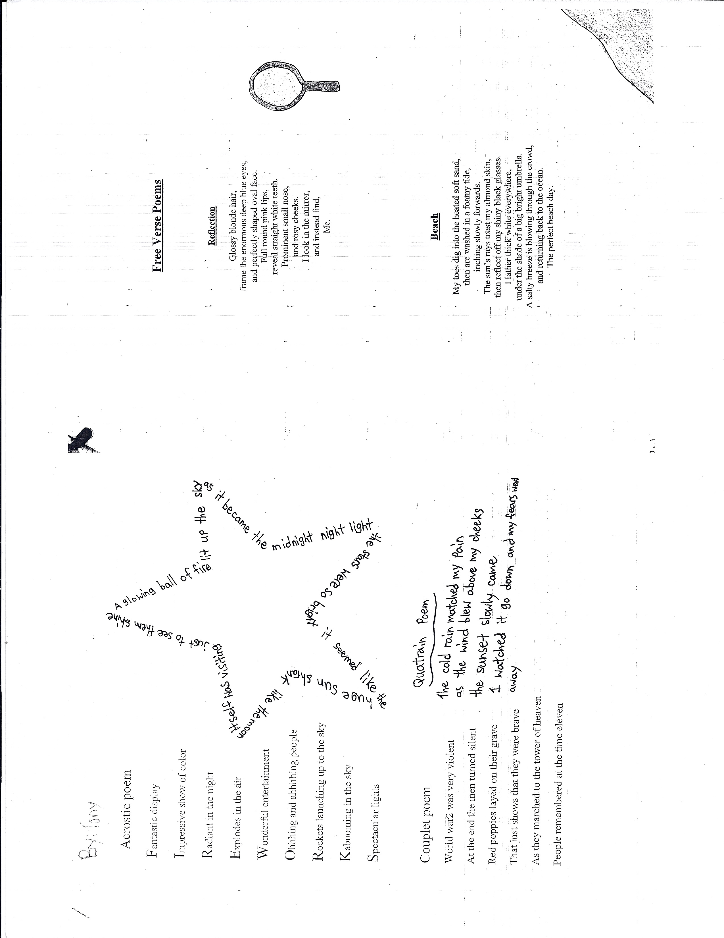
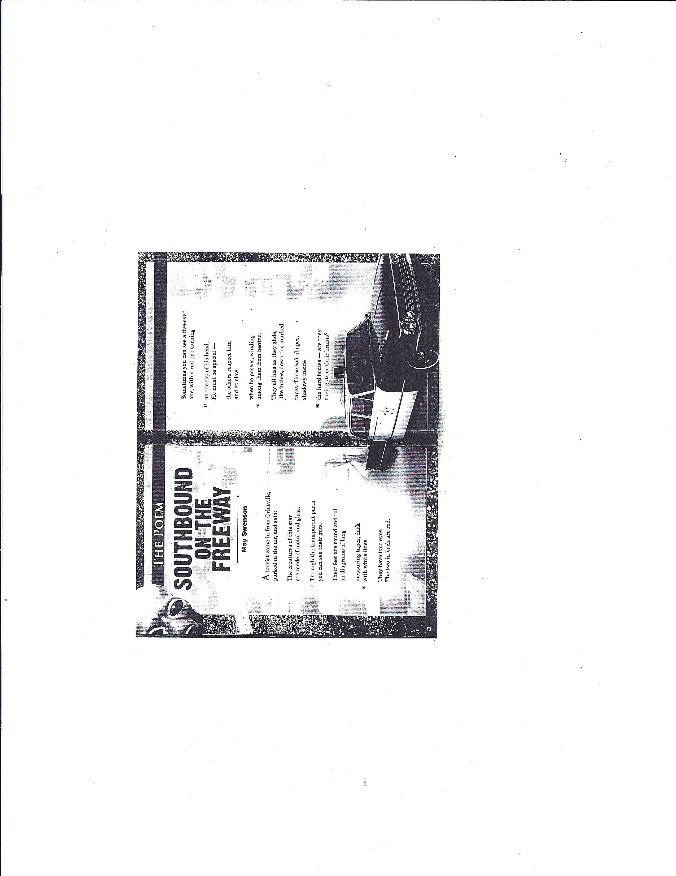
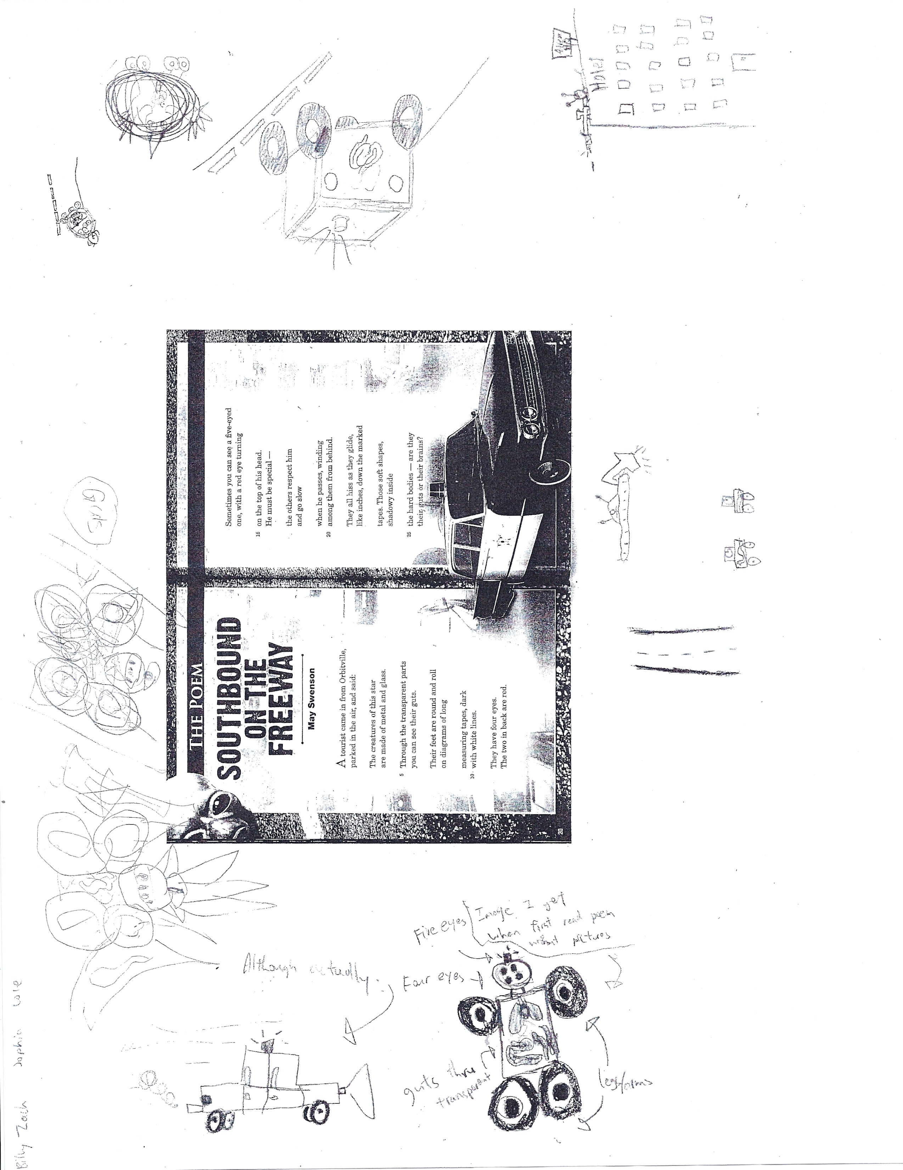
Study Habits: A Poem for Two Voices
I expect to get a good mark on this test.  I spent all week studying. It was torture, but it was worth it.  I’m going to get an iPod.  I feel so confident. This is such a wonderful day! | Oh my God! I’m going to fail.  I spent all week playing video games. So much fun. I finally beat the last level.  If I fail, I’m going to have to go to summer school.  My heart is pounding so hard, I think it will jump out of my body any second.
The teacher is handing out the test!
Perfect as always. A glittery, smiley sticker beside my perfect score. Another great addition to my perfect test papers! | I’m going to die! Scribbled on the top of the test, in red, were the words “See me after school.”
I got the mark I deserved!
Normal: A poem for two voices.

My life was ruined when I was diagnosed with leukemia years ago.  I have breakfast in bed – through tubes.  People treat me like a one year old.  I can’t go to school. I learn through flashcards.  People think I have no feelings.  I want to play 7th grade sports again.  I hate how people look at me. | I’m perfectly healthy and smarter than all the others.  I go downstairs with cereal everyday.  I’m treated like a 20 year old.  I’m 6 years advanced. I still get straight A’s.  My family praises me everyday.  I want to go back to Grade 7.  I hate how my parents think too highly of me.
I wish I was…
Normal.

lostboysconsulting.ca
bryangidinski@gmail.com or
604-434-8747

Available for school-based, or district professional development. Please contact for availability and rates.

